|  |  |
| --- | --- |
| **California**  1845 Industrial Drive  Auburn, California 95603  Telephone: (530) 885-1482  Facsimile: (530) 885-0593 | **Kansas**  307 Plymate Lane  Manhattan, Kansas 66502  Telephone: (785) 539-6305  Facsimile: (415) 358-4340 |

#### 

#### **SURFACE SYSTEMS & INSTRUMENTS, INC.** [**smoothroad.com**](http://www.smoothroad.com)

#### **Custom Test Equipment • Mobile Technology Solutions • Inertial Profilers • ADA Compliance • FF/FL Testing**

Profiler V3 Operation Manual

CS-9100/9300/9400

Version 3.3.0.0.

|  |  |  |
| --- | --- | --- |
| **Hardware Design & Fabrication** 1845 Industrial Drive Auburn, CA 95603 Tel:  (530) 885-1482 Fax:  (530) 885-0593 **Email:**[**info@smoothroad.com**](mailto:info@smoothroad.com) | **Sales & Administration** P.O. Box 790 Larkspur, CA 94977 Tel: (415) 383-0570 Fax:  (415) 358-4340 **Email:**[**info@smoothroad.com**](mailto:info@smoothroad.com) | **Electronics & Software** 307 Plymate Lane Manhattan, Kansas 66502 Tel:  (785) 539-6305 Fax:  (785) 539-6210 **Email:**[**info@smoothroad.com**](mailto:info@smoothroad.com) |

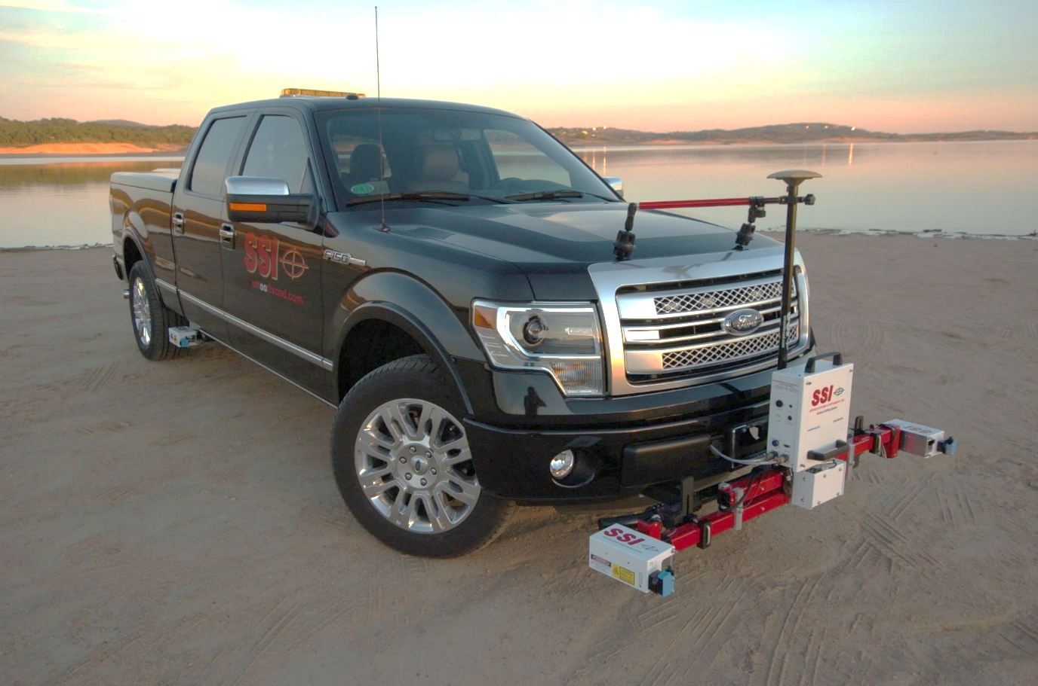

Table of Contents

Data Collection 1

Safety 1

Storage 1

Truck Mounted Inertial Profilers 1

Lightweight Inertial Profilers 1

System Setup 1

Run as Administrator (Windows 7) 1

Run as Administrator (Windows 10) 2

DMI Assembly 4

Main Electronics Housing 5

CS9300 Bumper Mount 5

CS9300 Hitch Receiver Mount 5

Front Mount Hardware 5

CS9100 Mid Mount 6

Connecting Hardware 7

Disconnecting Hardware 7

7

GPS Setup 7

9350 Survey System 7

Novatel GPS Setup 8

Inertial Systems With Novatel External GPS Receiver 8

CS9300 Bumper Mount GPS Setup 8

Trimble 5kHz GPS 8

Arm Adjustment and Laser Placement 9

Calibration 10

Distance Calibration 10

Distance Calibration with the Electric Eye 10

Accelerometer Calibration 11

Inclinometer Calibration (If Equipped) 14

Dual Axis Inclinometer Calibration 14

IMU Cross-Slope Calibration 16

Transverse Calibration 17

Calibration Summary 17

System Settings 18

Laser Type 18

Collection Settings Tab 19

GPS Settings 19

Camera Settings 20

How to Begin Using the Camera 20

Enabling Camera Settings 20

21

System Verification 22

Laser Height Verification 22

Bundling Multiple Height Verification Reports 23

Bounce Test 24

Inclinometer Verification 27

Collect 27

27

System Status 27

Collection Information 28

Collecting Data 28

The Three Ways to Start a Collection 29

1) Starting a Collection: Run Up 29

2) Starting a Collection: Back up 29

3) Starting a Collection Using the Electric Eye 30

Ending Collections 30

**1)** **By Electric Eye** 30

**2)** **Through the Stop Icon** 30

**3)** **Speed Drop Out and Backing Up – “Save”** 31

Aborting Collection 31

Stopping a Collection 31

Saving the Collection 31

Changing Units of Plot 31

Post-Collection 32

Reporting 32

File Tab 32

New 32

Open 32

Open Recent 32

Clear Recent 33

Save 33

Save As 34

Exporting 34

Export Location 35

36

Exporting to ERD Format 36

Station Extraction 36

Filter Settings—High & Low Pass length 36

Include Run Up – Run Up Data 37

Export Raw Data 37

Match Tracks and Choosing Tracks 37

Match Tracks 37

Choosing Tracks 37

Ignore Pauses 38

Include Run Up/ Run out 38

Export for ProVal 38

Exporting to PPF Format 38

Station Extraction 38

Filter Settings—High & Low Pass Length 38

Available Filters: 39

Include Run Up and/or Run out Data 39

Match Tracks 39

Ignore Pauses 39

Export for ProVal 39

Exporting to PRO Format 40

General Settings 40

Station Extraction 40

Filter Settings-High Pass Length 40

Export Raw Data 40

Match Tracks 40

Handle Pauses By: 41

Details 41

Exporting to Survey Format 41

Station Extraction 41

Filter Settings 42

Output Sampling Interval 42

Exporting to Excel Format 42

Export to Template 43

Defects Template 43

IRI Template 43

PRI Template 43

Summary Unmatched 43

Exporting to Google Earth 43

Exporting to GPX Format 44

45

Exporting to Sidewalk Format 45

Exporting to Localized Roughness 46

Specify Station Numbers 46

GPS Reporting 47

Lane Settings 47

Customization 47

Merging 47

Export Defect Locations 47

ProFAA 48

RMS Export 48

GIS Export 49

Exporting Raw Data 49

Exiting Program 49

Shortcut Bar 50

Edit Data 50

Edit Run 50

Sampling Interval 50

Edit Segments 51

Adding & Editing Pauses 51

To Edit a Pause 51

Pause Definition 52

Pause Notes 52

Pause List 52

Start Station 52

End Station 52

Save Pause Icon 52

Ignore Length at Start/End 52

Pause Buffers 52

Event Buffers 52

Use Same Length 52

Edit Events 52

To add an Event 53

Editing an Event 53

Deleting Events 53

Crop Data 53

Project Parameters 54

Job Information 54

Project 54

Road 55

Paving 55

Additional 55

Report Memo 55

User Defined 56

Settings 56

General Settings 56

File Settings 57

Default File Type (RSD, RHD) 57

Default File Location 57

Default File Name 57

Creating a New Template 57

User Defined Parameter 57

Changing the Template Name 57

Adding Parameters to the Template 57

On Startup 58

Load Previous File on Startup 58

Load Previous File’s Settings 58

Use Last File’s Parameters 58

Choose from a Previous File (Browse) 58

Set File Parameters after Collection 58

Automatically Refresh Reports 58

Data Collection Hardware 58

Search for Hardware on Startup 58

Disconnect Hardware When Changing Tabs 58

Report Generation 58

Generate Reports in Color 58

Include the Footer 58

Enable Animations 58

Resize for Printrex 58

Report Scale 59

Formatting 59

Font Settings 59

Image Scaling 59

Profiler Software Update 59

Program Language 59

Analysis Parameters (Ride Values) 59

Profiling Units 59

English 60

Metric Meters 60

Metric Centimeters 60

Metric Millimeters 60

CA Bridge 60

CA Bridge Metric 60

Segment Length 60

Merge Last Segment if Less Than 60

Exclude Paused Sections 60

Include Paused Sections 60

Paused Sections Only 60

Analysis Type 61

IRI 61

PRI 61

PRI Parameters 62

Scallop Definition 62

Blanking Band 62

Minimum Scallop Height 62

Minimum Scallop Width 63

Scallop Resolution 63

Reset File Settings 63

Minimum Scallop Height Inclusive 63

HRI 63

RN 64

RMS Roughness 64

Ride Index Thresholds 64

Highlight Index Values Above 64

Highlight Index Values Below 64

Analysis Parameters: Filters 65

High Pass Filter 65

Low Pass Filter 65

PRI Filter 65

Moving Average 65

Butterworth 65

Filter Gain—1.00 65

Localized Roughness 66

Defect Detection 66

Bump Parameters 66

Height 66

Width 67

Dip Parameters 67

Depth 67

Width 67

Localized Roughness Report Options 67

Display Defects By: 67

Display Maximum Peak/Low Values for Defects 68

Identify GPS Closest to Defects 68

Defect Data Type 68

Profilograph 68

Relative Height 68

Texas-1001-S Method 68

IRI 68

General in Localized Roughness 69

Merge Defects within: 69

Shade Defects on Plot 69

Report Settings 69

Track/Segments General Settings 70

Multiple Track Reporting Track Select 70

Match Tracks 70

Trace Settings 70

Amplitudes on Plot 70

Note Reporting 71

Report Speed Notes 71

Report GPS Notes 71

Customize Reporting Intervals (GPS/Speed Notes) 71

GPS Note Reporting Interval 71

Speed Note Reporting Interval 71

Report Content 71

Summary Report 71

Image Summary Report 72

Trace and Calibration Reports 72

Show Summary in Table 72

Simple Calibration Report 72

Extended Calibration Report 72

Tables 73

Enable/Disable Reports 73

Themes/Fonts 74

View 75

Report 75

Refresh 75

Print 75

Printrex 422 Thermal Printer 76

To PDF 76

Report Options 76

View by Segments 76

Collect 77

Trace 77

Choosing Tracks for Plotting 77

Refresh 77

Plot Options Icon 78

Profile/Continuous IRI 78

Plot Options Settings 79

Display Run in/ Run out Data 79

Apply filters 79

Show Point Labels 79

Rendering Mode 79

GPS Lock-On 79

Display Current Location 79

Center Trace on Current Location 79

Highlight IRI Thresholds 79

Base Length 79

1st, 2nd, 3rd [in/mi] 79

Localized Roughness in Trace View 79

Display Localized Roughness 80

Use Localized Roughness Settings in Trace View (Recommended) 80

Navigation 80

GPS Tagging Tool 80

Dynamic Tagging 80

Static Tagging 81

Grinding Simulation and Navigation 81

Print 82

Save 82

Zoom 84

Zoom Previous Icon 84

Zoom Fit Icon 84

Pan/Zoom Mode Icon 84

Units for Height and Station 84

GPS Editing and Tagging 84

Advanced Tools 84

Images Window 85

Images in the Report 85

Grind Sections 86

Navigation (Map Views) 86

Google Maps. 87

Display Current Location on Map 88

Lock on Current Location 88

Directions from Current Location 88

About 89

Manual 89

Check for Updates 89

Send Feedback 89

Third Party Components 90

Recommended Tools 90

Create a personal default file name convention for you project 90

Load analysis parameters and settings from previous projects 90

Set a default file location 90

Use the extended calibration report to print PDFs 90

Use dual plotter in trace view 90

Use GPS navigation within trace view 90

Use hot keys during collection 91

Import grind locations into Profiler for use in trace view navigation 91

Use Google Maps to crop and edit data based on stationing and pin information 91

Troubleshooting and Support 91

When Contacting SSI Technical Support 91

Attaining Profiler Software and Replacement Parts 91

Panasonic Toughbook Computer 91

Paper Supplies or Printer Servicing. 92

Is your Software Up to Date? 92

Do Not Attempt To Repair Electronic Components 92

Is your Power LED Illuminated? 92

Hardware Not Found 92

Example Diagnostics 92

Failed Height Verification 92

Failing Accelerometer Calibration 93

Lasers Not Firing 93

Failed Bounce Test 93

Distance Not Correct 93

High IRI/Ride Value 93

Electric Eye Events/Pause/Start/Stop Collection Did Not Work 94

GPS Navigation Timed Out (Map Point, Google Maps, Trace View) 94

The Camera is not taking color pictures 94

**Table of Figures**

Figure 1: Compatibility window for running Profiler software as an administrator in Windows 7. 1

Figure 2: Searching for Profiler V3 program file. 2

Figure 3: Selecting ‘Properties’ from drop down menu. 2

Figure 4: Check ‘Run as Administrator’ in the Short Cut tab. 3

Figure 5: Click ‘OK’ and ‘Continue’ to confirm and run Profiler as Administrator. 3

Figure 6: Window for disactivating notification of changes to computer. 4

Figure 7: The DMI wheel attached to an 8-lug vehicle with a 4-lug extender configuration. 5

Figure 8: The DMI pole and receiver 5

Figure 9: The hitch receiver mount with lock brackets. 6

Figure 10: The LED power indicator 7

Figure 11: The vertical dovetail and laser plate assembly 9

Figure 12: The Calibration Menu 10

Figure 13: Distance calibration options 10

Figure 14: The first step towards a distance calibration 11

Figure 15: To end the calibration, align the lasers (or other fixed point) on the end line 11

Figure 16: The first step of the accelerometer collection 12

Figure 17: The upright accelerometer position 13

Figure 18: The accelerometer upside down 13

Figure 19: The accelerometer on its side 14

Figure 20: Window to Enter Inclinometer Angle 15

Figure 21: The inclinometer must be level before starting the calibration 15

Figure 22: The inclinometer on the flat plate for a rear-mount. 15

Figure 23: The inclinometer on the angled plate for a rear-mounted system 16

Figure 24: A three laser system with a level straightedge for inclinometer 16

Figure 25: The Calibration Summary 17

Figure 26: The laser type window for a Survey 3-Laser system 18

Figure 27: The HSP dot laser system laser options window 18

Figure 28: GPS setting window 19

Figure 29: Camera Settings 20

Figure 30: Advanced camera settings 21

Figure 31: Camera Preview window in Collect Screen 21

Figure 32: Verification Menu 22

Figure 33: The initial step for a height verification is to place a base plate under the laser being tested. 22

Figure 34: To continue height verification, select “Yes” 23

Figure 35: Saving Preferences after a Height Verification 23

Figure 36: The correct block Orientation for the Height Verification 24

Figure 37: The static test of the bounce test. Do not touch or move the vehicle during this portion of the test. 24

Figure 38: The static test being performed 25

Figure 39: The beginning of the Dynamic Bounce Test 26

Figure 40: The dynamic test is performed by bouncing the vehicle vertically 26

Figure 41: The Dynamic Test Results 26

Figure 42: The main collection window. 27

Figure 43: The System Diagnostics 27

Figure 44: The Collection Information window 28

Figure 45: The collection screen after “Begin” was selected 28

Figure 46: The Electric Eye (EE) is armed to start the collection 30

Figure 47: The procedure to change units of the data plot is shown 31

Figure 48: Opening a data file in the Profiler V3 program 32

Figure 49: The Open Recent feature 33

Figure 50: The clear recent feature 33

Figure 51: Saving a file through Save As in RSD format 34

Figure 52: Window for exporting the data into Excel format 34

Figure 53: Select location to save the exported file 35

Figure 54: The export type drop down menu 35

Figure 55: The export folder location selection 35

Figure 56: The ERD format export window with match tracks selected 36

Figure 57: The ERD export window settings 38

Figure 58: The PPF export window 38

Figure 59: Optional settings when exporting in PPF format 39

Figure 60: The PRO format window 40

Figure 61: The Details tab contains information about the project 41

Figure 62: The window for exporting in Survey format 41

Figure 63: Stationing units dropdown menu and options 42

Figure 64: Exporting the data into Microsoft Excel format 42

Figure 65: The types of excel formats are listed 43

Figure 66: Google Earth export settings 43

Figure 67: Google Earth view on laptop 44

Figure 68: The export window for GPX format 45

Figure 69: Export to Sidewalk window 46

Figure 70: The Localized Roughness export options window 46

Figure 71: The Customize Window 47

Figure 72: ProFAA window 48

Figure 73: RMS export settings 48

Figure 74: GIS export settings 49

Figure 75: Exporting Raw Data Settings 49

Figure 76: Exiting the program- Saving 49

Figure 77: The shortcut bar with all of the frequently used windows 50

Figure 78: The Edit Run Options 50

Figure 79: Adding or removing pauses from the collection 51

Figure 80: Edit Events Tab 53

Figure 81: The Crop Data Tool 53

Figure 82: The Project Parameters window 54

Figure 83: The Report Memo window 55

Figure 84: The User Defined section 56

Figure 85: The General Settings window showing the Configuration 56

Figure 86: The custom file naming convention 57

Figure 87: The units and rounding section of the General Settings 59

Figure 88: The IRI Analysis Parameters window 61

Figure 89: The Analysis type drop down menu 62

Figure 90: An example of the blanking band in the trace report 62

Figure 91: The HRI analysis window with the available filter 63

Figure 92: The RN analysis window with the filter options shown 64

Figure 93: The filters within the IRI analysis parameter window 65

Figure 94: The filters for the PRI analysis parameter 65

Figure 95: The Localized Roughness window with the defect settings 66

Figure 96: When only bumps are selected, dip parameters are unavailable 66

Figure 97: When only dips are being tested for, the bump parameters become unavailable. 67

Figure 98: Localized roughness settings 67

Figure 99: Types of testing available for finding defects 68

Figure 100: Merge Defects 69

Figure 101: The report options window 69

Figure 102: The Track and Run Selection Window 70

Figure 103: The Report Content window 71

Figure 104: The Image Summary Report options under Report Content. 72

Figure 105: The Trace and Calibration Report options 72

Figure 106: The Table options under Report Settings 73

Figure 107: The Enable/Disable Reports window 73

Figure 108: The Reports selections after Enable/Disable configuration is set 74

Figure 109: Themes and Fonts option under Appearance settings. 74

Figure 110: The summary header of a single trace report 75

Figure111: Printing Options Window 75

Figure 112: The drop-down menu for the report options 76

Figure 113: The segment or defect navigator 76

Figure 114: An example of the profile trace 77

Figure 115: Recommended Plot Options window 78

Figure 116:The dual plot of the Continuous IRI and Median Profile 78

Figure 117: The Continuous IRI trace with the localized roughness diamonds shown 80

Figure 118: Dynamic Tagging Feature 80

Figure 119: Static Tagging Feature 81

Figure 120: Grinding Navigation with green current location displayed 81

Figure 121: The Print window after the print icon is selected 82

Figure 122: The tool bar for the trace window 82

Figure 123. The available picture formats to save the trace graph. 83

Figure 124: Windows explorer to save 83

Figure 125: The Images Window under Advanced Tools 85

Figure 126: : The Continuous Trace Report with Images. 86

Figure 127: The Google Maps start window. 87

Figure 128: Google Maps showing the localized roughness 88

Figure 129: The About Window 89

# Data Collection

## Safety

Turn on headlights when profiling to alert other drivers and co-workers of your presence.

Road profilers are precision instruments, handle with care. Improper maintenance and use will reduce system life and collection accuracy.

## Storage

### Truck Mounted Inertial Profilers

When the inertial profiler is not in use remove the lasers and store them in a dry, shock protected place. This will protect the glass sensor windows that are commonly damaged by rocks. Remove the DMI (Distance Measurement Interface) when the IP will not be used for long periods of time or during long distance traveling.

### Lightweight Inertial Profilers

Place the lightweight profiler on stands with the wheels elevated off the ground. This will ensure that the wheels remain true and round. Remove the lasers and protect them in a shock proof case when not in use. When parking the lightweight in a trailer or truck bed, focus on the DMI and the front of the cart so they are not damaged.

## System Setup

### Run as Administrator (Windows 7)

Certain laser models with ethernet connection require Profiler to be run as Administrator. Go to the Desktop, right click on the SSI Profiler icon and select the “Compatibility” tab. At the bottom of the window under “Privilege Level”, select the check box for “Run this program as an administrator.”

Figure 1: Compatibility window for running Profiler software as an administrator in Windows 7.

### Run as Administrator (Windows 10)

Certain laser models with ethernet connection require Profiler to be run as Administrator.

Right click on the Profiler V3 icon ‘P3’, go to More>Open File Location.

Figure 2: Searching for Profiler V3 program file.

Right click on SSI Profiler shortcut, go to properties

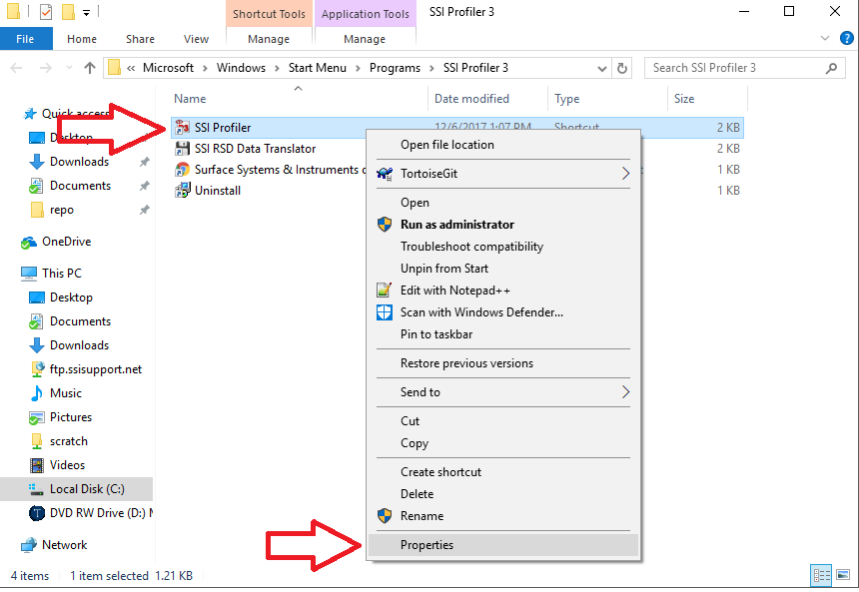

Figure 3: Selecting ‘Properties’ from drop down menu.

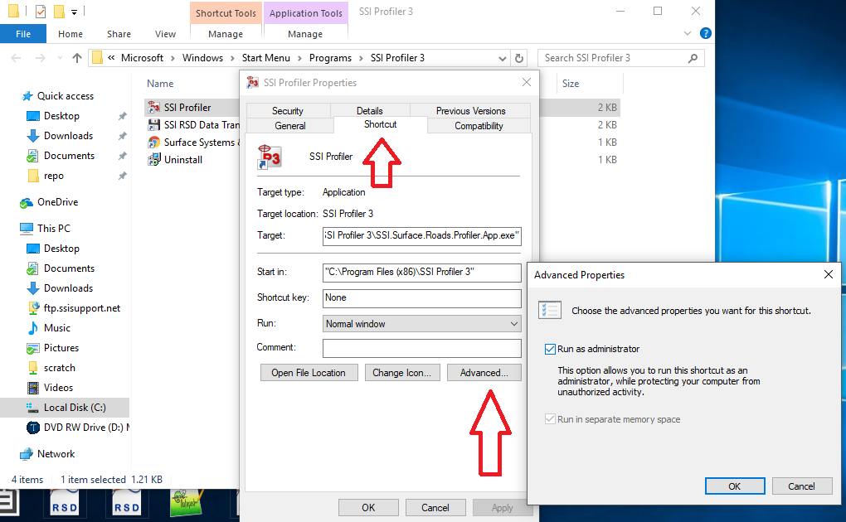In Shortcut tab go to Advanced... Check ‘Run as Administrator’ and then ‘ok’.

Figure 4: Check ‘Run as Administrator’ in the Short Cut tab.

Click ‘Continue’, in Access Denied window for Profiler to run as Administrator every time.

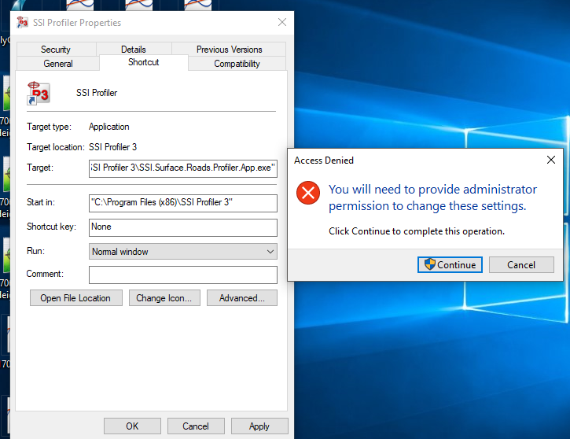

Figure 5: Click ‘OK’ and ‘Continue’ to confirm and run Profiler as Administrator.

After setting Profiler V3 to run as Administrator, a popup with appear every time you open the program. To get 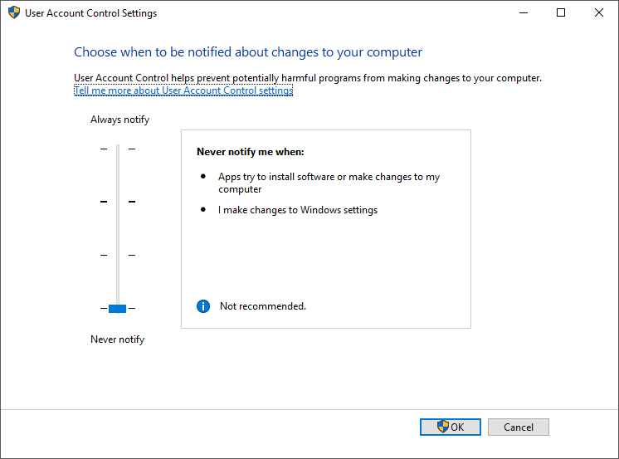rid of the popup search "user account control" and set to "never notify" (this is Optional)

Figure 6: Window for disactivating notification of changes to computer.

*Note: The settings.xml file goes in C:\Users\SSI PROFILER\AppData\Roaming\SSI\SSI.Surface.Roads.UDP.LaserRec*

## DMI Assembly

The installation of the DMI encoder assembly to the vehicle rim is the initial step of distance calibrations. If the vehicle is a Polaris 570 the DMI may be embedded and does not require assembly. Install the supplied collets onto the lug nuts of the vehicle. The collet assembly includes the collet, the housing and a machined bolt with both male and female ends. Space the collets depending on the number of lug nuts. For a six-lug wheel, use three collets in an approximately equilateral triangle formation. For an eight-lug wheel, use a square collet formation. There are machined numbers on the internal ring of the DMI disk to determine to correct placement and number of collets. The design of the DMI forces the collets to center themselves if the collets are in the correct position. If the DMI is installed off-center, the vertical movement of the position pole will be large. The wire harness for the encoder can be tied to the vertical position pole to avoid damage from tangling with the vehicle. Keep slack in the wire at the top of the pole using gear ties or zip ties so there will be no tension on the wire. To install the position pole correctly, insert the pole into the delrin guide attached to the vehicle body before attaching the DMI disk to the lug extenders.

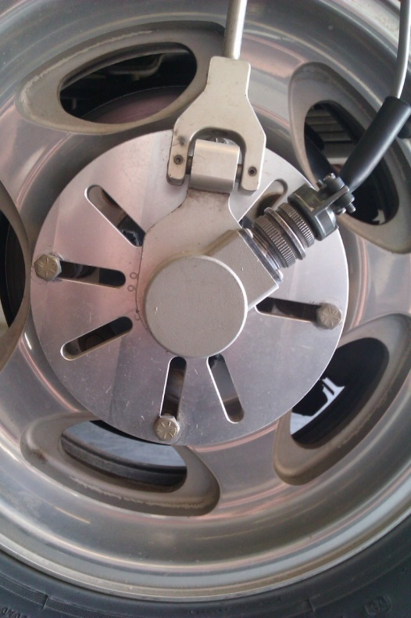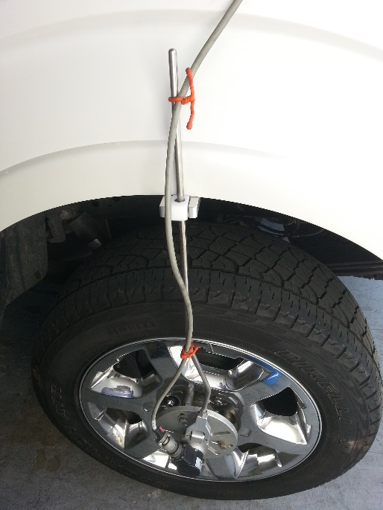

Figure 7: The DMI wheel attached to an 8-lug vehicle with a 4-lug extender configuration.

Figure 8: The DMI pole and receiver

## 

## Main Electronics Housing

### CS9300 Bumper Mount

The main housing for the 9300 systems is mounted to the hitch receiver. The 9300 hitch receiver is bolted to the back plate of the housing. The height of the profiling system can be adjusted through the machined slots on the hitch receiver. The laser heights can be changed by adjusting the dovetails mounted on the laser plates by loosening the ½ inch set screw with a ¼ inch allen wrench. The receiver hitch bolt is used to secure the system to the vehicle along with the supplied receiver tube brackets. The thicker end of each bracket is bolted against the white receiver tube. Always use both brackets and the receiver bolt to mount the profiling system. If the brackets are mounted backwards, the face of the brackets will not be parallel to the walls of the vehicle’s hitch receiver. Power to the main housing is supplied by the seven pin connection through the trailer wiring. To determine if power is reaching the profiling system, check the LED at the top of the housing. The LED will illuminate when power is being supplied.

### CS9300 Hitch Receiver Mount

The hitch receiver tube is connected to the vehicle using the hardware supplied with the system. There will be four 5/16”-24 bolts supplied with the system that mount the receiver tube to the aluminum back plate. The supplied bolts and bracket for the hitch receiver are oriented so that the thicker end of the brackets are in contact with the profiler’s male end of the receiver tube. This assembly can be seen in **Error! Reference source not found.**.

### Front Mount Hardware

When the system is mounted to the front of the vehicle by the tow-hook mounting tubes, there are six bolts supporting the system; four 5/16”-24 bolts (1/2” wrench) and 2 U-bolts at the ends (9/16” wrench). The U-bolts are paired with the plastic sleeves. Make sure that the system is as level as possible when attaching the U-bolt supports.

### CS9100 Mid Mount

The main electronics housing is mounted under the back seat for the CS9100 mid-mount profiling systems. The laser heights can be changed by adjusting the dovetails mounted on the laser plates by loosening the ½ inch set screw with a ¼ inch allen wrench. Power to the housing is supplied by a 12V DC cigarette lighter plug. When power is reaching the housing the blue LED will be illuminated.

**Note:** Connect the Amphenol harnesses to the housing without torsion being applied to the wire. Turning the entire harness instead of the threaded connector will break off the soldered wires within the harness.

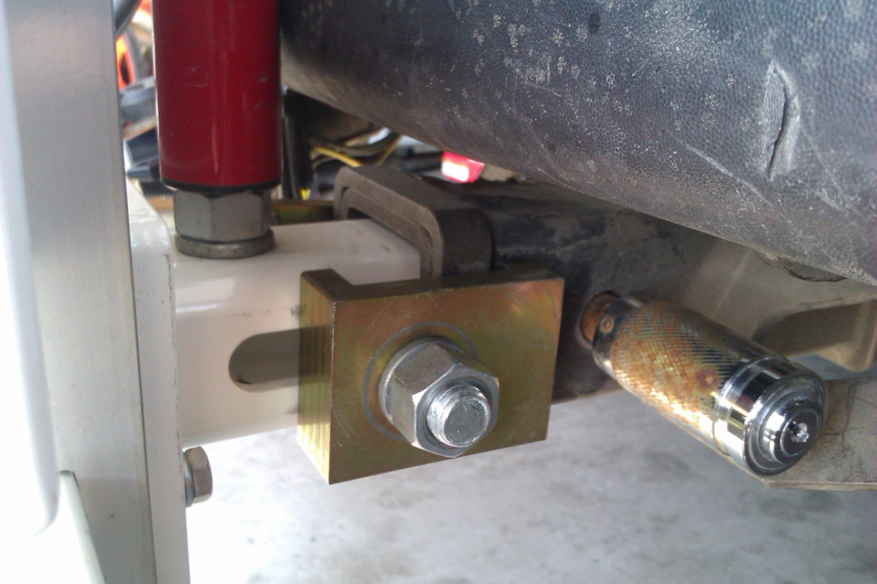

Figure 9: The hitch receiver mount with lock brackets.

## IMAG0115.jpgConnecting Hardware

During assembly, connect the serial cable coming out if the pelican case or the white housing (6 pin amphenol) to the computer’s DB-9 serial port. Once the program is opened and Collect is selected the software will search for hardware.

## Disconnecting Hardware

If the hardware, lasers, GPS, and DMI do not need to be used while the system is connected through the serial port then the operator may use the Hardware Disconnect button at the bottom right of the collection screen. To reconnect the hardware again, select Collect and the software will search for hardware.

## 

Figure 10: The LED power indicator

## GPS Setup

Models with high resolution GPS for survey and cross slope applications may have additional steps to set up GPS. For all internal GPS receivers built into the SSI electronics the operator will use the USB cable to send commands. Otherwise, the commands will be sent through a serial or USB cable directly connected to the GPS receiver. If the receiver is powered on and connected with no signal, the SSI Profiler program wil display “No GPS Signal.”

## 9350 Survey System

The survey consists of three key components: base station receiver with tripod, pole with receiver and the rover or embedded GPS board. The base station is the main transmission point. It receives static GPS points for corrected GPS. The position of the profiling system is referenced off of the base station to determine the corrected GPS coordinates.

**Note:** The base station in not needed for profile smoothness data. It is used only to receive corrected GPS for survey data.

The GPS pole is secured by threading the pole to the bracket mounted to the backside of the white housing. The cable from the antenna receiver is connected to the rover or SSI electronics box. If no GPS signal is found, make sure the baud rate for the GPS receiver is matching the SSI electronics at a rate of 9600, 38400 or 115200. This can be changed in the GPS manufacturer software. For more assistance contact SSI Support.

## Novatel GPS Setup

The Novatel GPS receivers used on the CS7900 and most high and mid-resolution GPS options have multiple platforms for programming. Contact SSI if you are unsure which system you have and the electronic limitations. Novatel systems can be mounted as stand-alone receivers, embedded inside the SSI electronics or mounted in a self-contained Pelican case as in the CS7900. If the receiver is embedded within the SSI electronics housing do not attempt to open the electronics or program the board. Contact SSI for a technician assist. All external receivers (Flex2, Flex6 and Span-CPT) can be programmed through a USB or direct cable.

### Inertial Systems With Novatel External GPS Receiver

These systems run at 10Hz with a GPGGA string through the serial port on the outside of the White SSI housing. If the receiver needs reprograming, enter the following commands in Putty or Novatel Connect. You should see an “OK” after each command is entered.

1. unlogall
2. com com1 38400 n 8 1 n off on
3. log com1 gpgga ontime 0.1
4. saveconfig

Note: Newer systems with the latest firmware have a baudrate of 9600. Note the baud rate in which you connected to the receiver and use the same number.

## CS9300 Bumper Mount GPS Setup

Measurements must be taken to set up the GPS in order to accurately pinpoint the defects detected by the inertial system. For this process a tape measure is required. There is only a need to re-measure when the system changes dimensions or changing the vehicle host. A new dimension is mainly from a change in the length of the arms from disassembling the system for storage. The measurements are from the left laser (track 1) to the center laser (track 3), from the track 1 laser to the track 2 laser, and the elevation measurement. The elevation measurement is the distance from the bottom of the center laser (track 3) to the top of the GPS pole. The top of the GPS pole does not include the antenna and is only to the end of the cylindrical pole.

The “GPS Distance Forward” is the distance from the center laser to the GPS antenna going from back to front of the vehicle for rear mounted systems (it is a positive value when the GPS antenna is closer to the front of the vehicle than the laser). For front mounted systems, this measurement is from front to back of the vehicle (it is a positive value when the GPS antenna is closer to the vehicle’s body than the laser).

## Trimble 5kHz GPS

The Trimble GPS system is fully integrated to the profiler system. The coordinates will be found when the collection program is initiated as long as the GPS antenna is not obstructed. The GPS coordinates will be shown in the Main Collection Window beneath the status bar. Details about the GPS system and the coordinates of the system can be viewed by selecting the GPS Details icon. The electronics is searching for GPS signal when the GPS status bar displays, “No GPS Signal.”

## Arm Adjustment and Laser Placement

The arms or dovetails of the profiling system can be used to move the lasers over the tracks that need to be profiled. To adjust the arm length on the CS9300 and CS9350, all three brackets must be loosened, a total of four bolts. If the profiling system has three lasers, the center laser is mounted in front of the center 2 bolts. To adjust the arms, the center laser must be removed so that the two bolts at the center of the system can be accessed. The laser heights (vertical distance to the ground) can be adjusted through the receiver tube plate or the dovetails mounted to the laser plates. The dovetails are secured by tightening the 1/2“set-screw which acts on nylon bushings to compress the dovetail pair together.

High standoff spot lasers (Selcom SLS5000 325/400) have a recommended height of 15 inches above the ground. The range is plus or minus four inches of the recommended height (±4 inches).

The Selcom RoLine 1145, LMI Gocator 2342, and the Selcom low standoff (Selcom SLS5000 200/300) lasers have a recommended height of 11 inches above the ground. This is the reason the RoLine three laser systems use a low standoff spot laser in the center track (Track 3). The minimum height above the ground is 200mm or 7.8 inches. The height range is between 7.8 and 15 inches.

Gocator 2375 high standoff infrared lasers should be mounted 26 to 78 inches above the ground.

***Be aware of the minimum laser range when performing the height verification. Always place the lasers at the correct height. Be aware of your systems laser type if you fail the height verification. The operator can view the laser type when System Settings is selected.***

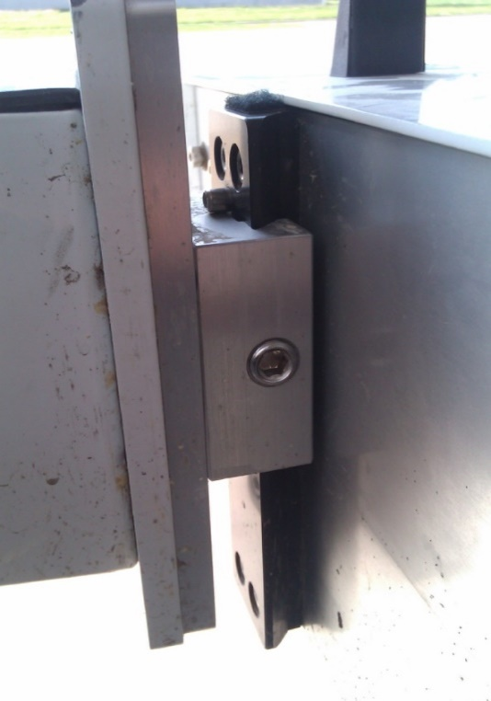***Even if the laser configuration is set to auto detect, review the laser type under system settings to confirm its accuracy.*** ***The laser type can be reviewed under the Collect Window, after selecting the System Settings icon.***

To adjust the height of the lasers, loosen the set screw in the center of the female dovetail with a ¼ inch allen wrench. The set screw does not need to be completely removed. When tightening the set screw, do not over-tighten. The nylon bushing can be damaged when excessive force is used. Tighten the set screw so that the laser plate cannot slide vertically when pulled.

Figure 11: The vertical dovetail and laser plate assembly

For the CS9100 Mid-mount systems the operator must slide the horizontal dovetail outside the truck body to install the vertical dovetail and laser plate assembly. The horizontal and vertical dovetails of the mid mount assembly can be adjusted by loosening the set screw with a ¼ inch allen wrench. Set the laser height and spacing with this method. Only tighten the set screw so that the dovetails cannot move when firmly pushed.

# Calibration

Figure 12: The Calibration Menu

## Distance Calibration

A precise distance calibration is crucial to collecting accurate surface profiles. The distance calibration is traditionally performed on a tenth of a mile track (528 feet or 160 meters). The key component of the distance calibration is the DMI assembly and encoder. Prior to calibrating, measure a tenth of a mile track over an ideally straight, flat and clean area. Open the distance calibration within Profiler V3 and line the lasers on the starting line of the calibration track. Follow the calibration instructions to complete the distance calibration.

It may be necessary to perform multiple distance calibrations within a day of profiling. As temperature changes the air pressure within the tire also changes, modifying the wheel circumference. Whenever this happens, the collected data will become further and further from the actual distance depending on the temperature gradient and the distance traveled. If the distance seems to be deviating from the actual stationing, take the time to recalibrate.

***Always calibrate on a straight 0.1 mile section of pavement at the speed you will be collecting.***

### Distance Calibration with the Electric Eye

Figure 13: Distance calibration options

***If an encoder distance calibration is selected, a traditional distance calibration, not an electric eye calibration, will be performed.***

Distance calibrations can be completed quickly and efficiently by using the electric eye (EE) to mark the beginning and end of the calibration length. This feature requires two points with **DOT**-**C2** compatible reflective tape in range of the electric eye sensors. These two points should be at least 528 feet apart, or another distance given by the resident engineer. It is important that the two reflective tape stations are at accurate positions for the calibration track.

To begin the calibration, follow the message prompts in the instruction window. Select “Next” and drive past the start position electric eye to begin the calibration. After the EE begins the calibration, an estimated distance will be shown (do not be alarmed if the distance is way off from the actual distance). Near the final reflective tape location, arm the EE by selecting “Next” again. The calibration will finish when the EE is triggered. The user will then be prompted to enter the actual distance traveled.

Averaging the counts with previous calibration is a way to reduce error. The average of two correctly calibrated runs will be more accurate than a single calibration run. Even so, this feature is not required since one accurate calibration will work for the distance calibration. When the information is entered the distance calibration may be started. Select accept to end the distance calibration.

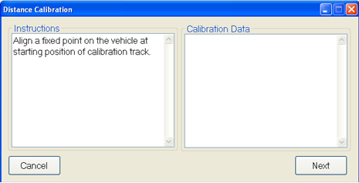

Figure 14: The first step towards a distance calibration

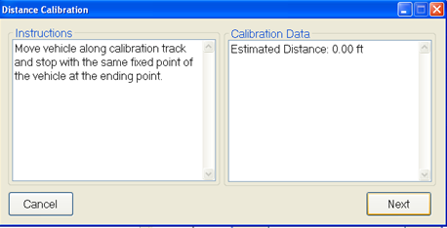

Figure 15: To end the calibration, align the lasers (or other fixed point) on the end line

## Accelerometer Calibration

The accelerometers are an important component of the inertial profiling system. They are used to determine the vehicle chassis’ vertical motion. The vehicle’s vertical motion is then subtracted from the laser readings to determine the profile of the surface (integrating this data with the distance encoder readings). It is important that the accelerometers are calibrated properly and their position on the profiler is constant and correct. The accelerometers should always be in the

upright position except during calibration (Accelerometer is upright when the arrow etched in the accelerometer on the opposite side of the wire is point up). If the accelerometer is oriented in any other way the data will be incorrect. Be aware of any vibration in the laser or accelerometer hardware. Vibration will cause anomalies in the data.

**Note: Both accelerometers are calibrated at the same time. Make sure the vehicle is off (no vibration) and on a level surface**. To calibrate the accelerometers start with both in the upright position (they should already be in this position). Follow the instructions on the computer screen to complete the calibration. The accelerometers will be rotated from upright, to upside down, to on their side and finally returning upright again to complete the calibration.

***When placing the accelerometer on its side during calibration, the wire may face either up or down.***

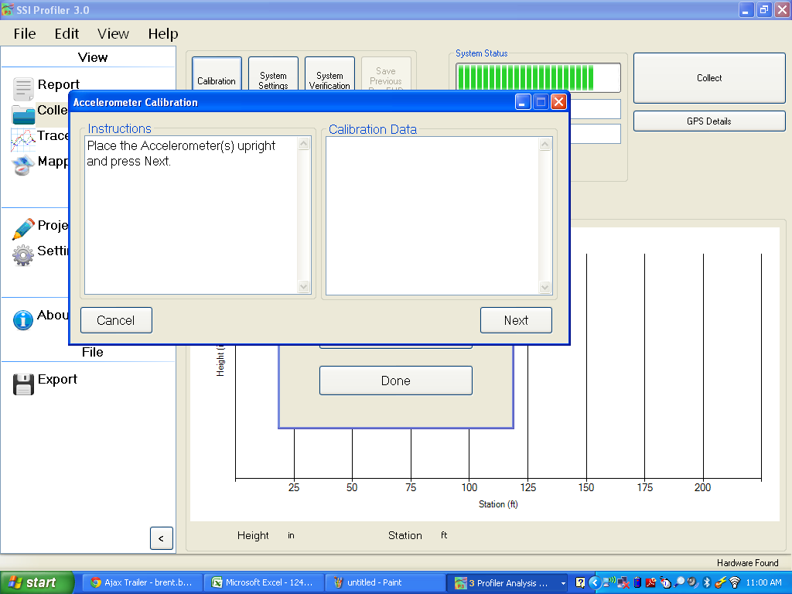

Figure 16: The first step of the accelerometer collection

***Calibrate all of the accelerometers at the same time.*** The calibration is to begin with the accelerometers in the upright position. This is the normal functioning position, the position the accelerometers should be in during collections.

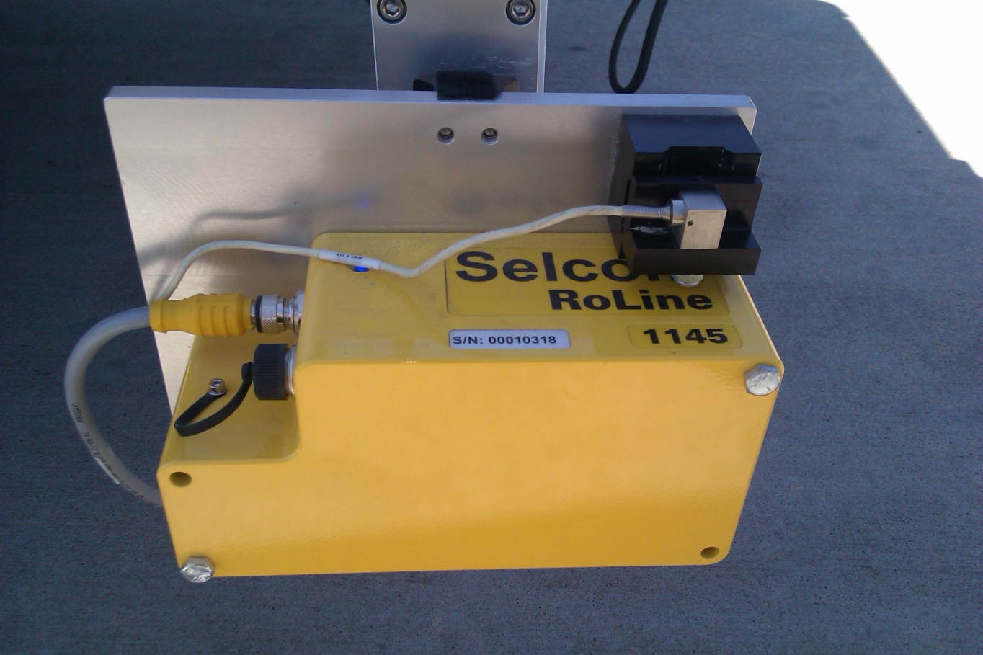

Figure 17: The upright accelerometer position

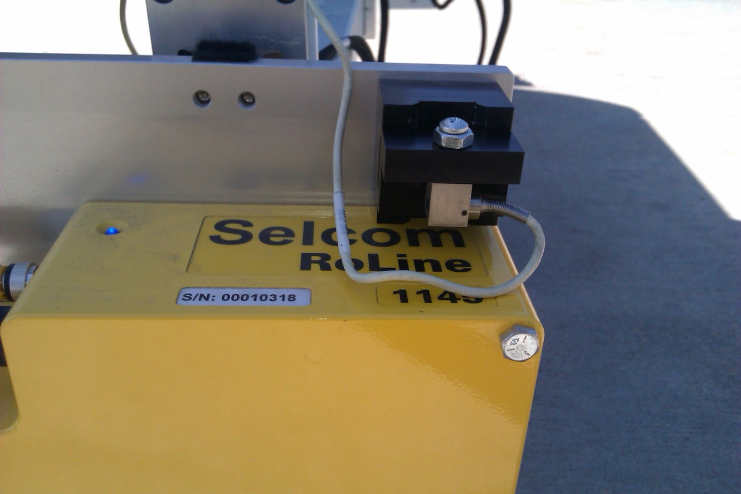

Figure 18: The accelerometer upside down

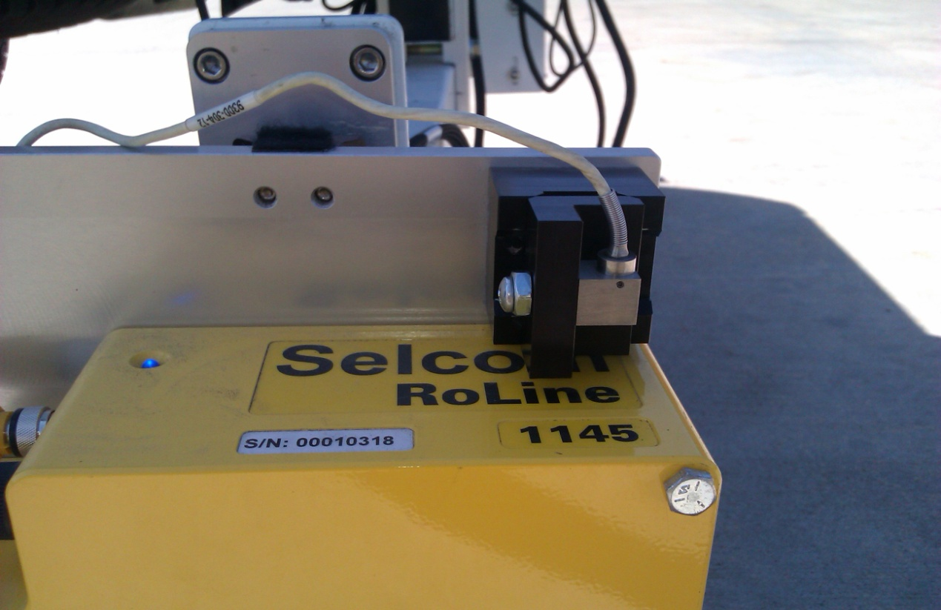

Figure 19: The accelerometer on its side

## Inclinometer Calibration (If Equipped)

The inclinometer is used to calculate the cross slope of the profiled surfaces. All of the survey systems are equipped with some type of incline measurement device. The inclinometer is located under the grey electronics box inside the white housing or is embedded within the electronics housing. ***For the inclinometer mounted UNDER the grey box, the lead wire of the inclinometer is always pointed in the direction of forward travel for the vehicle. The high side of the angled block always faces the passenger side.***

## Dual Axis Inclinometer Calibration

The initial step is to level the white housing when it is mounted on the front or back of the truck (or level the entire truck if the inclinometer is mounted to the truck body like on the mid-mount system). For survey systems, set the straight-edge below each of the lasers and use the bolts to level the bar. Set the inclinometer on the flat block ***while the entire system is level***. When prompted, enter the step block’s unique angle. Follow the on screen instructions and move the inclinometer to the angled block (having the wire face the same direction of forward travel). Then remove the inclinometer and replace on the flat plate when prompted. Never move the vehicle while calibrating the inclinometer. Once the inclinometer is calibrated correctly, secure the inclinometer to the flat plate with the thumb screws.

The ***entire*** system must be level during an inclinometer calibration. For bumper-mount systems the white housing must be level. If the inclinometer is mounted to the truck chassis, the entire truck must be level. ***For three laser systems the level straightedge is required***. This level straight-edge is used to notify the system what the lasers see as a level surface. This information can be used with the inclinometer information to calculate the differences on slope for the profile data. The level straightedge is not needed for the dual or single laser systems.

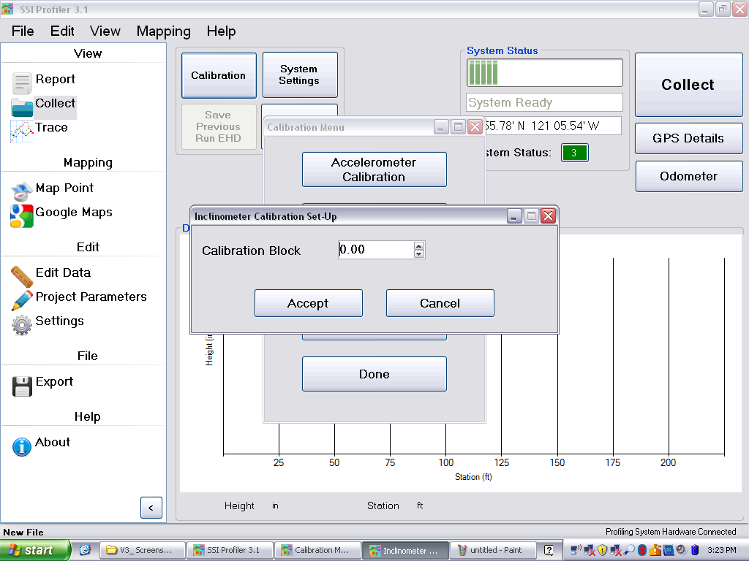***At all times the high side of the angled calibration plate faces the passenger side and the wire of the inclinometer faces the direction of forward travel of the vehicle.***

Figure 20: Window to Enter Inclinometer Angle

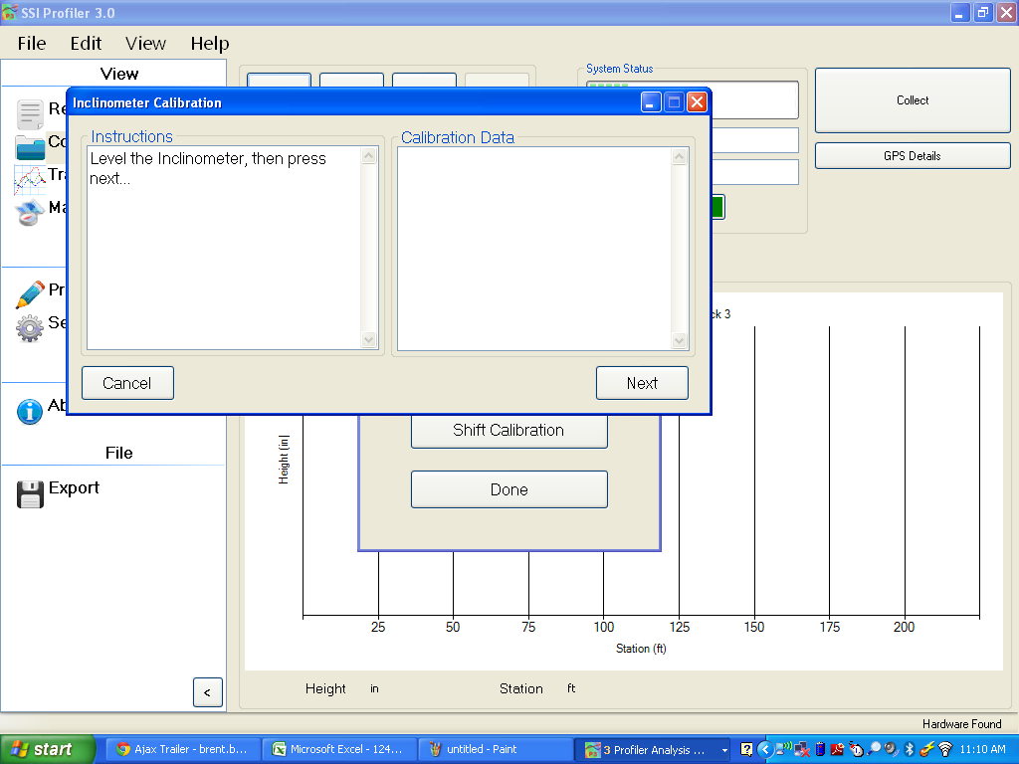

Figure 21: The inclinometer must be level before starting the calibration

The housing and the surface the lasers act on must be level. Use the straight edge with the bubble levels and bolts to level the surface the lasers act on.

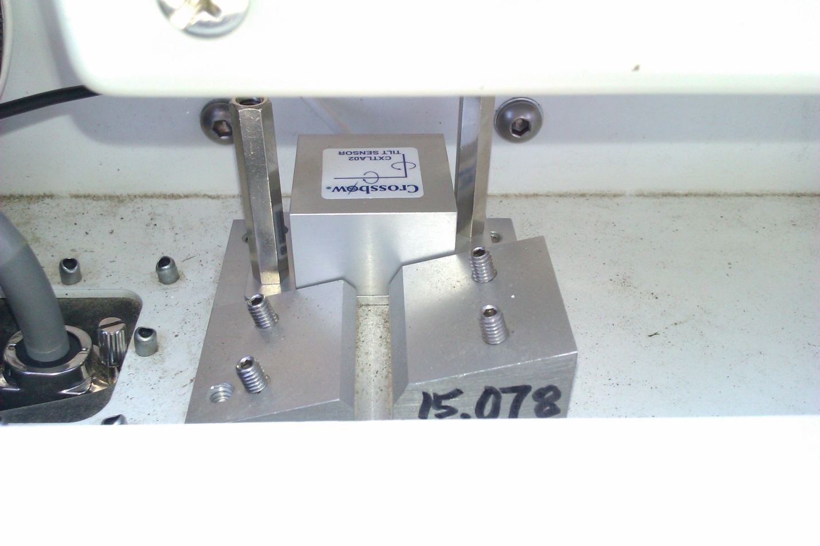

**Passenger Side**

High side of angled plate faces towards passenger side for rear bumper mount systems

Traffic Direction

Figure 22: The inclinometer on the flat plate for a rear-mount.

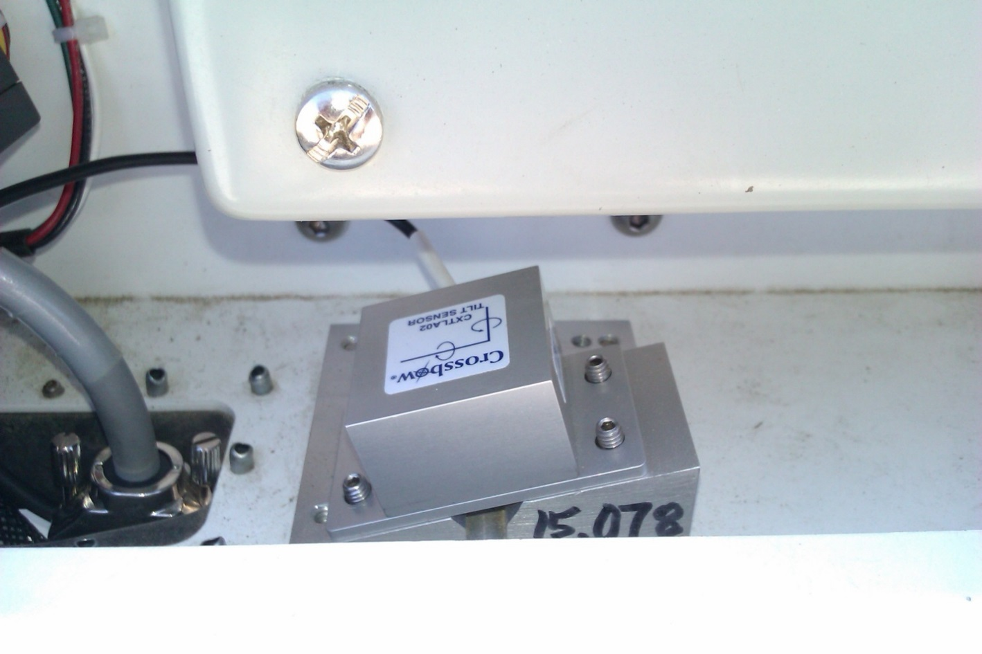

Traffic Direction

Figure 23: The inclinometer on the angled plate for a rear-mounted system

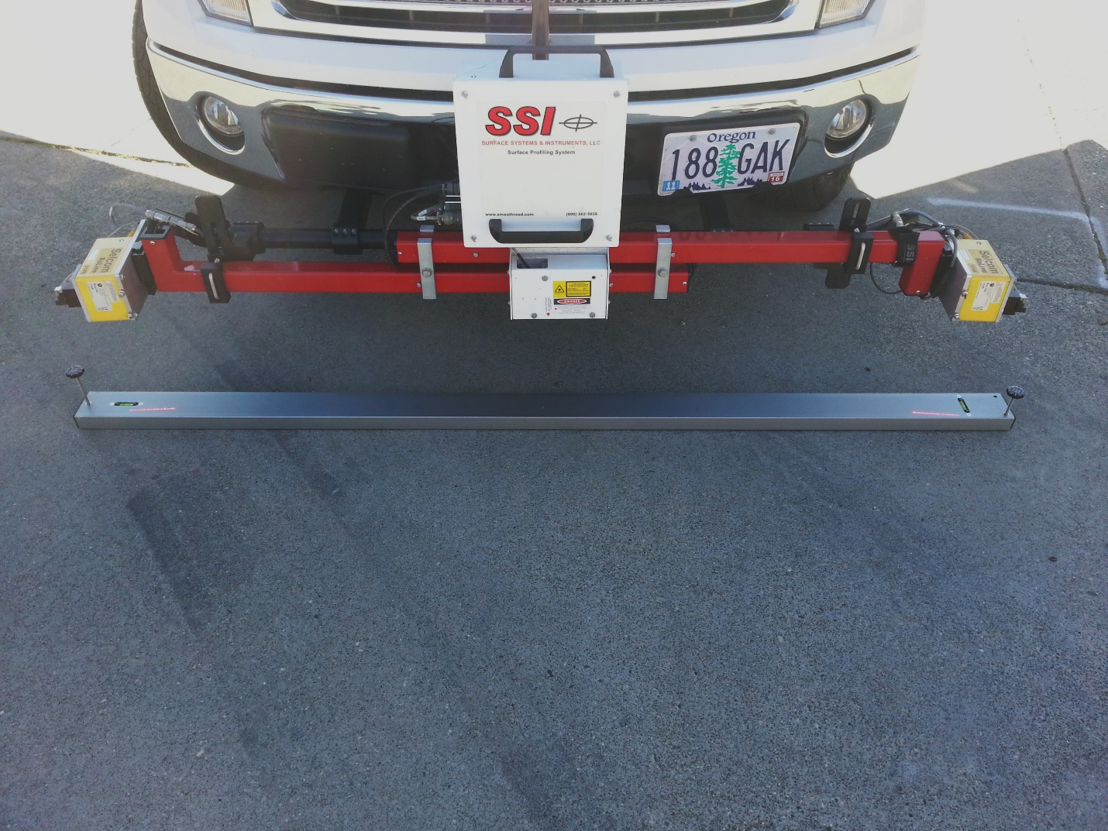

Figure 24: A three laser system with a level straightedge for inclinometer

## IMU Cross-Slope Calibration

The embedded IMU sensors are the high-resolution solution to measure cross-slope. All of the IMU sensors are controlled by the SSI UDP collector; a variant of the SSI Profiler program. When calibrating the IMU the first step is to align it with the satellites so the UDP collector displays, “Solution Good” with a low standard deviation. Once aligned the IMU must be leveled. This can be adjusted by getting close to zero on the UDP collector roll value and turning the tires of the vehicle. Once the IMU’s roll value is rapidly changing between negative and positive, place and level a bar under all lasers. This is the level reference for the system. At this point you may run through the SSI calibration program under the calibration menu.

## Transverse Calibration

The transverse calibration sets the Gocator 2375 transverse lasers at the correct offsets to measure a level line. ***This calibration is required only when the supporting hardware is changed or adjusted.*** This calibration shall be completed on a flat, level floor or long, flat and level straightedge. The laser beam can be found by using an infrared card indicator. **Do not look into the laser emitter at any time when the system is on.** Level the truck and IMU (if applicable). The calibration will first level all of the lasers through the calibration menu. Follow the prompts on the screen and verify that the post-calibration graph is acceptable within tolerance.

A secondary calibration within the Gocator browser window may need to be completed if the lasers are moved or the frame and mounting position is adjusted laterally. The lateral calibration starts at an arbitrary number like 7000 for the X-axis value of the Gocator measurement output. From the browser window, the two adjacent lasers are turned on and an object is placed between the laser within the overlapping beams. The laser reading is fixed for the left laser, but the right value is adjusted until the objects coordinates match between the two lasers. Save all changes within the browser window. The Gocator IP address will be specific to the laser position and will be with your profiler documents.

## Calibration Summary

The current calibrations for the inclinometer, accelerometers, and distance encoder can be viewed be selecting the Calibration Summary icon under the Calibration Menu.

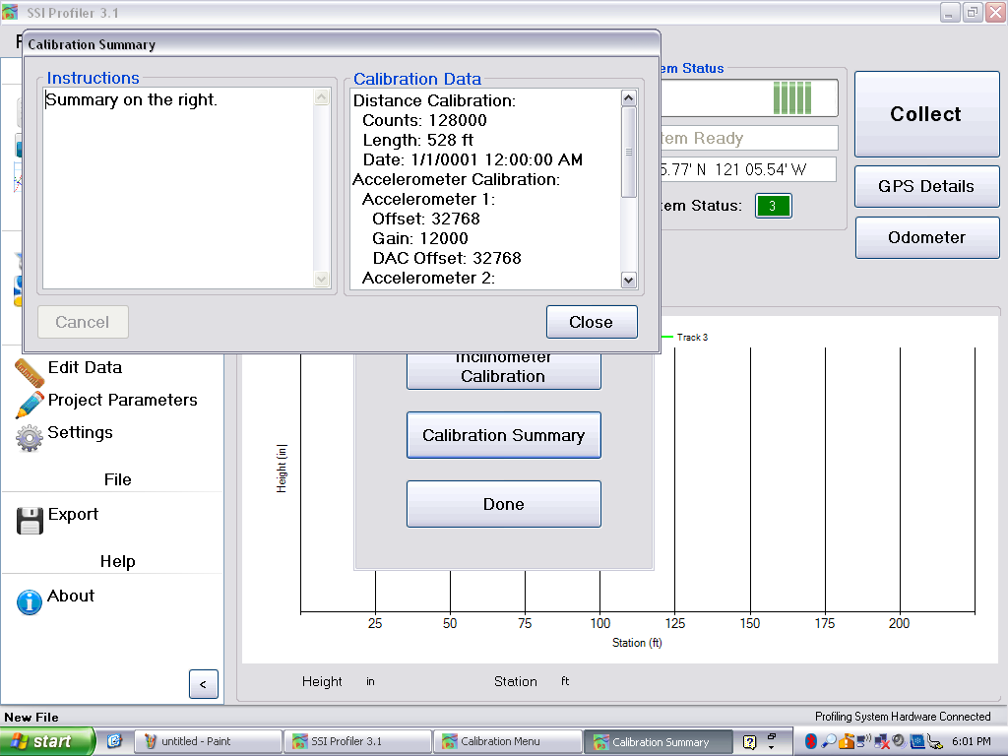

Figure 25: The Calibration Summary

# System Settings

## Laser Type

The laser type must be chosen within the System Settings. The choices are: Gocator/RoLine 1145, High Standoff Sport Lasers (Selcom SLS5000 325/400) and Low Standoff Lasers (Selcom SLS5000 200/300). If the system in your possession is a RoLine/Gocator three laser system, the center laser is a Low Standoff Spot Laser. If the laser type is saved incorrectly, the laser height verification will be inaccurate. If the laser height verification ever fails, review the laser type.

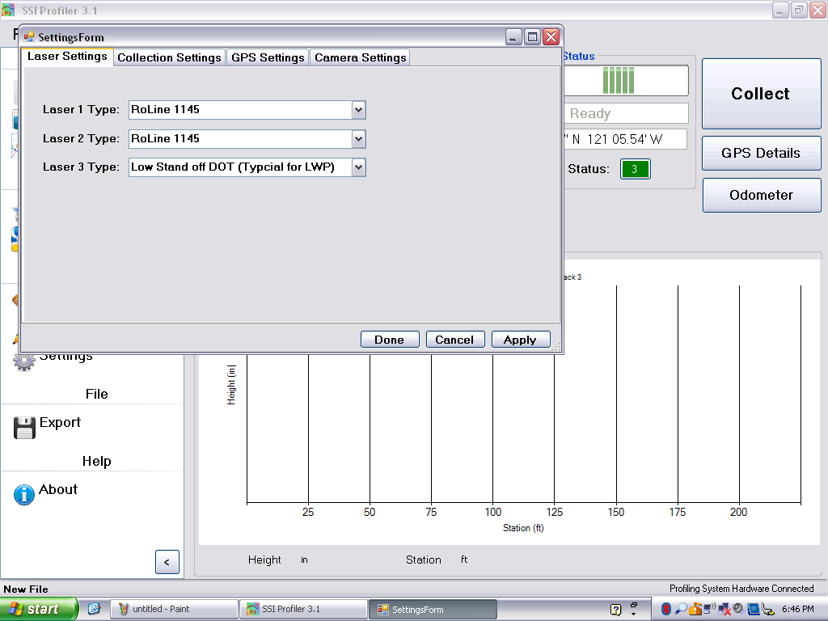

Figure 26: The laser type window for a Survey 3-Laser system

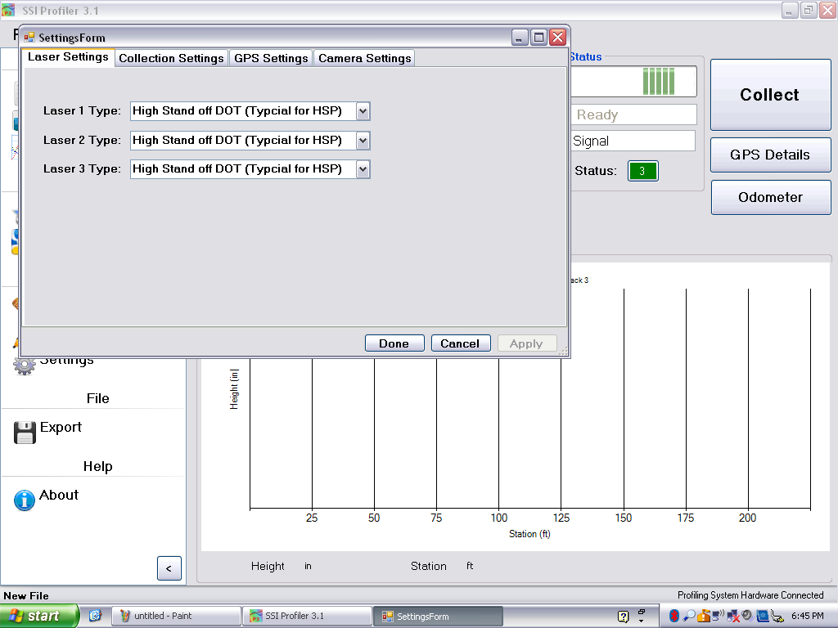***It is very important that the laser type is correct.*** Incorrect laser settings will cause inaccurate profiles and surveys. The inclinometer calibration will receive an error when the lasers are incorrectly set. The error will state that the laser heights differ more than 1.5 inches. Completing a height verification also determines the problem, which is resolved by changing the laser type to match the actual lasers.

Figure 27: The HSP dot laser system laser options window

## Collection Settings Tab

Simulated Travel is for troubleshooting and bounce tests. Simulated travel sends the system through a simulated profile collection without moving. Laser data is still collected, but real distance is not recorded. The sampling interval is the distance between measurements of the simulated travel option.

## GPS Settings

The distance adjustments to make more accurate GPS data is found under this tab. Measurements must be taken to set up the GPS to accurately pinpoint the defects that the system detects. For this process a tape measure is needed. There is only a need to do this measurement when the system changes dimensions. A new dimension is mainly from a change in the length of the arms from disassembling the system for storage. The measurements are from the left laser (track 1) to the center laser, from the center of the track 1 laser to the center of the track 2 laser and the elevation measurement. The elevation measurement is the distance from the bottom of the center laser (track 3) box to GPS antenna.

Figure 28: GPS Settings

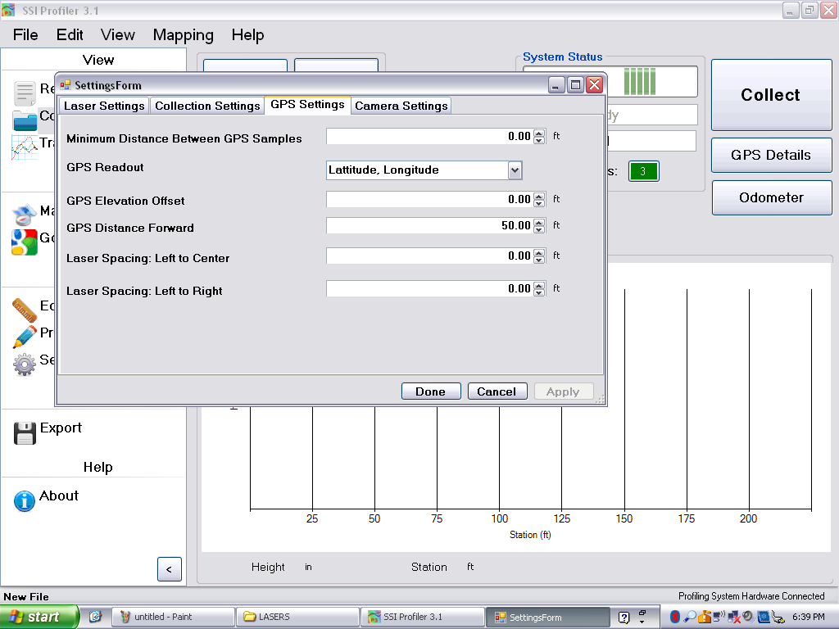

Figure 28: GPS setting window

The “GPS Distance Forward” is the distance measurement from the middle laser to the GPS antenna going from back to front of the vehicle for rear mounted systems (it is a positive value when the GPS antenna is closer to the bumper of the vehicle than the laser). For front mounted systems, this measurement is from front to back of the vehicle (it is a positive value when the GPS antenna is closer to the vehicle’s body than the laser).

The distance between GPS sample should be left to the default value to collect the most accurate data. The default value in Profiler V3 is zero feet or meters. The GPS readout changes the GPS string in the collect window, ***not the GPS string within the reports***.

## Camera Settings

Figure 29: Camera Settings

### 

### How to Begin Using the Camera

Install the Flycap2Viewer driver located on the disk supplied by SSI (or already installed on the computer). The correct driver depends on if the computer is 32 or 64 bit. To check this, open the start menu and right click on My Computer (or My PC) and choose ‘Properties’. On this window find the System Type and view if the system is 32 or 64 bit. If the computer is 32-bit, install the x86 flycap2viewer. If the system is 64-bit, install the x64 flycap2viewer. Once the driver is installed, plug in the Chameleon Camera to the computer’s USB port.

### Enabling Camera Settings

Once the profiling system is connected and the Collect tab is open, the operator can enable the camera. At this time make sure the flycap2viewer driver is installed and the camera is connected. Open the collect window and once the hardware is found, select System Settings. Under the system settings window, select the Camera Settings tab. To enable the camera feature select the check box under the Camera Settings Tab. The camera interval is the distance traveled between each picture. This can be set to any interval however, the more pictures taken results in more data saved to the computer and more time that post-processing will take. If the camera is not mounted upright, enter the correct rotation angle in degrees, selecting one of the four options. The camera is focused on the physical lens. Enter the serial number of the camera which is on the sticker on the back panel of the camera. Once apply is selected the camera will be found in under one minute for the first use. Once the settings are saved, the serial number will fade out, as seen below.

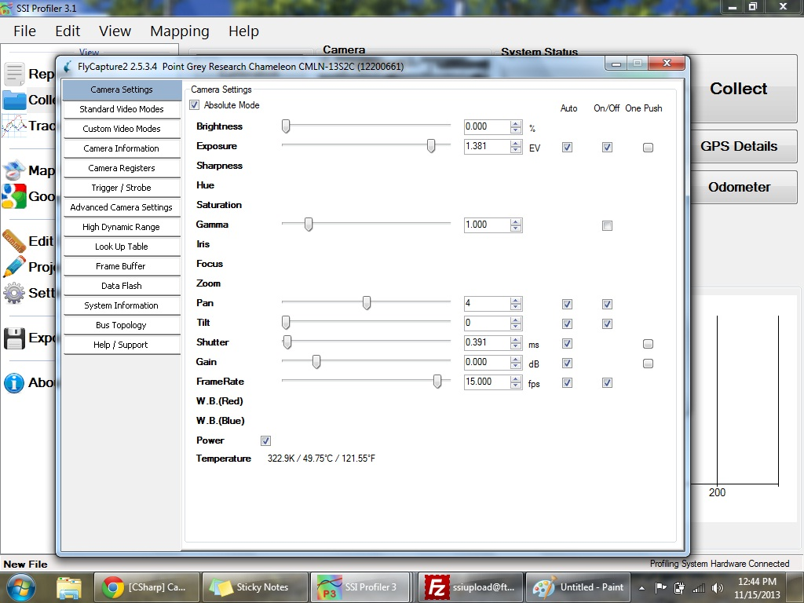

Figure 30: Advanced camera settings

The image preview should appear in the Collect window in color and at the correct orientation. If not, change the settings to the appropriate orientation or open the Advanced Settings.

To reduce the size of the image, change the resolution of the camera to 640x480. This will decrease the processing time and RSD file size. Under Custom Video Modes the operator can adjust the resolution and see the estimate of the file size.

Custom video modes can also be used to crop or adjust the viewable image area for each camera. There will be a red border for the active area for the camera. The user may adjust the height and top values to change the position of the camera frame. The end result should be to reduce the sky’s influence on the picture to keep sunlight or other reflective surfaces out of the frame.

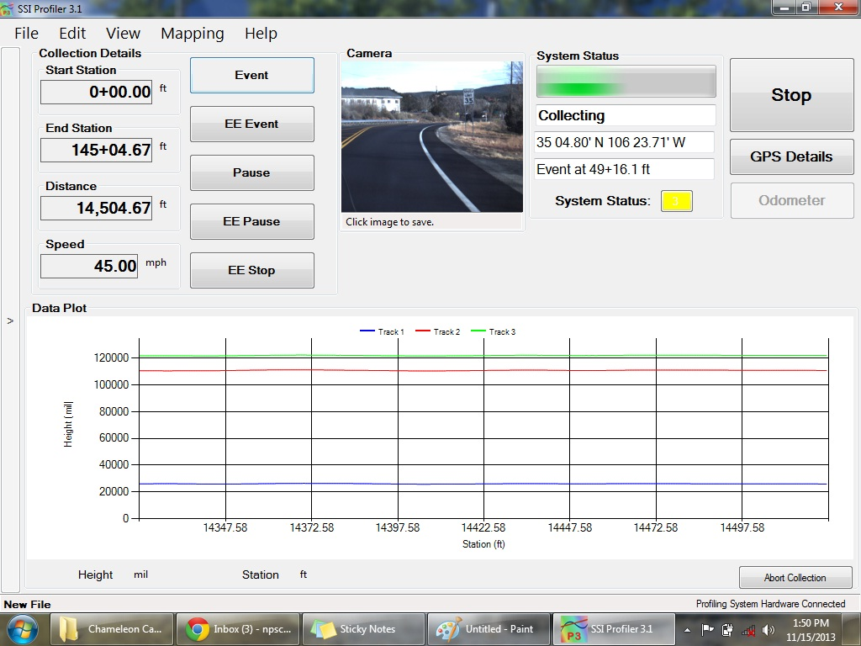

Figure 31: Camera Preview window in Collect Screen

# System Verification

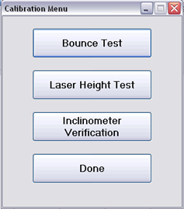The system verifications of the Profiler program are the bounce test and the height verification. The bounce test checks the validity of the accelerometer calibration and the correct laser type. Depending on the values of the static and dynamic bounce tests, the health of the system can be determined. The height verification is used to diagnose potential problems with the lasers and the cables. The verification will show if the lasers are connected incorrectly, or if the heights the lasers are set to outside of the recommended range. Another potential problem is the settings have the wrong laser type saved for the current system (e.g. Spot lasers saved instead of line lasers on a line laser system). The line lasers (Selcom 1145, Gocator 2342) should be 12 inches above the ground surface and their laser difference for the height verification should be less than one hundredths (0.01) of an inch. The dot lasers (Selcom SLS5000 325/400) should be 15 inches above the ground surface and have a measurement error of less than one hundredths (0.01) of an inch.

Figure 32: Verification Menu

If the laser type is saved incorrectly, the laser height verification will be inaccurate. If the laser height verification ever fails, review the laser type.

**Note: These procedures are *not* calibrations, only verifications**

### Laser Height Verification

The height verification assures the operator that all of the lasers are working properly. The height verification is deemed a success when each individual laser deviates less than a hundredth (0.01) of an inch. The height verification will also determine if the laser types are correct. The laser types can be viewed under System Settings.

Figure 33: The initial step for a height verification is to place a base plate under the laser being tested.

The first step of a height verification is to choose the location on the computer to save the height verification text file. Once chosen the program will ask the operator to place the base plate on the ground below the laser beam. ***Check that the base plate does not wobble and there is not a glare on the measurement blocks***. Once base plate is firmly on the ground, select next and start placing blocks according to the verification procedure.

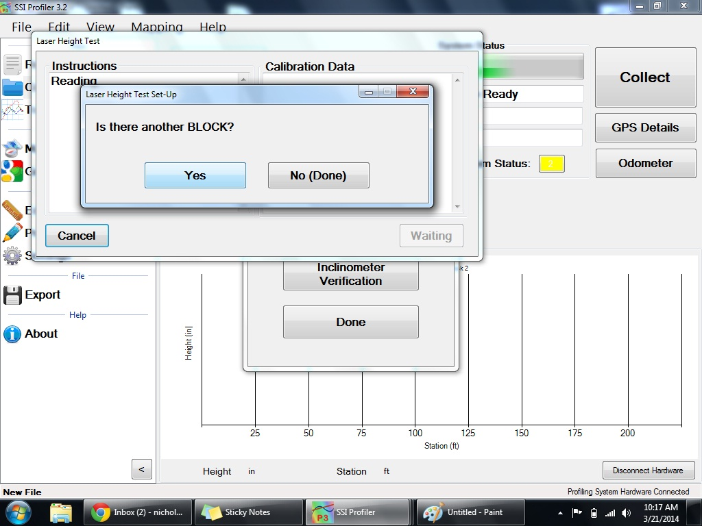Once all of the blocks have been placed by following the procedure, select “No (Done)” to set the saving preferences in the next window. By shifting the bubble to “No” or “Yes”, choose the laser reading to save in the text file and if the user would like to view the report instantaneously.

Figure 34: To continue height verification, select “Yes”

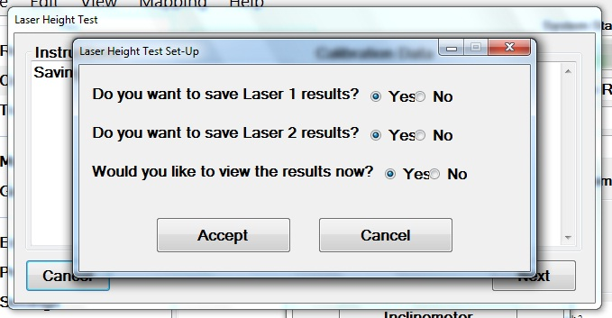

Figure 35: Saving Preferences after a Height Verification

After the laser verification the user will have the choice to save Laser 1, Laser 2, Laser 3 readings and to view the results instantaneously. Only choose the laser the height verification was performed under. If the results are viewed instantaneously a text file will appear showing all of the laser readings. The calculated height of the blocks will be displayed at the far right of the text file. These values must be within a hundredth on an inch (0.01”) according to AASHTO r57.

### Bundling Multiple Height Verification Reports

If the operator is running two successive laser verifications they will have the option to add the results of the last verification to the current verification report. In this way there will be two or three verification results in the text file. If bundled reports are not desired then select ‘No’ on this option. The Profiler V3 program will ask the operator to choose to bundle the height verification at the beginning of the second verification procedure. Select ´yes´ to bundle the files and ´no´ to keep the next verification as an individual file. This option will appear after the

When performing the height verification make sure the receiving sensor has an unrestricted view of the calibration block, as shown in the figure below. The high side of the calibration block should be outside the body of the laser, not below the middle of the laser (see image below).

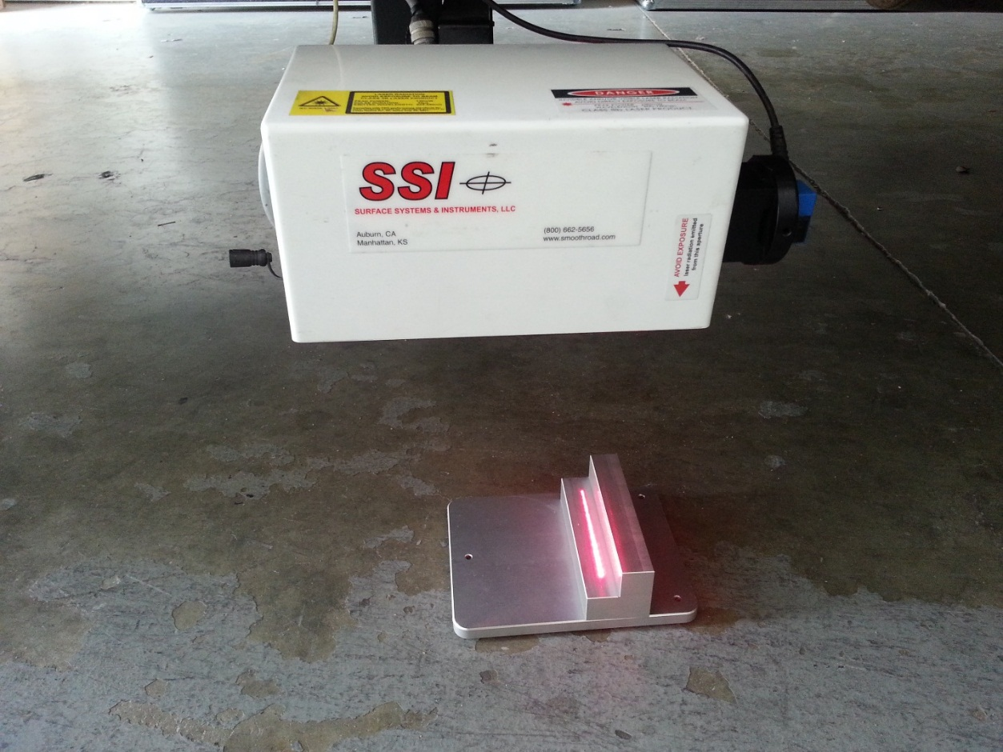

Emitter

Receiving Sensor

Figure 36: The correct block Orientation for the Height Verification

## Bounce Test

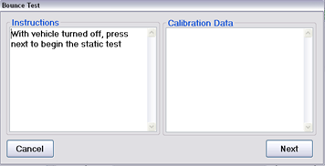The bounce test is a diagnostic procedure used to determine if the system’s accelerometers and height sensors are working in unison and calibrated correctly. The bounce test is not a calibration procedure and its results are not used to reset or adjust the profiling system. After the bounce test has finished, three data segments will be saved within a data file; two static and one dynamic bounce test. The results of the bounce test consist of an IRI value and detailed profile for each of the three tests. The IRI value is displayed at the end of the test, and the detailed trace can be viewed like any other data file in Profiler V3. A successful bounce test results in a completely flat profile trace and low IRI values. Industry standards and requirements vary as to whether a bounce test is required, and as to the results required from the test. For SSI’s inertial profiling systems, static bounce test IRI values below 5 in/mi (78.9 mm/km) and dynamic results below 15 in/mi (236.7 mm/km) are within manufacturer’s specifications for a properly functioning system. Some agencies follow AASHTO R057, which specifies a static bounce test IRI under 3 in/mile (47.35 mm/km) and a dynamic bounce test IRI under 8 in/mile (126.26 mm/km). The bounce test procedure is sensitive and must be properly performed for successful results.

Figure 37: The static test of the bounce test. Do not touch or move the vehicle during this portion of the test.

**Procedure**

Once a bounce test is initiated, the program will ask to name and save the file before the test begins. The static, dynamic, and again static data will be included in this file as Run 1, Run 2, and Run 3 respectively.

***Verify before starting test that:***

1. Only perform bounce test on a level surface, after accelerometers have been calibrated.
2. Vehicle’s engine is off.
3. Front tires are straight and in-line; Parking brake is off; No wheel chocks or other braces are to be used
4. A smooth, non-metallic surface is beneath the lasers (at the appropriate standoff)
5. The operator should introduce 1 inch (25.4 mm) of vertical travel at the laser modules

With the vehicle turned off, begin the static test. **Do not touch the vehicle at this time**. No movement should be introduced to the vehicle (Do not perform the static test in heavy cross winds or during an earthquake). For the dynamic test, introduce one inch of vertical travel into the vehicle’s suspension at a frequency between 1.25 Hz (which is a bounce every 0.8 seconds) to 2.5 Hz (which is a bounce every 0.4 seconds). Do not dramatically impact, or shock, the vehicle suspension when jumping on the profiling vehicle. Use only fluid movement. Only introduce vertical motion into the vehicle suspension during the dynamic portion bounce test. No lateral or side-to-side vehicle motion should be introduced. Make sure the wheels are in a straight line. Allow the vehicle to sit motionless for the final static test.

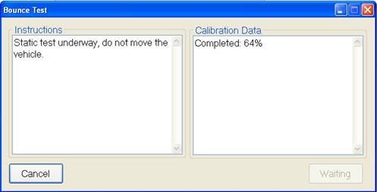

Figure 38: The static test being performed

Figure 39: When the dynamic test countdown.

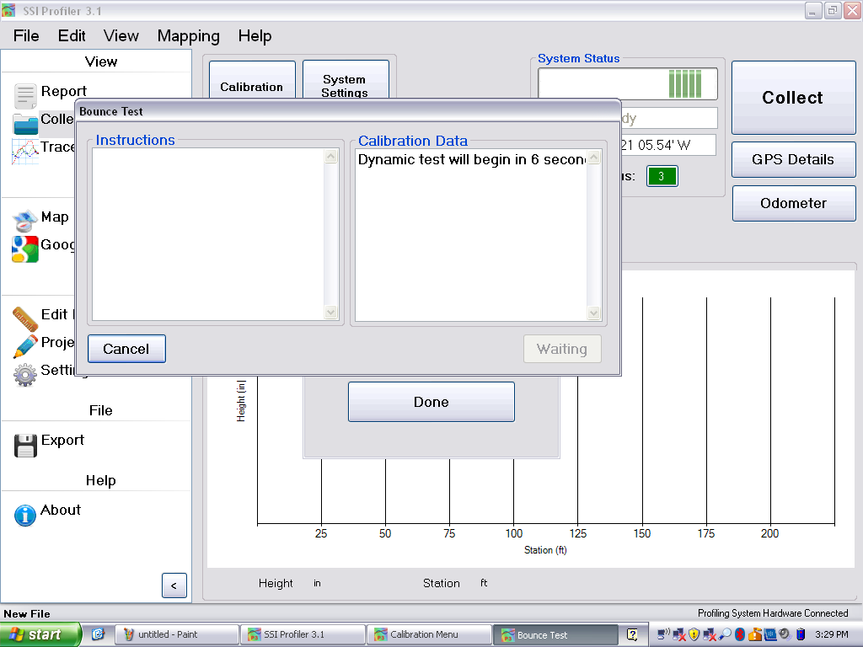

Figure 39: The beginning of the Dynamic Bounce Test

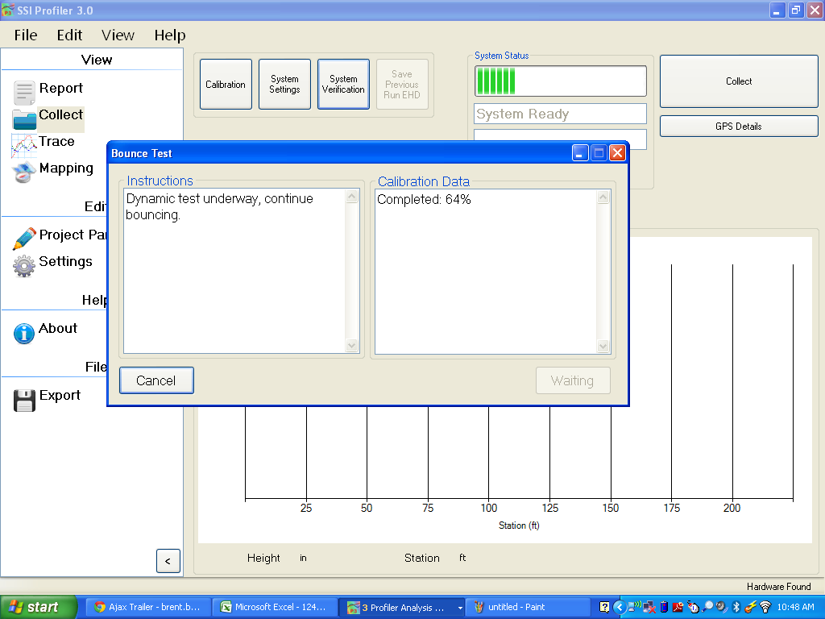

Figure 40: The dynamic test is performed by bouncing the vehicle vertically

7.5 in/mi

7.2 in/mi

7.4 in/mi

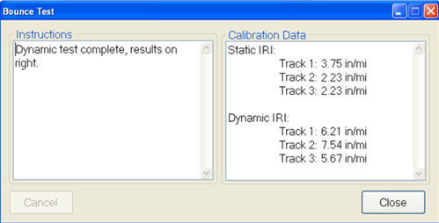

Figure 41: The Dynamic Test Results

## Inclinometer Verification

The inclinometer outputs can be verified by using the mounting block and a procedure similar to the inclinometer calibration. Enter the block angle when prompted by the program. The block angle is supplied with the system and can be found on the label attached to the grey box cover within the white housing.

# Collect

The optimal speed of collection is ***20+ miles per hour***. The accelerometers are most accurate within the range of 20 to 55 miles per hour for high speed profilers and trailers. Height data cannot be collected if the vehicle is traveling slower than 5 miles per hour.

## 

Figure 42: The main collection window.

## System Status

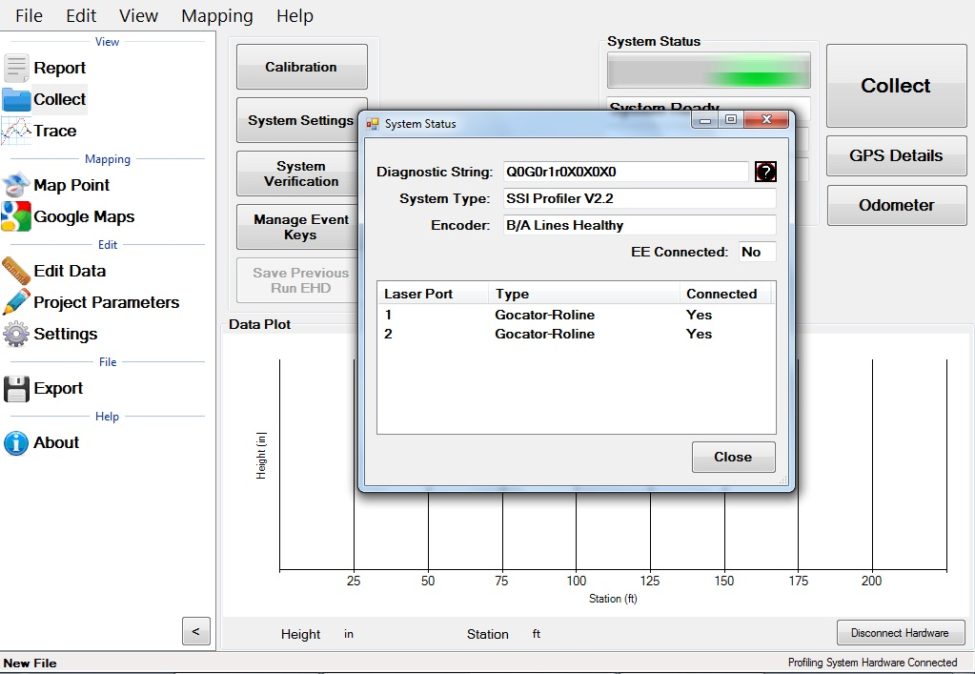The systems status icon (the colored box with a number inside) is used as a diagnostics tool for Profiler V3 collection systems. This window detects connection problems with the housing and electronics. SSI support staff may ask the diagnostic string (health string) while troubleshooting. ***The type of lasers connected should be shown correct automatically based on the type of system connected.*** Select the diagnostic information button at the top right of the window to better understand the purpose and meaning of the health string.

Figure 43: The System Diagnostics

## Collection Information

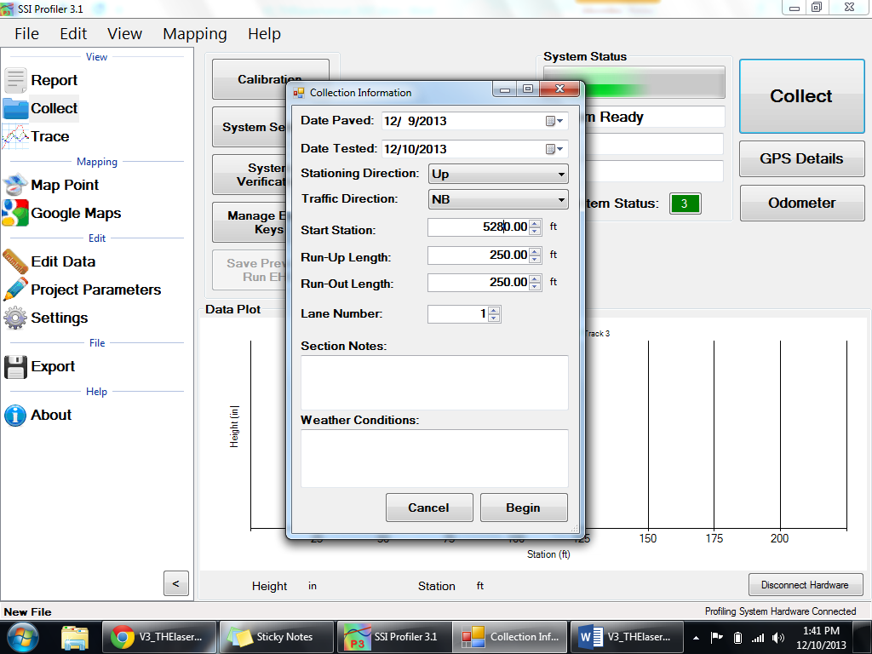The Collection Information window appears when the collect icon is selected. The most important information in this window is the start station, the direction, lane number and the run up lengths. Stationing, direction and run up/out lengths can be changed later through Edit Run. When "Begin" is selected, collection will initiate. Be in position to start collection when “Begin” is selected. The “Direction” is the direction of travel of the profiler (up station or down station). It is important that the direction is correct. The stationing can be changed at a later date if the direction of travel was incorrectly entered. To change the stationing or direction open the Edit Run feature.

Figure 44: The Collection Information window

***When this window is open, the profiling vehicle should be at the location to start collecting***. As soon as the operator selects begin, the collection will be ready to start. If the vehicle is not in position to profile, the self-start collection feature will start the collection at the wrong point. If the collection will be started by using ***Starting Forward*** or through the electric eye, “Begin” can be selected a reasonable distance before the actual start of the collection is to take place.

## Collecting Data

The optimal speed of collection is ***20+ miles per hour***. The accelerometers are most accurate within the range of 20 to 55 miles per hour for the high speed profilers and trailers. Height data is not collected if the vehicle is traveling slower than 5 miles per hour.

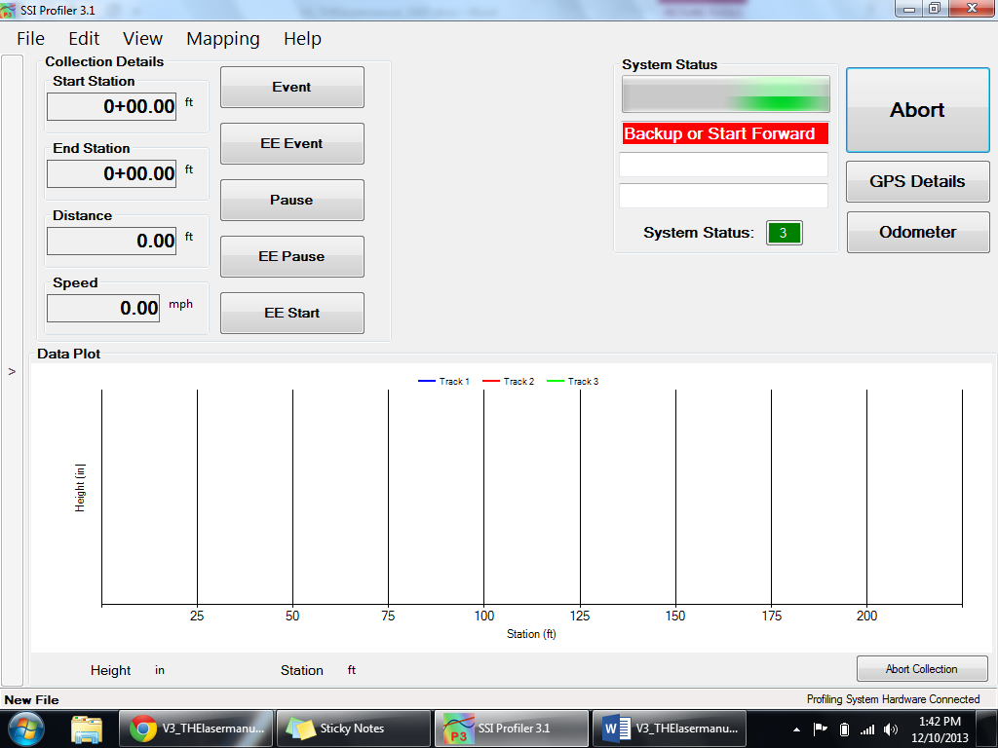

Figure 45: The collection screen after “Begin” was selected

## The Three Ways to Start a Collection

The operator can travel forward or backward once a collection is started. If the operator accelerates forward the Run-up procedure will be used with or without an electric eye. If the operator moves in reverse, the back-up collection procedure will be used. Both of these procedures can use the electric eye to end the collection. The benefit of using Run-up is that traffic will not be stalled while the operator begins a collection. The forward motion Run-up option can be started on a shoulder or at a large distance from start point (a large run up distance).

If the operator uses the back-up option, the vehicle must begin over the starting point and then move in reverse. Back up until the program instructs the operator to accelerate. The collection will begin when the initial point is crossed.

### 1) Starting a Collection: Run Up

After “Begin” is selected from the collection information window the vehicle may move forward. Once the vehicle is moving forward over 5 miles per hour and the run up distance is completed, the collection can be started through an electric eye, selecting the start icon, or selecting a programmed hot key. The collection can be ended by selecting the stop icon or using the electric eye. The stop icon will replace the start icon once the collection has been initiated.

The electric eye is used by arming the eye after “Begin” is selected. Once the electric eye triggers the start of the collection, a new icon appears giving the operator the option to end the collection by using the electric eye. These buttons are labeled “Start EE” and “Stop EE”.

### 2) Starting a Collection: Back up

After selecting “Begin” from the collection information window and the operator has the beams of the lasers over the starting point, the vehicle can be moved in reverse. The status bar will display “Back up or start forward” in a red fill, then “Backing up” as soon as the vehicle starts backward motion. The reverse distance will be measured by the profiling system. After 25 feet, the status bar will display “Accelerate”. The operator should accelerate forward along the same path to reach a speed over 5 miles per hour. When the minimum speed and the run up length has been achieved, the status bar will display “Self Start” and the collection will begin when the odometer reaches zero.

***Note: The path traveled in reverse should be the same path the vehicle makes when moving forward. If the paths are different, the collection’s starting point will differ from the initial point the lasers were aligned to.***

The collection can be ended by selecting the stop icon within the main window as the vehicle is moving. The collection can also be stopped by using an electric eye. To use the electric eye, select “Arm EE Stop” and the Profiler program will wait for the EE to be triggered before ending the collection. To trigger the EE properly and consistently, use the recommended DOT-C2 reflective tape and mount it near the path of the vehicle in clear view of the EE sensor. It is recommended to place the reflective tape within 10 feet of the electric eye and at the correct elevation of the sensor’s beam.

### 3) Starting a Collection Using the Electric Eye

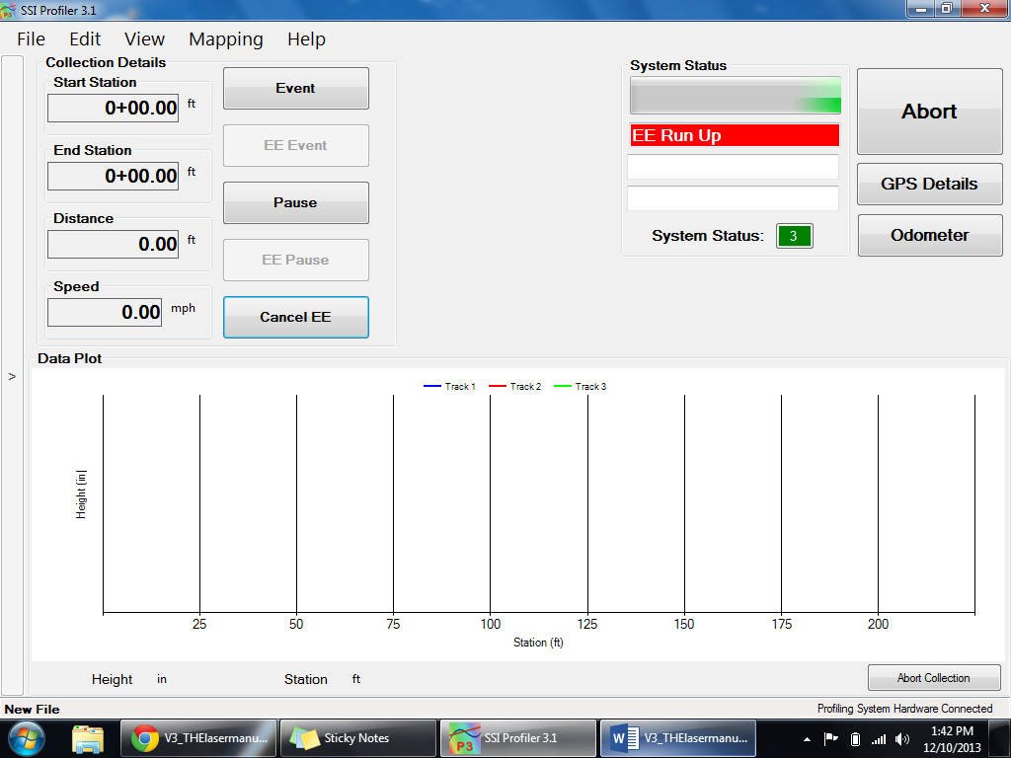The electric eye can be used to start and/or end a collection or end the Run-up and Bach-up collections. The recommended reflective tape to use with the EE supplied by S.S.I. is the DOT-C2 grade tape. Contact SSI for supply information. The electric eye tape can be mounted on a cone or a stationing marker, as long as it is in reach of the EE sensor which has an optimal range of six feet. Sick EE’s can sense the reflective tape 18 feet away. The closer the reflective tape is to the EE sensor, the more consistent the starting and ending of collections will be. If the reflective tape is too far from the EE, the sensor may not activate.

Figure 46: The Electric Eye (EE) is armed to start the collection

Most profiling systems have each side equipped with an electric eye. On the white housing there is a two-way switch with a label of left and right. The left side is the driver’s side electric eye. To determine if an electric eye is on, look for the amber light on the top side of the electric eye near the outgoing cable. The diagnostic will also inform the user that the electric eye is attached. The diagnostic will not inform the user which side the vehicle the electric eye is powered on.

Use DOT-C2 grade reflective tape for the electric eye collections. The reflective tape can be mounted on a stationing marker or on a cone for repetitive use. Sick EE’s can sense the tape 18 feet away. Other brand EE’s should be placed 6 feet away to function.

## 

## Ending Collections

1. **By Electric Eye**

To end a collection using the electric eye, arm the electric eye after the collection has been started by selecting the Arm EE Stop icon on the screen or through a hot key. When the electric eye sensor detects a reflective surface, the collection will be ended and run out will be collected

1. **Through the Stop Icon**

The collection can be ended by the operator selecting the Stop and Save icon with a left click of the mouse. This option is not as precise as using an electric eye or backing up to end the collection, but it is more efficient when collection multiple runs of data with a loose tolerance and is sometimes necessary when collecting without traffic control.

1. **Speed Drop Out and Backing Up – “Save”**

When a speed drop out occurs (when the vehicle is moving less than 5 miles per hour) the operator has the option to back up and save the data. This option of ending a collection is an accurate alternative of completing a collection. The operator can just back up to the desired ending location. All of the surface data that was collected when moving forward is omitted while moving backward over the same surface. This creates profiles of the same length which are convenient when comparing the profiles to a reference file.

## Aborting Collection

The collection can be aborted at any time before the file is saved. The abort icon is displayed at the bottom right of the Collect window. When a collection is not in progress the abort collection icon is the disconnect hardware icon.

## Stopping a Collection

A collection can be ended using the **electric eye**, **selecting Stop Collection**, or **stopping the vehicle and backing up to the end point, then hitting Save**. If accurate end points are needed in a lane closure, it is recommended to use the electric eye or stop and back up option. If operating in traffic at highway speeds where stopping is not an option, use the electric eye end collection, select the stop collection icon on the screen, or select a user programmed hot key. When using the stop collection icon the distance collected may be off of your desired stop station. Post analysis can fix this through the Edit Data feature and crop data tool or the GPS tagging tool located in the Trace window.

## Saving the Collection

When a run is finished Profiler V3 will open a window automatically asking the operator to save the file. The three options are to **Save as New File**, **Save File**, and **Do Not Save File**. If the file will be saved, windows explorer will open and the operator will be allowed to save the file to any folder location on the computer or external device. If the operator selects do not save, the collected data is still in the program until a new file is opened or the program is closed. If there is any unsaved data when the program is closed, Profiler V3 will ask the operator to save their changes. It is always possible to save the data by selecting File>Save or selecting Ctrl+S on the keyboard. ***To always save a run in a separate file choose Save as New. This is recommended for multiple runs and simple post-processing.***

## Changing Units of Plot

To change the units, click on the current units and select from the menu.

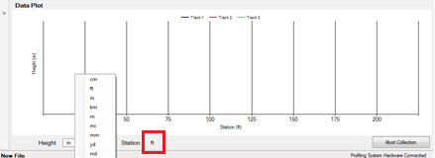

Figure 47: The procedure to change units of the data plot is shown

# 

# Post-Collection

# Reporting

# File Tab

## New

Selecting New creates a new project file to be saved on the operator’s computer or external device. The file will open automatically and the bottom left corner of the program will display “New File.” If data has been collected with this file, the name will be displayed with as asterisk as “New File*.”

## Open

Opens a project file previously saved on the operating computer or connected external device. Profiler V3 creates RSD type files. The RHD file type from the previous version of Profiler can also be opened Profiler V3. If your file is in another format, use the appropriate translators found on the support website (<http://www.smoothroad.com/support/download.asp>) or contact S.S.I. Customer Support. The only two file formats used in the Profiler V3 program are RHD and RSD. Profiler V3 only collects data in the ***RSD*** format.

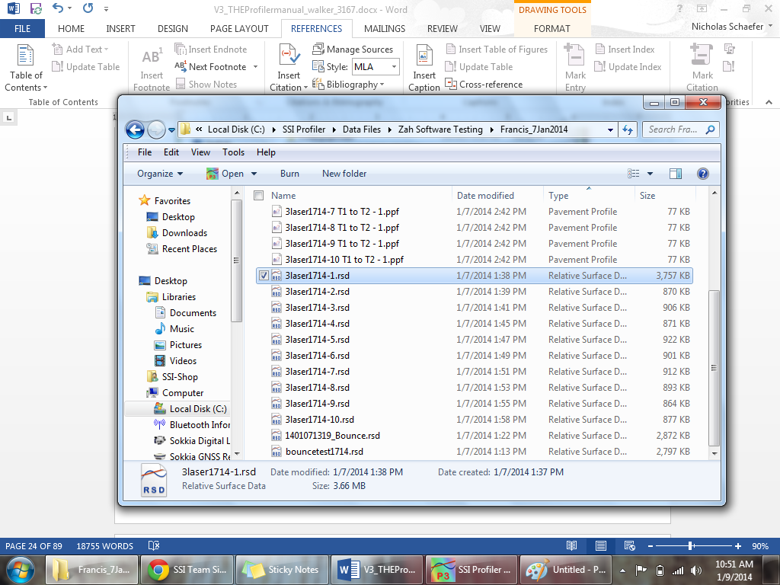

Figure 48: Opening a data file in the Profiler V3 program

## 

## 

## Open Recent

Opens recently viewed or created project files. Files will only be available if they are saved on the operating computer or connected external device. The Open Recent feature is a shortcut to find current profiling data. It is also possible to use the File>Open tool to open saved data. The only two file formats used in the Profiler V3 program are RHD and RSD. Files can only be saved in RSD.

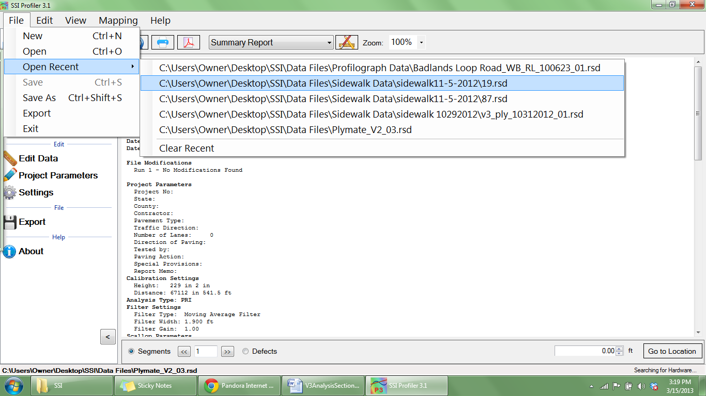The default file to be searched for in Window’s Explorer can be changed under General Settings and the “Default File Type.”

Figure 49: The Open Recent feature

## Clear Recent

Clear Recent deletes the history of previously viewed RHD and RSD files. Once the history is cleared it cannot be reversed. The operator must navigate to File>Open to view saved files.

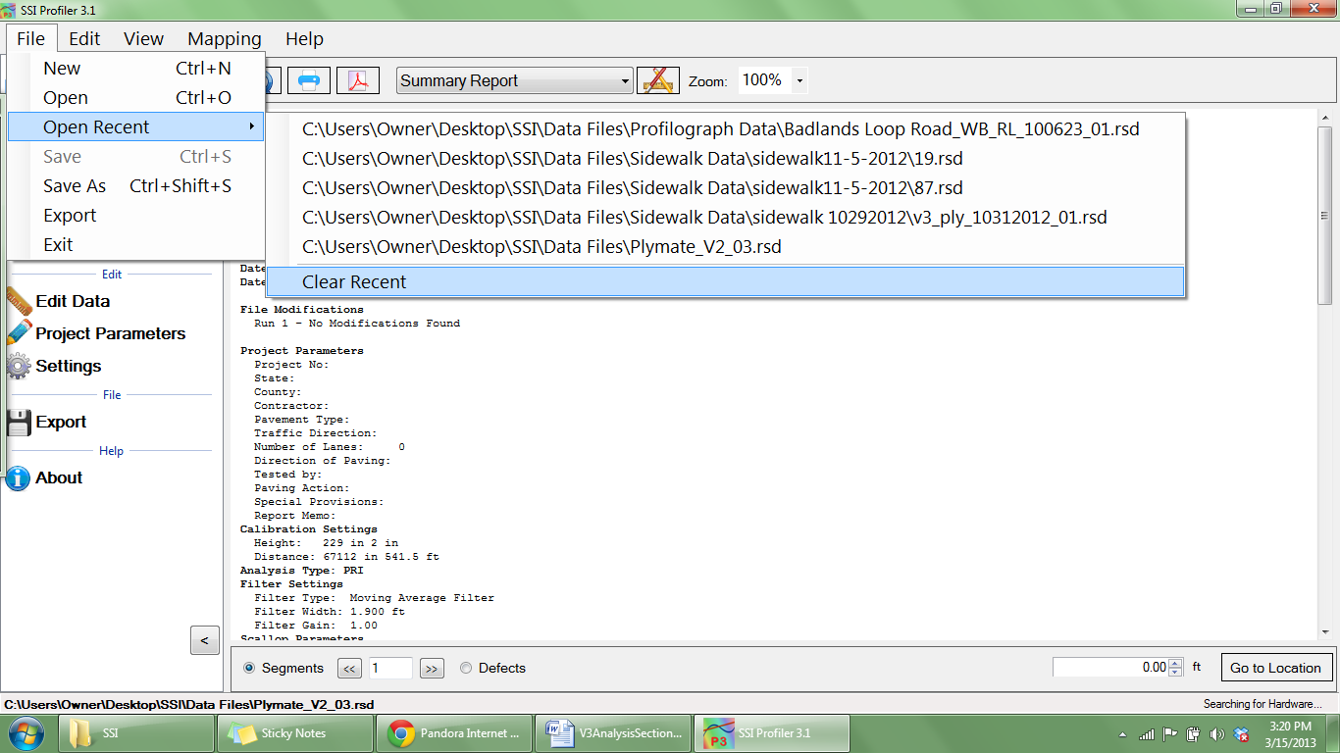

Figure 50: The clear recent feature

## Save

Save allows the operator to save the current file in RSD format on the operating computer or connected external device. If ‘Save’ is selected while an unsaved file is open, the operator will be prompted to choose a file name and folder destination to save the current file. The file will be saved in SSI´s patented RSD format. If another format is required, visit the SSI support website (<http://www.smoothroad.com/support/download.asp>) to download the latest translators or contact SSI Customer Support.

## Save As

Figure 51: Saving a file through Save As in RSD format

When Save As is selected, the operator will be prompted to choose a file name and folder destination in which to save the current file. The file will be saved in SSI´s patented RSD format. If another format is required, visit the SSI support website ([http://www.smoothroad.com/ support/download.asp](http://www.smoothroad.com/%20support/download.asp)) to download the latest translators or contact SSI Customer Support.

***Note: Save and Save As are only available after data has been collected or if changes are made to preexisting file.***

# Exporting

Exportingallows the operator to create files in **ERD, PPF, PRO, Survey, GPS Matching, and Excel** formats. The settings for each export feature are described below. For each of the exporting formats, a folder destination is required. The Export feature can be found in the shortcut bar on the left hand side of the Profiler V3 window and in File>Export.

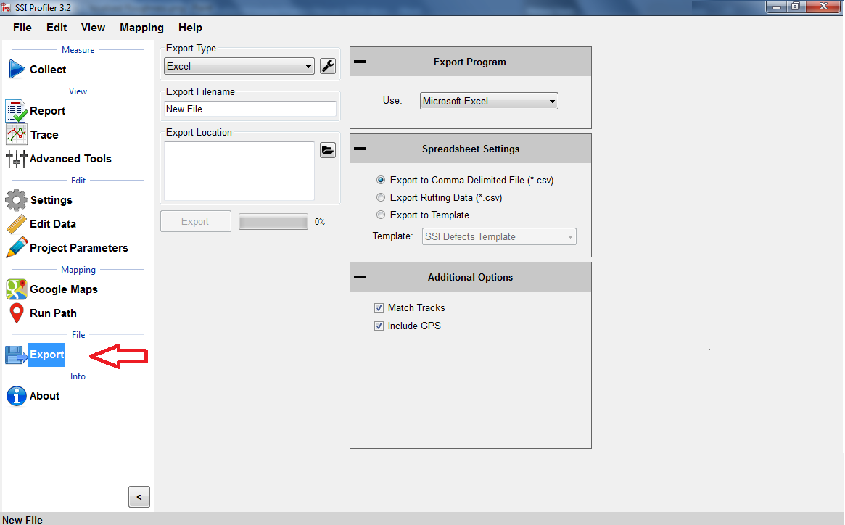

Figure 52: Window for exporting the data into Excel format

## Export Location

To select the folder destination, select ‘Browse’ and navigate through Windows Explorer to the desired folder. Once the folder destination is reached and selected, left click on ‘OK’ at the bottom of the window to save the folder location.

Figure 53: Select location to save the exported file

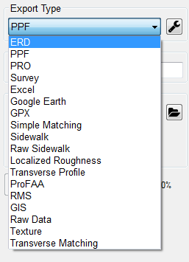

Figure 54: The export type drop down menu

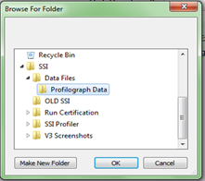

Figure 55: The export folder location selection

## 

Figure 56: The ERD format export window with match tracks selected

## Exporting to ERD Format

### 

### Station Extraction

The operator has the option export only certain sections of the data, based on the stationing set within the profiling data. To use this feature, select the check box near “Specify Station Numbers.” When the box is selected, the operator will be able to adjust the stationing numbers. The ‘Start’ stationing is the initial stationing where the exported file will begin, while the ‘End’ stationing is the point where the exported file will finish. These values can be adjusted by typing values into the box or by using the arrow keys to the right of the box.

### 

### Filter Settings—High & Low Pass length

The exported data file can have additional filters applied while being processed into the chosen format. To not filter the data, leave the filter lengths at the default value of 0.00 feet.

***Moving Average High Pass Filter***

A high pass filter will remove any trend that is shorter than the selected length. Typical range of length for this filter is one hundred feet (100 ft.) through two hundred feet (200 ft.).

***Moving Average Band Pass Filter***

This filter only allows the desired frequency of data to be shown. Adding this filter will adapt the profile trace to remove the high frequency motions. Moving average filters are typically used for short data runs less than two hundred feet (200 ft.).

***Butterworth High Pass Filter***

High pass filters allow the high frequency characteristics of the data plot to pass through while blocking the lower frequency attributes of the data run. Butterworth filters do not introduce a phase shift into the plot like moving average filters. Butterworth filters are traditionally used for longer data runs over two hundred feet.

***Butterworth Band Pass Filter***

This filter will perform both a high pass and low pass Butterworth filter operation on the data. The result is a run that has frequencies within the lower and upper bounds. Butterworth filters do not introduce a phase shift into the plot like moving average filters. Butterworth filters are traditionally used for longer data runs over two hundred feet.

### Include Run Up – Run Up Data

Some High-Speed Profiling data files have Run Up and/or Run out data associated with them, depending on the practice used to collect the data. If this data exists in the data file, it will be included in the exported file if this box is selected. Run Up and Run out is used to allow the electronics to settle on the accurate profile.

Run Up data exists in HSP data files if the operator selected a Run Up and/or Run out distance in the initial stages of setting up a collection. In the HSP collection software, the Run Up and Run out settings are found on the last window before performing a collection. Use run up and run out to stabilize the electronics before the starting location is reached.

### Export Raw Data

Selecting the Export Raw Data check box assures the operator that only unfiltered data collected from the profile will be exported into the chosen file.

### Match Tracks and Choosing Tracks

### 

### Match Tracks

Selecting ‘Match Tracks’ exports all of the tracks associated with the lane file. For the three laser systems, this includes Track 1, 2 and the center trace. For Profilograph files, the tracks are matched based on the settings entered prior to profiling. The label of the track number and stationing cannot be changed after collection.

### Choosing Tracks

The tracks that are exported are checked under “Track Selection.” If Match Tracks is selected the user cannot deselect track 1 or 2.

### Ignore Pauses

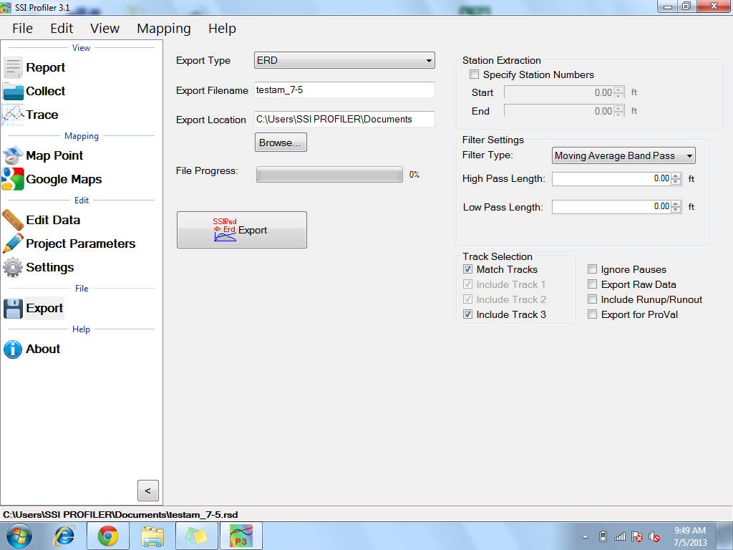Pauses are useful when an obstruction comes into the profiling path or when a section of pavement is not to be profiled. When Pause is activated, the stationing remains constant and under the same file. Pauses can either be omitted or included in reports and exported files of Profiler V3 software. To omit pauses from the exported file, select the check box, “Ignore Pauses.”

### Include Run Up/ Run out

When this option is selected, the Run Up and Run out data collected during the collection will be included in the export data.

### Export for ProVal

When the user exports an ERD file for use in ProVal, it changes the file’s default filters and settings to more accurately match the values in ProVal.

Figure 57: The ERD export window settings

## 

## Exporting to PPF Format

### Station Extraction

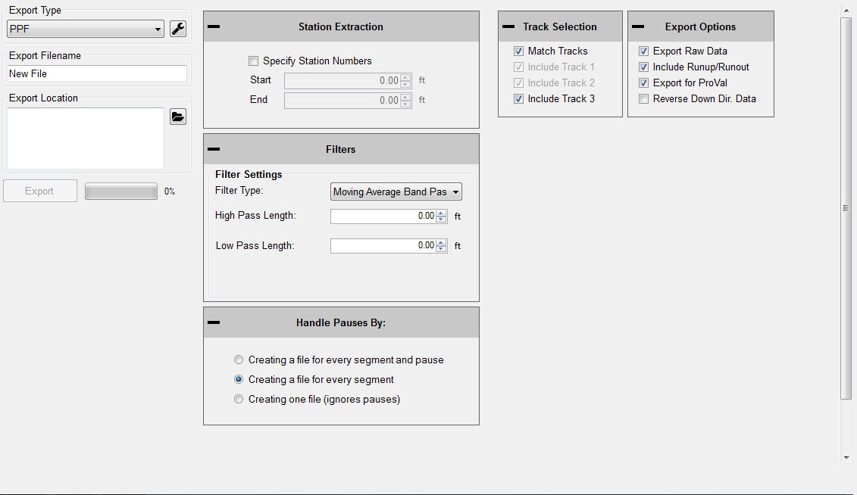The operator has the option to export only certain sections of the data, based on the stationing set within the profiling data. To use this feature, select the check box near “Specify Station Numbers.” When the box is selected, the operator will be able to adjust the stationing numbers. The ‘Start’ stationing is the initial stationing where the exported file will begin, while the ‘End’ stationing is the point where the exported file will finish. The start and end stationing can be adjusted by typing values into the box or by using the arrow keys to the right of the box.

Figure 58: The PPF export window

### Filter Settings—High & Low Pass Length

The exported data file can have an additional filter applied while being processed into the chosen format. To not filter the data, leave the filter lengths at the default value of 0.00 feet.

### Available Filters:

***Moving Average High Pass Filter***

***Moving Average Band Pass Filter***

***Butterworth High Pass Filter***

***Butterworth Band Pass Filter***

### Include Run Up and/or Run out Data

Some High-Speed Profiling data files have Run Up and/or Run out data associated with them, depending on the practice used to collect the data. If this data exists in the data file, it will be included in the exported file if this box is selected.

**Run Up data only exists in HSP (High Speed Profiler) data files if the operator selected a Run Up and/or Run out distance in the initial stages of setting up a collection**. In the HSP collection software, the Run Up and Run out settings are found on the last window before performing a collection.

### Match Tracks

Selecting ‘Match Tracks’ exports all of the tracks associated with the lane file. For the three laser systems, this includes Track 1, 2 and the center trace (track 3). For the Profilograph files, the tracks are matched based on settings entered prior to profiling. The stationing and number label assigned to the track are settings that cannot be changed after collection.

### Ignore Pauses

Pauses are used when an obstruction comes into the profiling path or when a section of pavement is not to be included in the calculation of ride values and localized roughness. While Pause is activated, the program will continue to collect stationing data, but will not collect height data. Pauses can either be omitted or included in reports and exported files. To omit pauses from the exported file, select the check box, “Ignore Pauses.”

For importing into ProVal, the best method is to include pauses. The pauses of the rsd file will turn into a leave-out section within ProVal. If pauses are not included during export, it will result in two PPF files for the same track. There will be one more PPF file than the number of pauses.

### Export for ProVal

When the user exports a file for use in ProVal, it adds a negative sign in front of all stationing. This is done because ProVal does not use stationing, it only uses forward distance. If you collect data down station, you must check the Export for ProVal box to keep accurate stationing through the collection. ***Always choose “Export for ProVal” when importing into ProVal.***

Figure 59: Optional settings when exporting in PPF format

## Exporting to PRO Format

Figure 60: The PRO format window

### General Settings

### Station Extraction

The operator has the option to export only certain sections of the data, based on the stationing set within the profiling file. To use this feature, select the check box near “Specify Station Numbers.” When the box is selected, the operator will be able to adjust the stationing numbers. The ‘Start’ stationing is the initial stationing where the exported file will begin, while the ‘End’ stationing is the point where the exported file will finish. These values can be adjusted by typing values into the box or by using the arrow keys to the right of the box.

### Filter Settings-High Pass Length

The High pass filter length can be changed when exporting files to PRO format. A High Pass Filter removes all of the data trends below the filter length. The default length of the High Pass Filter is 200 feet. In order to export the data without filtering, the ‘Export Raw Data’ check box must be selected. See ‘Export Raw Data’ below.

### Export Raw Data

Selecting the Export Raw Data check box assures the operator that only unfiltered data collected from the profile will be exported into the chosen file.

### Match Tracks

Selecting ‘Match Tracks’ exports all of the tracks associated with the lane file. For the three laser systems, this includes Track 1, 2 and the center trace (Track 3). For the Profilograph files, the tracks are matched based on settings entered prior to profiling. The label of the track cannot be changed after collection.

### Handle Pauses By:

Figure 61: The Details tab contains information about the project

The paused sections within the collected data can be exported in two ways. Separate files can be created for each segment or the profile data can be exported with the paused sections included in one file. The difference in these two options is that creating separate files for each segment exports multiple files into the folder location, while the “Using pause events” option exports one file including all of the data. If the pauses were used to omit data because of pavement anomalies, use the option of ignoring the pauses.

### Details

The details section of PRO exporting is the job specific information saved with the file, such as **District Number,** **County Number,** **Reference Marker,** **Reference Offset, Highway Descriptor,** **Lane Descriptor,** **Certification Number,** **Certification Date, and Comments.** This information is then saved with the PRO file to be displayed when the file is opened or printed using another program.

## Exporting to Survey Format

### Station Extraction

Figure 62: The window for exporting in Survey format

The operator has the option to export only certain sections of the trace, based on the stationing set within the profiling data. To use this feature, select the check box near “Specify Station Numbers.” When the box is selected, the operator will be able to adjust the stationing numbers. The ‘Start’ stationing is the initial stationing where the exported file will begin, while the ‘End’ stationing is the point where the exported file will finish. These values can be adjusted by typing values into the box or by using the arrow keys to the right of the box.

### Filter Settings

High and Low Pass filters are optional when exporting to survey format. The exported data file can have an additional filter applied while being processed into the chosen format. To not filter the data, leave the filter lengths at the default value of 0.00 feet.

**Available Filters:**

***Moving Average High Pass Filter***

***Moving Average Band Pass Filter***

***Butterworth High Pass Filter***

***Butterworth Band Pass Filter***

### Output Sampling Interval

Figure 63: Stationing units dropdown menu and options

The sampling interval is the distance between readings of the SSI survey system. The default length of this interval is 1 foot. This feature allows other intervals to be implemented, depending on the accuracy specifications required in the surveying program.

The raw GPS will be exported in a separate text file in a NMEA (GPGGA) GPS string format.To match tracks 1 and 2 within the same file select the match tracks option.

## Exporting to Excel Format

Exporting the profile data to excel gives the operator versatility and efficiency when an adjustable numerical printout is needed.

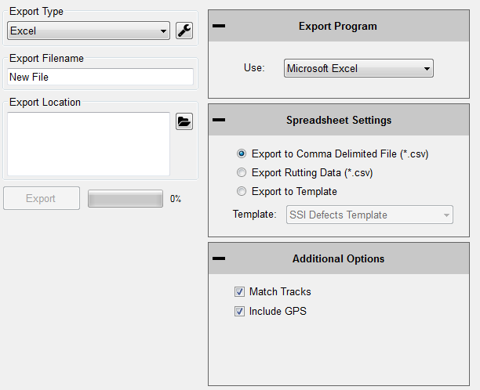

Figure 64: Exporting the data into Microsoft Excel format

### Export to Template

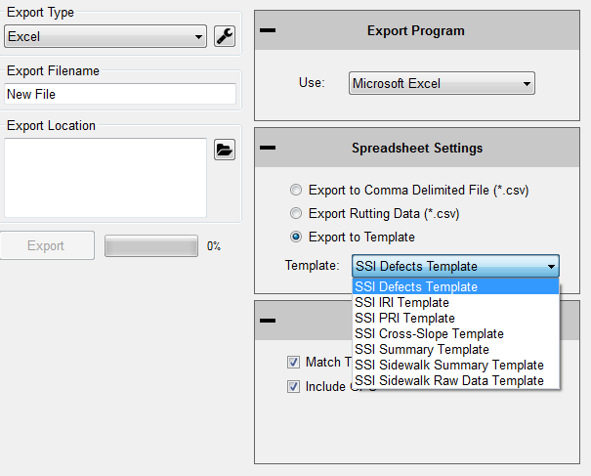To choose a SSI Excel Template, select “Export to Template.”

### Defects Template

The Defects Template shows the locations and heights of the defects and information about the file in spreadsheet form.

### IRI Template

The IRI Template shows IRI statistics along with the defect locations and heights.

### PRI Template

The PRI Template lists the PRI for each track along with the bump heights, locations and settings.

Figure 65: The types of excel formats are listed

### Summary Unmatched

The Summary Template shows a version of the summary report the calculated PRI for each track along with the bump heights, locations and settings in spreadsheet form.

*Note: Sidewalk templates are reserved for Sidewalk Profiler. For more info visit www.smoothroad.com*

## 

## Exporting to Google Earth

Figure 66: Google Earth export settings

The export to Google Earth feature allows operators with Google Earth installed on their computers to view the test data in the real environment. The view of the Google Earth feature shows the project area with the traces superimposed onto the window. The user may view the traces and project from any view or angle. For this feature to be used, the operating computer must have Google Earth installed.

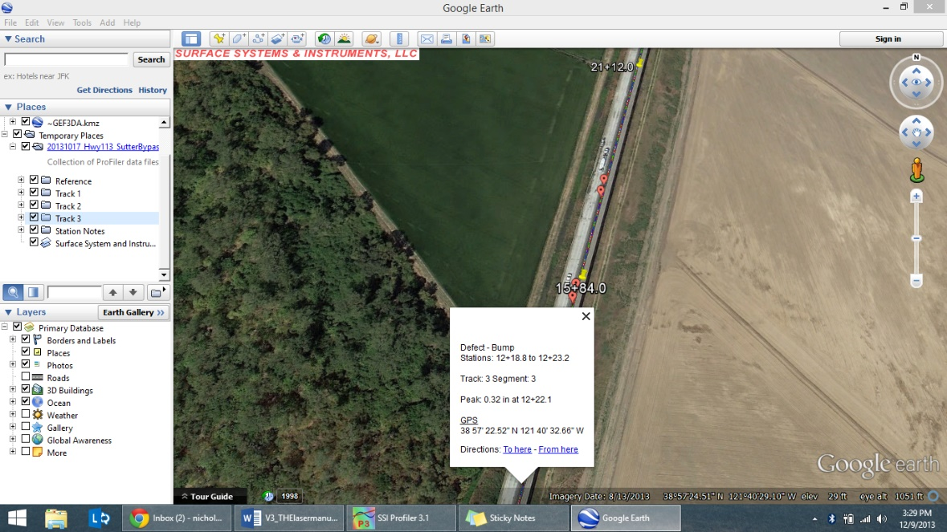The user may then use Google Earth to view the profile trace in their computer, tablet or smart phone as long as the device has Google Earth installed. The .kmz file can be emailed to the device or sent via Bluetooth if your Toughbook is equipped.

Figure 67: Google Earth view on laptop

## 

## Exporting to GPX Format

The GPS coordinates can be exported into a format for submittals. The GPS coordinates of the defect can be viewed through the defect start station, defect end station or the defect peak station. Specific runs can be chosen to retrieve the GPS coordinates by adjusting the drop-down menu under the title, “Select Run to Export.”

Under the title "Data to Export" there are multiple check boxes. In order to export the defect’s GPS coordinates, the "All Raw GPS Locations" check box must be unchecked. Once the "All Raw GPS Locations" box is deselected, the options to export the defect stationing GPS coordinates become available.

## 

Figure 68: The export window for GPX format

## 

## Exporting to Sidewalk Format

***This option is only to be used with files collected with the SSI Sidewalk Profiler (CS-8850)***. The sidewalk format has all of the information of the collection exported into GIS compatible file types. The files types and the corresponding information (See Glossary for explanation) are:

**Ngd:** Contains synchronized distance, time, and gyroscopic data for a specified collection interval.

**pxyzd:** The three dimensional profile derived from the travel grade and gyroscope.

**pxyzdg and pxyzdinc:** Same as pxyzd, except without column headers for the data.

**rmpslp:** Rmpslp is the ramp and running slope exceptions. The column headers are travel distance, marker distance, time, ramp type, and casename.

**rmpslpg:** Rmpslpg contains the same data as the file rmpslp, except rmpslpg does not have column headers. This format contains travel distance, marker distance, time, ramp type, and casename.

**rmpslpg_ls:** Rmpslpg_ls is a line segment version of rmpslpg without column headers.

**uba:** This file contains the bump height and bevel slope data. The column headers are; travel distance, bump type, bump height [inches], bevel slope, and the casename.

**ubag:** Ubag contains the same data as uba, but ubag does not have column headers for the data. This format contains travel distance, bump type, bump height [inches], bevel slope, and the casename.

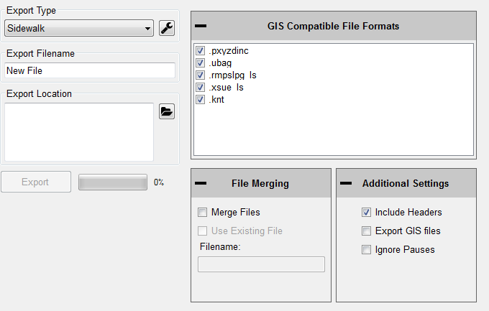

Figure 69: Export to Sidewalk window

## Exporting to Localized Roughness

The localized roughness export feature allows the user to create an excel spreadsheet of the localized roughness, or defects, for the collected data.

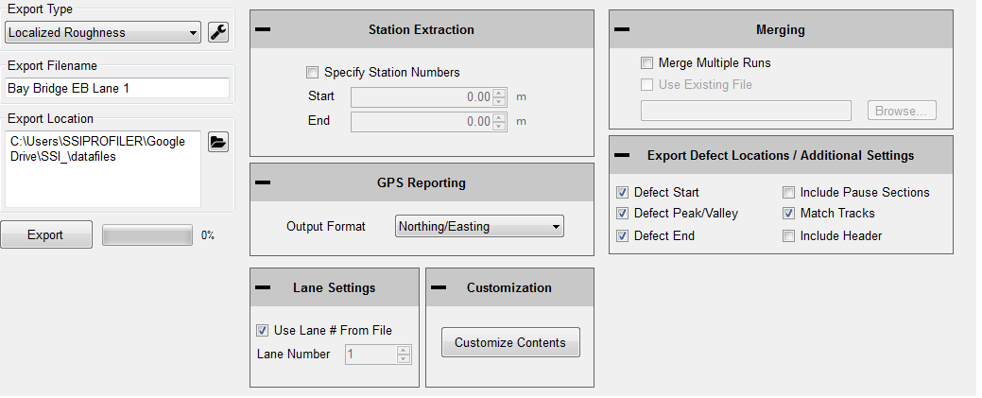

Figure 70: The Localized Roughness export options window

### Specify Station Numbers

If the user desires to only export a section of the collection, select this check box and enter the start and end stationing of the soon to be exported section. If the specify station numbers is not selected, the entire collection will be exported.

### GPS Reporting

To choose the type of GPS format used in the export, select Northing/Easting, Decimal Degrees, or NMEA Format from the drop-down list.

### Lane Settings

The user may change the lane number that is currently in the collection file by selecting this check box and entering the correct lane number. To change the lane number, deselect the check box and change the lane number in the input location.

### Customization

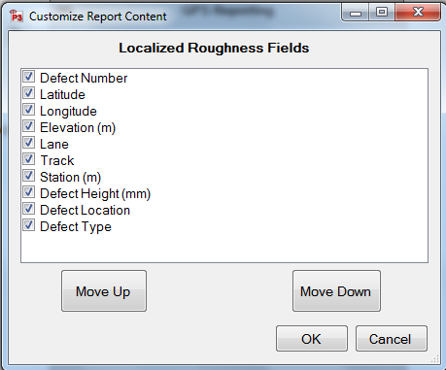The user may add, move and remove columns from the Excel spreadsheet format. To do this, open the “Customize Contents” window and use the arrow keys. Move up and move down to change the order of the included columns. The columns types are at the top of the “Columns in File” side the left-most columns in the exported Excel file.

Figure 71: The Customize Window

### Merging

The ´Merge Multiple Runs´ check box allows the user to include multiple collection runs in the spreadsheet. Runs that are saved in a separate file can be opened and exported alongside the current file by selecting “Use Existing File” and browsing to enter the location of the file.

### Export Defect Locations

Use the check boxes to select whether the program will export the start, peak and end of the defect in the spreadsheet. The user will have the option to match tracks 1 and 2, include the paused sections, and include the header information. When paused sections are included the defects within the paused sections will be listed.

## ProFAA

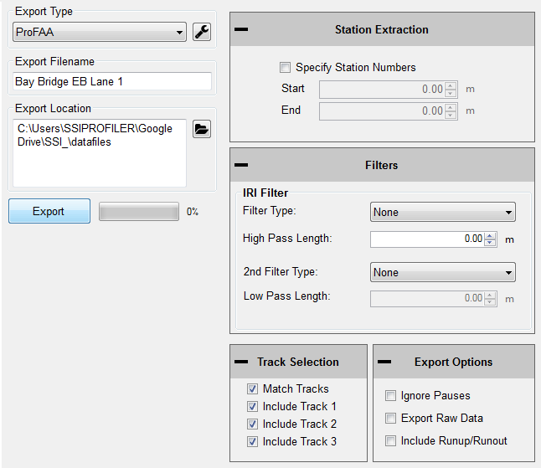ProFAA is the format used for the Federal Aviation Administration (FAA) profiling program. This is the program that uses the Boeing Bump test method.

Figure 72: ProFAA window

The user can enable high and low pass filters, change the start and end stationing, including the pauses and exclude specific tracks from the exported data.

Exporting raw data will force the data through a linear regression filter and have the data begin and end at zero elevation. The Run Up and Run out data can be included by selecting the check box.

## RMS Export

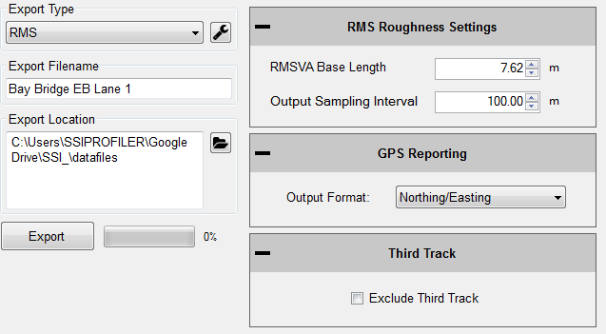The RMS export is a normalization of the profile data. RMS removes the influences of long wavelengths and grades while focusing on the amplitudes of the wavelengths in the profile. The RMS output does not show the frequency of these amplitudes in the profile, only that they exist.

Figure 73: RMS export settings

Set the RMS base length for continuous RMS and the sampling/segment interval.

## GIS Export

The GIS export will create shape files for the segments, localized roughness, events, and track path for the profile. These files will be organized into their own folder entitled GIS Files under the destination folder.

Figure 74: GIS export settings

## Exporting Raw Data

The user can export raw elevation data, GPS data and GPS height data. The settings can be changed to export certain GPS string formats. It is recommended to use the Linear Regression Removal Filter to set the raw elevations along the null line. Otherwise there can be drift in the trace and give inaccurate elevation data.

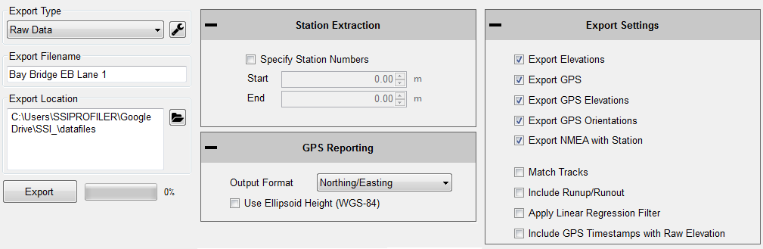

Figure 75: Exporting Raw Data Settings

## Exiting Program

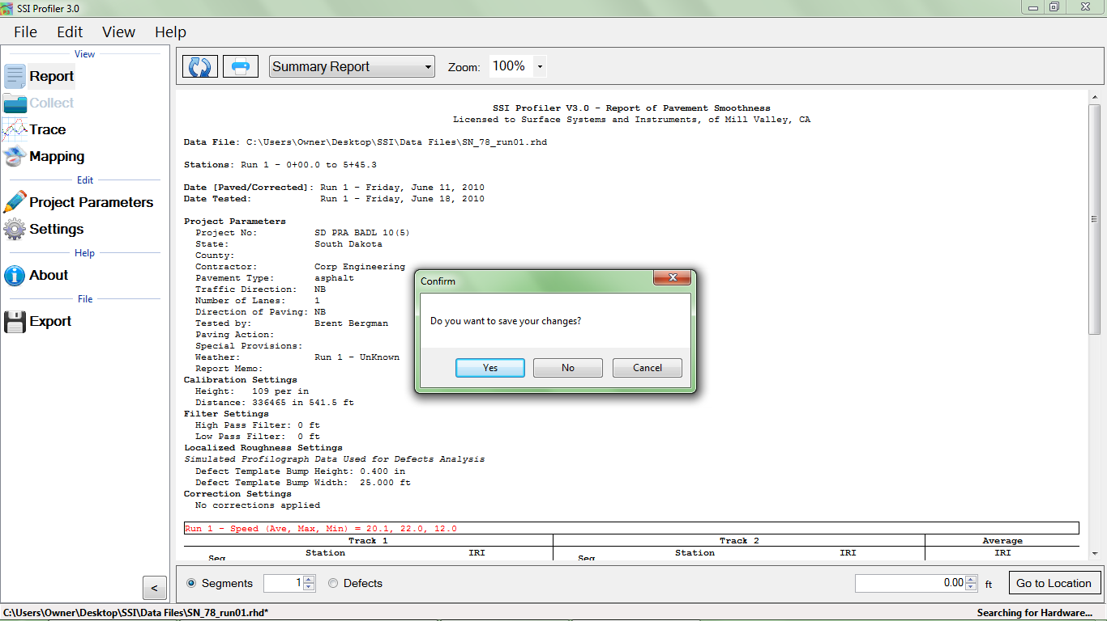To exit the Profiler V3 program, save current project and click the red “X” at the top right corner or navigate to the File tab and select Exit. If the current project is not saved when the program is terminated, Profiler V3 will ask if the operator would like to save the current project. To save and exit the program, select “Yes.” If you do not wish to exit to program, select cancel and the program will remain open.

Figure 76: Exiting the program- Saving

## Shortcut Bar

The Shortcut Bar is located at the left side of the main window. The shortcut bar is used to navigate around the profiler program without using the menu bar.

The shortcut bar can be hidden by selecting the arrow at the bottom of the window. The direction that the arrow is pointing is the direction that the shortcut bar will move. It will either become hidden or reappear.

Figure 77: The shortcut bar with all of the frequently used windows

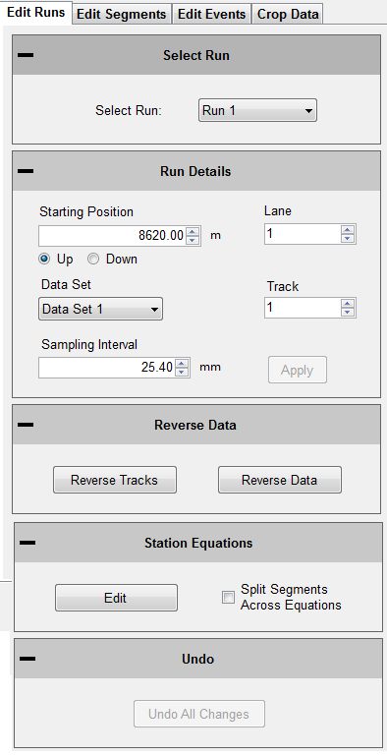

Figure 78: The Edit Run Options

# Edit Data

***Note: Any edit to the data will be described in the report header under File Modifications.***

The edit data feature allows the user to adjust the starting station, insert pauses, or add events. All of this can be done in post processing, after a collection has been completed. To edit the collection:

1) Open the tab that has the information that needs adjustment. (Edit, Runs, Segments, Events)

2) Select the run that needs to be adjusted from the drop-down menu.

3) Change the parameter of starting position, run direction, and Run Up or Run out data.

4) **Select apply.**

## Edit Run

Under Edit Runs the user can adjust the starting position and change the Run Up or Run out lengths. If the data was collected in the wrong station direction, this can also be reversed by changing the bullet selection to “Up” or “Down.”

## Sampling Interval

The sampling interval is the distance between readings of the electronics of the profiling system (DMI, lasers, etc.). This is usually set to 1 inch.

## Edit Segments

The Edit Segment feature allows the user to add pauses to the collection or to ignore a certain distance of collected data at the beginning or end of the run. The data will not be included in calculation of the PRI.

## Adding & Editing Pauses

**To add a pause**

1.New Pause will be added above the highlighted blue bar “(add new pause).”

2.Select the run number to add the pause to from the drop down menu.

3.Select the pause type (Exclusion, Bridge, Intersection)

4.Enter the start station for the pause

5.Enter the end station for the pause (The pause length will be updated automatically)

6.Select Add. The pause stations will appear in the Pause List.

7. The user will now be able to add Pause Notes.

1. Select **Apply** to save the pause note.

***Note: A pause will not be added unless the Start Station is different than the End Station.***

***The pause can be edited at any time. Any pause or edit made after collection will be displayed in the report header under file modifications.***

### To Edit a Pause

1.Select the paused section to be edited in the Paused list. It is selected when the blue bar is highlighting the pause title (Ex. “Run 1 - 0+00.0 to 0+010.0”)

Figure 79: Adding or removing pauses from the collection

2. Change the stationing.

3. Select Save to set the changes.

4.Select **Apply** for the changes to take effect

***Note: The run(s) that the pause is applied to cannot be changed through Edit Run. Please create a new Pause to change the pauses of a run. See directions above to create a pause.***

***If the pause is going to be deleted, select the* Delete *icon to remove it from the list.***

### Pause Definition

When the collection system is paused, height data is omitted but the distance is still collected. When the paused sections are excluded, the height values are not used in the calculation of localized roughness or ride values.

### Pause Notes

To explain the reason for the pause or the location, enter the information in the pause notes. This information will appear in the track notes of the trace reports.

### Pause List

The Pause List shows all of the paused sections of the selected runs. The runs are selected from the drop-down menu of “Add Pause to Run.”

### Start Station

The Start Station in the stationing where the pause is to begin.

### End Station

The End Station is the stationing where the pause will stop, and collection will resume.

### Save Pause Icon

When the operator selects a created pause in the Pause List by left clicking on it and highlighting it blue, the two options of Save and Delete appear in the middle of the window. To save the selected pause in the Pause List, left click Save.

### Ignore Length at Start/End

This feature ignores a distance at the ***start and end of a collection*** by adding a pause at these locations. If the “Use Same Length” box is not selected, the ignored distance at start and end will be the same.

### Pause Buffers

The Pause Buffer icon opens a new window to add length around pauses in the Pause List. Choose the Pause in the Pause Buffer window and add the buffer length. Select OK when finished.

### Event Buffers

The Event Buffer icon opens a new window to add length around events around events in the Events Tab. Choose the event in the Event Buffer window and add the buffer length. Select OK when finished.

### Use Same Length

When the Use Same Length check box is selected, the runs will be trimmed to the same length.

## Edit Events

Edit Events allows the user to input events that were not added during collection, or to delete saved events. The events can have information associated with them that is inputted into the text box. The types of events for walking profilers (Sidewalk) are Height and Width obstruction. High speed and Profilograph systems should use the “Default” Event Type.

### To add an Event

Figure 80: Edit Events Tab

1. Select the run to add the event to

2. Select New Event

3. Change the Stationing to the correct point location

4. Adjust the Event type to explain the event

5. Under notes, add information about the event. (Start Structure, manhole, drainage, etc.)

7. **Select Apply**

### Editing an Event

1) Select the event in the Data Events list to highlight it blue.

2) While highlighted, the event stationing, type or notes can be changed

3) **Select Apply**

### Deleting Events

1) Select the event in the Data Events list

2) Select Delete to remove the event.

3) **Select Apply to save the changes**

## Crop Data

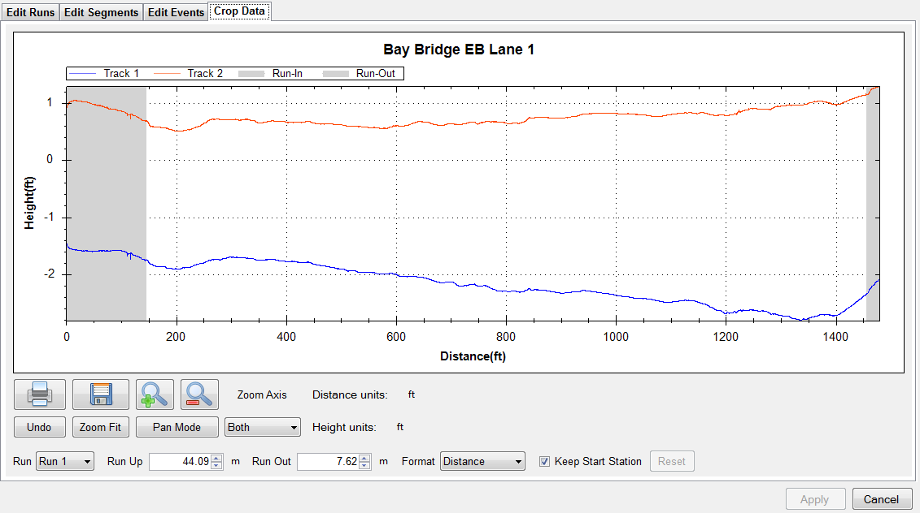The Crop Data tool allows the user to trim the collections before analysis and reporting. If any changes are made to the file, the information that was changed will be described in the report header under File Modifications. To crop the collection, change the distances for the run up and/or run out distances. When the lengths are at the desired distances, select **Apply**.

Figure 81: The Crop Data Tool

To reset the run up and run out to the original lengths select the rest icon next to run out. This icon will become available once a change has been made ***and*** Apply has been selected.

It is recommended to use the dropdown menu and choose the “Station” option instead of the distance option for cropping data.

# Project Parameters

The Project Parameters section is the location where the job information is inputted. This information appears on the header of the reports and the exported excel templates. Before leaving the Project Parameters window, always select ‘Apply’ if changes were made.

## Job Information

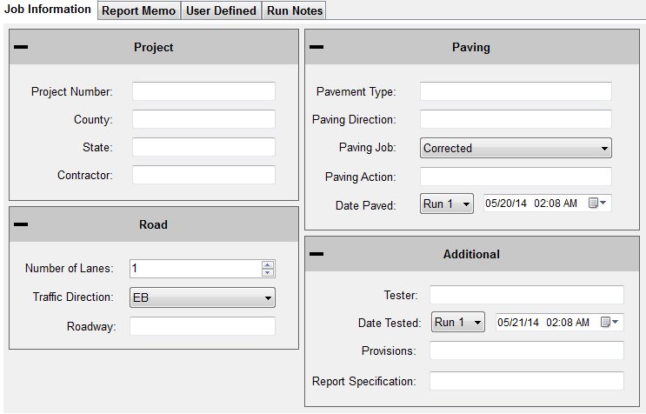The job specific criteria listed below are descriptive information about the project. Review the contract to enter the required information into the sections listed below. These sections can be edited at any time within Profiler V3.

Figure 82: The Project Parameters window

## 

## Project

**Project Number**

The Project Number is unique to each project. This is to be determined by the State, Federal DOT or by the contractor. This information will be listed in the project contract.

**County**

This location is reserved to list the county where the profiling is taking place.

**State**

The state in which the profiling is taking place and the job is located.

**Contractor**

This section is for the name of the paving company or for the company operating the profiler.

## Road

**Traffic Direction**

The traffic direction of the lane to be profiled.

**Number of Lanes**

The number of lanes of the project. This section can be changed by inputting values directly or by using the arrow keys. Traditionally, the number of lanes is the number of lanes travelling in the same direction for main line freeways. Use a classification system that can be understood during post-collection analysis.

## Paving

**Pavement Type**

Input the type of pavement here. Enter pavement types such as Cold–in–Place Asphalt, HMA, JPCP, CRCP, Open Grade etc.

**Paving Direction**

Enter the direction of the paver when placing the pavement.

**Paving Job**

Specify the type of paving job, either corrected or original.

**Paving Action**

Under paving action list any further information about the paving process.

## Additional

**Tester**

The individual operating the profiling equipment over the pavement surface.

**Provisions/Weather**

The weather at the time of profiling the pavement. Such as: Cold, Hot, Overcast, Morning, Afternoon, Evening, etc.

# Report Memo

Report Memo is a section available for inputting large amounts of text to be saved along with the data file. Anything from reminders to stationing can be inputted into the Report Memo and not influence the data.

Figure 83: The Report Memo window

## User Defined

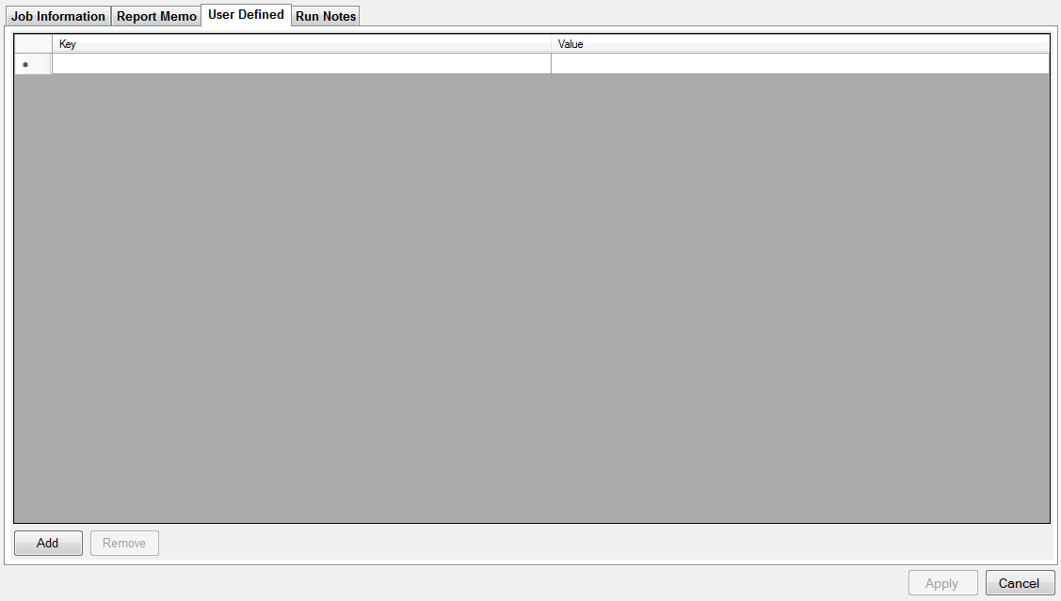Additional parameters can be stored in the data file as desired by the operator. Consult the contract for any additional user defined parameters that may be required for the profile data files. Add new parameters by selecting ‘Add’ at the bottom of the window. The parameters are entered by double-left clicking on the ‘Key’ column and typing in the required information.

Figure 84: The User Defined section

# Settings

User defined parameters can be used in conjunction with the Default File Naming tool.

### 

## General Settings

The default file preferences and settings for report generation can be changed under the “Settings”. Whenever a change is made, always select the **Apply** icon in the lower right corner.

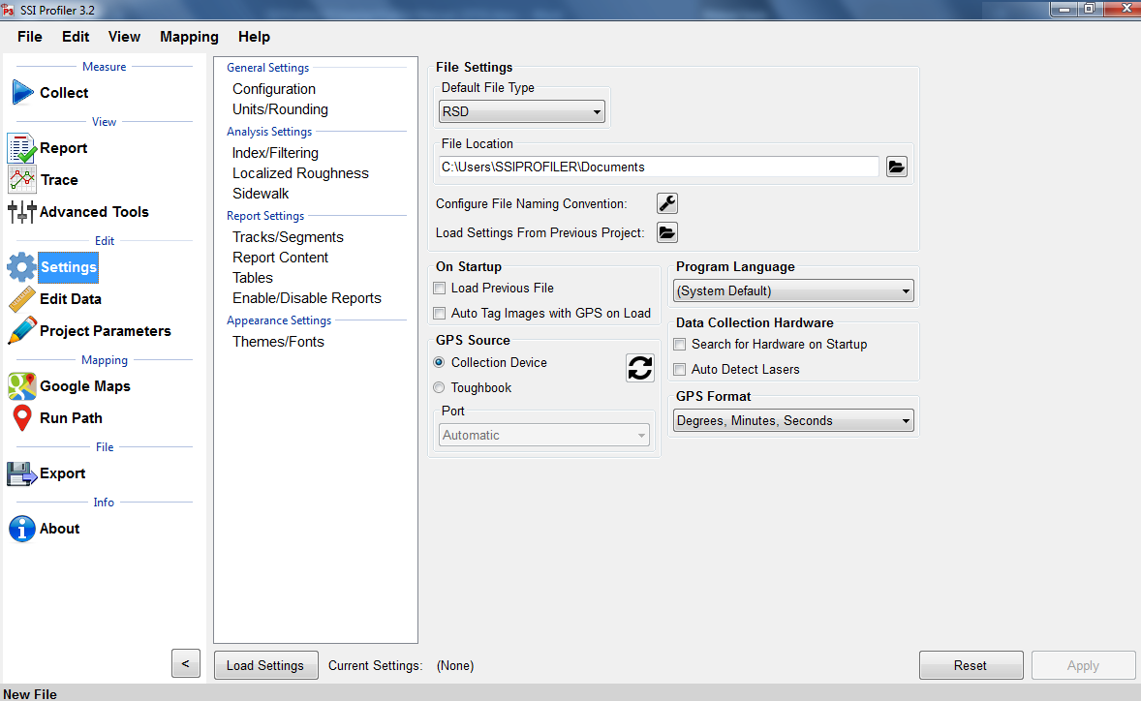

Figure 85: The General Settings window showing the Configuration

## File Settings

### Default File Type (RSD, RHD)

The drop-down menu can be used to select the type of file opened in Profiler V3. Both RHD and RSD files can be imported into the program at any time. The default file type is the file format that will be used automatically when files are opened. ***Profiler V3 only saves in the RSD format.***

### Default File Location

The default file location is the folder on the computer or external device that Profiler will search for the default file type. This folder can be changed through the Browse icon. If a location is used to open a file, the program will use this location to open files for future attempts. This feature saves time opening files since the program opens directly to the file location. Select **Apply** after a folder is chosen.

### Default File Name

The file name can be chosen to have a name based on parameters of the program or by using a pre-loaded template. The parameters can be chosen from the list of (multiple can be chosen): Contractor, Country, Tester, etc. When a template is selected there will be a preview at the bottom of the window. Select OK and Apply to set this configuration as the default file name.

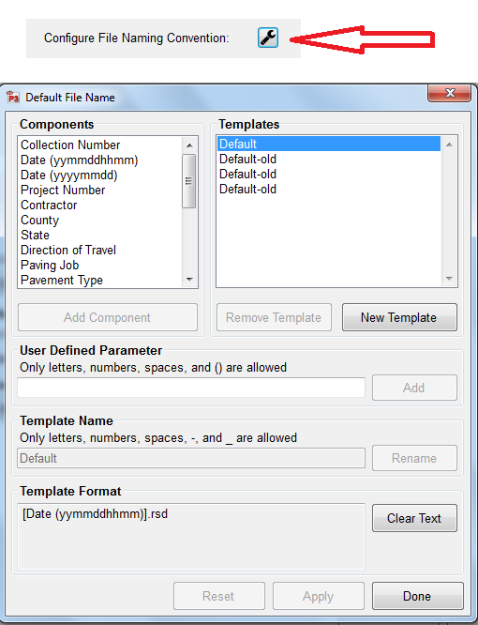

Figure 86: The custom file naming convention

### Creating a New Template

Create a New Template by selecting the “New Template” icon on the right side of the window. Select the template’s name to rename it and append parameters to it. ***The template will be used as long as it is selected when OK is selected at the bottom right corner when exiting the Default File Name tool.***

### User Defined Parameter

To create parameters that are specific to the job, type a new parameter name into the User Defined Parameter text box and select “Add User Defined Parameter.” The bracketed variable will appear in the filename preview. To add information to the user defined parameter, open Project Parameters and the User Defined Tab. The name of the parameter will be under the Key column. Under the Value column, enter the information that is needed in the filename.

### Changing the Template Name

The template’s name can be changed by changing the characters under Template Name. Once a change is made, the Rename icon will be available. Select OK or Apply to save the changes.

### Adding Parameters to the Template

When adding parameters to the template they will only be added to the right end of the template, as seen in the naming preview. **Select *Apply* after changes are made to the template**.

## On Startup

### Load Previous File on Startup

If this box is selected in figure 85, the file that was open when profiler closed last will be reopened when the program is started. A report of this file will be generated when the program is opened.

### Load Previous File’s Settings

The user may choose a previous file to save time if entering the same analysis parameters or project parameters under “Settings.” To load a previous file’s setting’s, choose the file under General Settings ***or*** start a new file and choose one of the three options.

### Use Last File’s Parameters

This option will use the last file’s settings under the localized roughness and project parameters.

### Choose from a Previous File (Browse)

When this option is chosen a window explorer window will appear and the user may select a file that is saved on the computer to import the saved file’s parameters under analysis and project parameters.

### Set File Parameters after Collection

By choosing this option the user will not import a previously collected file but will instead manually set the parameters after the collection has finished.

### Automatically Refresh Reports

The reports will automatically refresh when the operator navigates to the report window from another tab. When the user makes a change of report type within the report window, the refresh button will have to be selected manually.

### Data Collection Hardware

### Search for Hardware on Startup

If this option is selected in figure 85, the program will search for hardware, and if available, will connect to it upon opening the program.

### Disconnect Hardware When Changing Tabs

If this feature is checked the program will disconnect from the hardware when the operator leaves the collect tab.

### Report Generation

### Generate Reports in Color

If the reports are generated in color, the defect types will be more visible. On the trace reports dips will appear be highlighted blue and bumps will be highlighted red.

### Include the Footer

If the footer is included, the file name and the page number will be printed at the bottom of each page for the report. Select the check box to apply this feature.

***Do not include the footer while printing with a Printrex 422.***

### Enable Animations

When enable animations is selected, the windows within Profiler V3 will slide across the screen whenever the operator moves from one section to another (Reports to Collect). This feature does not affect the functionality of the program, but adds an aesthetic behavior when changing windows.

### Resize for Printrex

Check this box if printing with a Printrex 422 and uncheck include the footer. This option allows the operator to correctly scale the trace for use with a sliding scale if necessary.

### Report Scale

Depending on the specification and system type, the operator may choose between a 1”:25’ or a 1”:15’ scale. The bridge profilograph is usually a 1”:15’ scale while the California profilograph and all road profiling is 1”:25’ scale.

### Formatting

### Font Settings

The report font can be changed by selecting the Font Settings icon under formatting. This allows the user to make the size of the font smaller or larger. The image scaling allows the user to print off less pages by increasing the scaling factor. The window that appears can also change the font to a strike-through or an underline.

### Image Scaling

The default for the image scaling is 100%. When image scaling is set to a percentage greater than 100%, it acts the same way as the zoom function. The size of the traces within the reports will increase.

### Profiler Software Update

Profiler V3 will check the internet connection by attempting to connect to the website listed under this location. If the internet connection is found, the updates will be available for download from the SSI server.

## 

## Program Language

Choose between English, Spanish (North/Central America) and, Spanish (South America)

# Analysis Parameters (Ride Values)

## Profiling Units

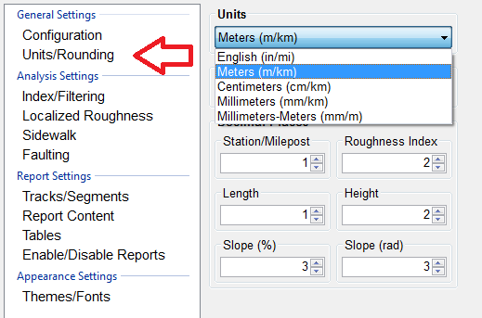

## 

### 

Figure 87: The units and rounding section of the General Settings

### English

Selecting English units sets the segment length to 528 feet. English units use inches for the height of the defects, counts for roughness settings, and feet for scallop width and filter lengths. After every change of units, select apply in the lower right corner to save.

### Metric Meters

In Metric Meters units, the blanking band, scallop height and scallop resolution are all in cms. The rest of the measurements for scallop width and filter lengths are in meters. The Metric Meters and Metric Centimeters settings have the same units of centimeters for height, and meters for length for all sections of defects and roughness. After every adjustment of units, select applydddd.

### Metric Centimeters

Selecting Metric Centimeters units, the blanking band, scallop height and scallop resolution are all in centimeters. The rest of the measurements for scallop width and filter lengths are in meters. The Metric Meters and Metric Centimeters settings have the same units of centimeters for height, and meters for length, for all sections of defects and roughness. After every adjustment of units, select apply in the lower right corner to save changes.

### Metric Millimeters

Selecting Metric Millimeters units, the blanking band, scallop height and scallop resolution are all in millimeters. The rest of the measurements for scallop width and filter lengths are in meters. After every adjustment of units, select apply in the lower right corner to save changes.

### CA Bridge

The CA Bridge setting is based off the California Bridge Profilograph spec, which is 12 ft long instead of the California Profilograph's 25 ft. The CA Bridge setting is in English units and has a segment length of 100 feet. After every adjustment of units, select apply.

### CA Bridge Metric

This setting is used for simulating the Bridge Profilograph's 12 foot frame. The Bridge Metric setting is the metric version of the CA Bridge Profilograph. Its segment length is 90 meters and the defects and counts for roughness are in millimeters and meters. After every adjustment of units, select apply in the lower right corner to save changes.

### Segment Length

Segment length is the interval of profiling that is used to calculate ride values. Traditionally the distance used for segment length is one-tenth of a mile, or 528 feet (160 meters). This section is adjusted by using the arrow keys or double-left clicking in the box to type the segment length.

### Merge Last Segment if Less Than

If the last segment is shorter than the segment length, it can be merged into the segment before. This prevents large ride values from short distances. Only use if your spec doesn’t require a specific segment length for pay incentives. The last segment length will be changed with this feature.

### Exclude Paused Sections

When selected, the paused sections created during collection or through the Segment Adjustment window will not be included in the report or the calculation of the ride values.

### Include Paused Sections

When Include Paused Sections is selected, the paused sections are included with the actual collection when calculating the ride values. The report will show the paused sections in the segment summary and the trace view.

### Paused Sections Only

When ´Include Paused Sections Only´ is selected from the drop-down menu, only the paused sections created during collection or through the Segment Adjustment Window will be displayed in reports and used to calculate ride values and counts for roughness.

## Analysis Type

### IRI

The International Roughness Index is a universal ride index for concrete and asphalt roads around the world. The profile is analyzed using a quarter-car simulation that is weighted towards the frequencies of body and vehicle bounce; the most uncomfortable riding conditions.

To calculate IRI in Profiler V3, select IRI from the drop down menu, then adjust the filter settings if necessary according to the contract specifications. View the report under the Report Tab to observe IRI.

$IRI=\frac{Standarized Vehicle^{'}s Accumulated Suspension Motion}{Distance Traveled}$

### PRI

The Profile Ride Index is a simple calculation to classify the smoothness of a road profile against other roads. The formula for this calculation is:

**English Units:**

${ 5280 ft ×\left(Total Roughness in inches in Segment\right)}/{(Segment Length \left[ft\right])}$

**Metric Units: $${1000 m ×\left(Total Roughness in m, cm, or mm in segment\right)}/{ (Segment Length \left[m\right])}$$**

To calculate the PRI in Profiler V3, select PRI from the Analysis Type drop down menu. Once the settings are correct, select Apply and then view a report to observe the PRI ride values.

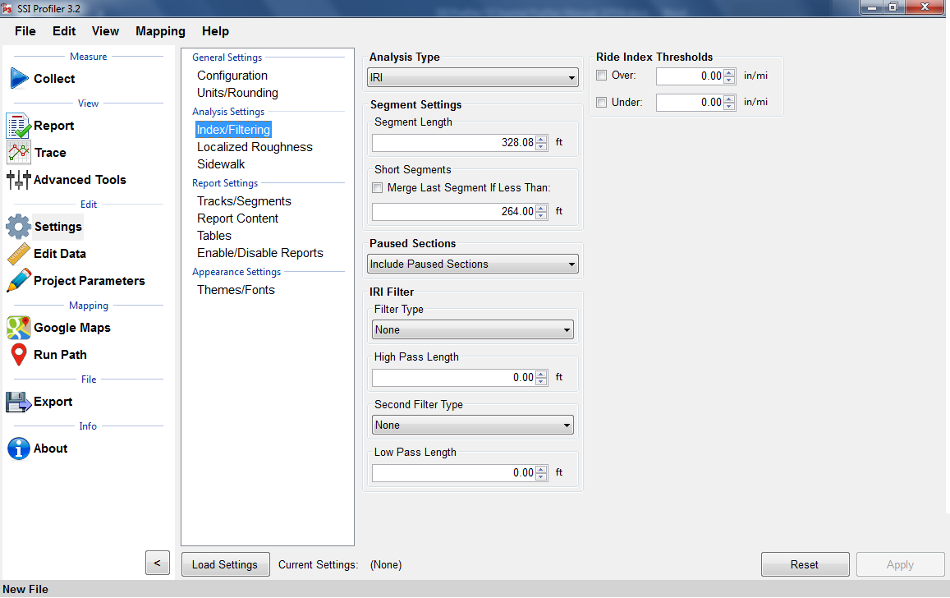

Figure 88: The IRI Analysis Parameters window

### PRI Parameters

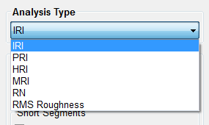Note that the PRI Parameters are only for the calculation of the Profile Ride Index (PRI). Blanking Band, and Scallops have no connection to the manner in which defects are found. For defect settings, see *Localized Roughness*.

Figure 89: The Analysis type drop down menu

### Scallop Definition

Scallops are the deviations of the profile trace from the blanking band. If the trace exceeds the defect height but the minimum width of the scallop is not reached, the deviation is not included as a defect. Although defects are not included in Ride Values, if the deviation still exceeds the defect height parameter, it adds to counts for roughness.

### Blanking Band

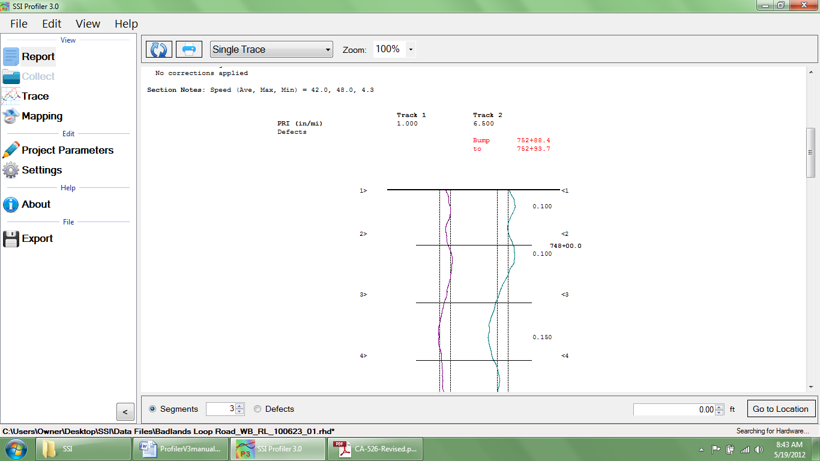The blanking band is a null area that classifies the height of all sections of the trace within its borders as zero. Therefore, a trace that remains within the borders of the blanking band would have zero counts for roughness and a PRI of zero.

### Minimum Scallop Height

The minimum scallop height is the minimum deviation height from the blanking band or null line. Frequently, the value for minimum scallop height is 0.035 or 0.9mm, which is the default value for the Profiler V3 program.

Figure 90: An example of the blanking band in the trace report

### Minimum Scallop Width

The minimum scallop width is traditionally 2 feet (0.61 meters). Review the Department of Transportation smoothness specification that pertains to the project. The minimum scallop distance is the minimum longitudinal length (the direction of traffic) that is used to find the deviations of the profile off of the null line or blanking band. The setting of 2 feet or 0.61 meters is the default setting for Profiler V3.

### Scallop Resolution

The scallop resolution is the accuracy of the height measurement. Current equipment is accurate to 0.01 inches, the default value for Profiler V3 software. A resolution of one-hundredth of an inch means that the scallop heights will always be rounded to the hundredth decimal. Consult the recent smoothness specification released by the overseeing agency to confirm the scallop resolution value.

### Reset File Settings

Selecting this icon brings all values in Settings to their default program values.

### Minimum Scallop Height Inclusive

When this box is selected, the minimum scallop height will be included as a scallop. Meaning, if the minimum scallop height is 0.035, 0.035 will be the minimum instead of 0.0351.

### HRI

The Half Car Ride Index (HRI) is found by applying IRI to an average of two profiles. HRI uses a half car simulation, unlike IRI which uses a quarter car simulation. To calculate the HRI in Profiler V3, select HRI from the Analysis Type drop down menu and verify the settings of filter length based on the project specifications. Once the filters are correct, select **Apply** to save the settings. To view the calculated HRI, view one of the reports under View>Report.

Figure 91: The HRI analysis window with the available filter

### RN

The Ride Number (RN) can be calculated in Profiler V3 byselecting RN from the Analysis Type drop down menu and verifying the settings of filter length based on the project specifications. Once the filters are correct, select Apply to save the settings. To view the calculated RN values, view one of the reports under View>Report.

Figure 92: The RN analysis window with the filter options shown

### RMS Roughness

The RMS roughness is a ride value method calculated by profile height over a base length of 25 feet. This is how RMS roughness gets inches as it´s units. The RMS Roughness report gives a depiction of the amplitude and wavelength but does not necessarily give the frequency that this amplitude and wavelength occurs. The output is similar to a PSD plot.

## Ride Index Thresholds

### Highlight Index Values Above

The operator may choose the threshold in which to highlight a certain interval of ride index values above a number. The highlight color is red and can be seen in the summary table of the reports. Only the segment ride values are highlighted, not the total ride values. This is convenient for comparing segment ride indexes to determine where grinding should be done.

### Highlight Index Values Below

The operator may choose the threshold to highlight a certain interval of ride index values below a chosen number. The highlight color will be green and it is seen in the summary table of the reports. Only the segment ride values are highlighted, not the total ride values. This is convenient for comparing segment ride indexes to determine where grinding should be done.

## Analysis Parameters: Filters

Figure 93: The filters within the IRI analysis parameter window

### High Pass Filter

The High Pass Filter will remove any trend in the data that is less than the chosen length. The length can be selected by typing the value in the box or by using the arrows to adjust the input.

### Low Pass Filter

The Low Pass Filter will remove any trend in the data greater than the chosen length. The length can be selected by typing the value in the box or by using the arrows to adjust the input.

## PRI Filter

### Moving Average

Figure 94: The filters for the PRI analysis parameter

A length of 2.0 feet can be chosen for the Moving Average Filter, depending on the contract specification. The use of the moving average filter was initially used by the Kansas Department of Transportation (see Report No. K-TRAN: KSU-9302 “An Automated System for Determination of Pavement Profile Index and Location of Bumps for Grinding from the Profilograph Traces.)

### Butterworth

The third order Butterworth filter has a default length of 2.0 feet. The Butterworth filter is not required for updated profiling specifications. The Butterworth filter was used for the original automated Profilograph systems.

**Available Filters:**

***Moving Average High Pass Filter***

***Moving Average Band Pass Filter***

***Butterworth High Pass Filter***

***Butterworth Band Pass Filter***

## Filter Gain—1.00

The filter gain is only used for necessary adjustments while comparing different profiling systems. The filter gain does not need to be used in normal profiling environments. When comparing high speed profiling systems to other Profilograph systems, the filter gain may be used to change the output of the data files. A filter gain setting of 1.00 does not affect the collected data. For typical profiling, use the default setting of 1.

## Localized Roughness

Localized roughness refers to the bumps and dips that occur over a determined distance.

Figure 95: The Localized Roughness window with the defect settings

## 

## Defect Detection

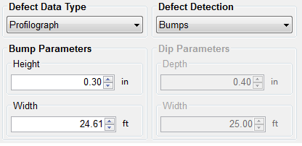The operator may choose the mode of defect detection in Profiler V3. The options to choose from are Bumps, Dips, Both, and None. To select the type, use the drop down menu labeled Defect Detection. ***No filters are associated with localized roughness***. “Both” is selected by default.

Figure 96: When only bumps are selected, dip parameters are unavailable

If only one defect type is chosen, be sure to change the correct settings. Do not change the dip parameters instead of the bump parameters by mistake. The report section of Profiler V3 can be used to review the settings and traces of the collection.

## Bump Parameters

### Height

Bump height is the maximum distance that a profile may deviate within the width of the bump. The width of the bump is the length of a Profilograph, or 25 feet (7.62 meters). A typical value for bump height is 0.3 inches. When the settings are changed for the bump parameters, always select **Apply** to save changes.

### Width

The width of a bump is based on the length of a Profilograph; 25 feet or 7.62 meters. This is the default value for the Profiler software.

## Dip Parameters

Figure 97: When only dips are being tested for, the bump parameters become unavailable.

### Depth

The depth of a dip is the maximum distance a profile trace may deviate within the width of the dip (25 ft or 7.62 m). The default value for dip height is 0.4 inches or 10.2 millimeters. When the settings are changed for the dip parameters, always select **Apply** to save changes.

### Width

The width of a dip is based on the length of a Profilograph; 25 feet or 7.62 meters. This is the default value for the Profiler V3 software.

## Localized Roughness Report Options

## Display Defects By:

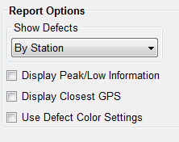The operator has the option to display defects by the station number or by the track in the report. To modify this setting, choose the desired display setting then select apply to save the changes. When displaying the defects by track, the defects are split up into their respective tracks. When the defects are organized by stationing they are listed in the same classification.

Figure 98: Localized roughness settings

### Display Maximum Peak/Low Values for Defects

Selecting this check box shows the peak values for the defects when viewing the summary report. When altering the settings, select **Apply** to save the changes.

### Identify GPS Closest to Defects

To show the closest GPS reading to each defect, select this check box. When viewing the summary, the GPS coordinates will be in the table with Defect Type, Track, Segment, and Stationing of the defect.

## Defect Data Type

### Profilograph

The Profilograph defect data type is the most common method used to find defects. The settings are the same as described above in Analysis Parameters, defect detection, bump parameters and dip parameters.

Figure 99: Types of testing available for finding defects

### Relative Height

Relative Height defect data type finds the defects of the profiled surface through the local differences in the trace. The settings required to be inputted within the Localized Roughness tab of the Settings Window are the bump and/or dip parameters.

### Texas-1001-S Method

The Texas 1001-S Method is used mainly by the Texas DOT for profiling with inertial profilers. The procedures and information for this test method can be found on the Texas DOT website; a direct link is below.

<ftp://ftp.dot.state.tx.us/pub/txdot-info/cst/TMS/1000-S_series/pdfs/spe1001.pdf>

The Texas-1001-S method detects localized roughness (defects) of the profiled surface by applying the base length and the threshold values saved in the Settings Window.

### IRI

When IRI Defect Data type is selected, the IRI calculation will be used to find the road’s defects (localized roughness) of the profiled surface. If this setting is selected the IRI ride value will not be shown in the summary. To list the IRI ride values on the reports, select the analysis type to be IRI in the Analysis Parameters tab. The ride interval is set (usually to 25 feet, in English units) and is used as a sliding guide across the profile. When the summation of the profile’s IRI exceeds the threshold, the entire continuous length which exceeds the threshold will be an area of localized roughness.

## General in Localized Roughness

### Merge Defects within:

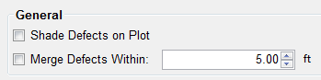The operator is able to merge multiple defects into one defect to eliminate high frequency grinding patterns. The action of merging defects does not affect the ride values or the defect heights. Merging adjusts the start and end stationing of two defects into one length. The default value of the merge defects tool is 5 feet. To use this feature, select the check box next to “Merge Defects Within.”

Figure 100: Merge Defects

### Shade Defects on Plot

The operator may use this feature to help identify defects.

# 

# Report Settings

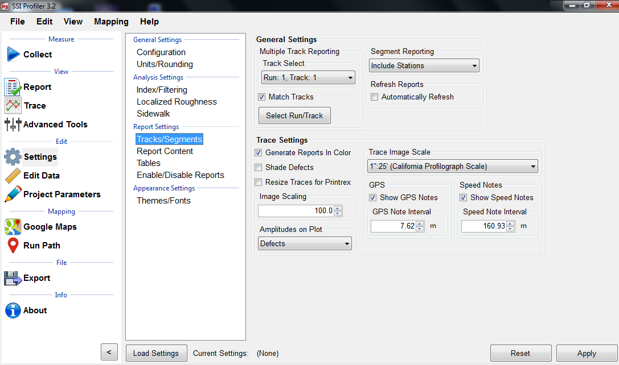

Figure 101: The report options window

## Track/Segments General Settings

### Multiple Track Reporting Track Select

Track Select is the tool that is used to select the track which will to be shown in the reports. From the drop-down menu, select a single track based on the label of [Run: Number, Track: Number].

When Match Tracks is not selected, the reports will only show one trace. The selected run in the drop-down menu will be the only run shown in the Reports of Single Trace, Continuous Trace, and All Traces.

To plot multiple or all tracks that are saved within the file, select Match Tracks. See below for information on Match Tracks. When Match Tracks is selected, the run shown on the collapsed Track Select drop down menu will be on the left side of the trace in the report. The figure above will have Run 1, Track 1 on the left side trace report. To report specific runs and tracks, select the “Select Runs” icon under Multiple Track Reporting. Here the user can select certain tracks or runs that will be included in the reports, localized roughness and ride value calculations.

Figure 102: The Track and Run Selection Window

### Match Tracks

When the Match Tracks check box is selected, all of the tracks associated with the file will be displayed in the reports of Single Trace, Continuous Trace, and All Traces.

With Profilograph profiles for the Profilograph, there are only two-wheel paths, while with some High-Speed Profiling Systems there have three traces. When dealing with multiple traces, the Track Select can change the order in which the tracks are displayed in the reports. The track that is selected in the drop-down menu within “Track Select” will be the trace that is on the left side of the report of the single trace, continuous trace and all traces plots.

In order to save changes made to the Multiple Trace Reporting Section, always select **Apply**.

Segment Reporting

The operator can choose to Include Stations and Segments Only. To include station and segment numbers in the continuous trace report select “Include Stations.” To only display the segment numbers select, “Segments Only.”

### Trace Settings

This section relates to the amplitudes of the collected data relative to the trace.

### Amplitudes on Plot

The operator has the option of showing the amplitudes for either the scallops or the defects on the plot. When comparing the reports to the SSI spreadsheet defects templates, the operators should choose to show only the defect heights. Scallops are the deviations of the trace outside of the centerline or blanking band. The defect heights will also be shown when scallops are selected, however there will be more labels on the deviations. Therefore, it is acceptable to leave the amplitudes on scallops.

## Note Reporting

### Report Speed Notes

To have the speed notes included in the printed report, the check box to the left of “Report Speed Notes” should be selected. To change the interval which the notes are reported, select the “Customize Reporting Intervals” icon. If changes are made, select **Apply**.

### Report GPS Notes

To have the GPS notes included in the report, select this box. If this box is not selected, the GPS notes will not be shown at the bottom of the report.

### Customize Reporting Intervals (GPS/Speed Notes)

The reporting intervals are the distances traveled while collecting data to between a GPS and or the Speed note on the report. A new note will be shown each time the distance of the interval is traveled. The types of intervals that can be adjusted are:

### GPS Note Reporting Interval

Chose the interval that you want the program to report the GPS notes.

### Speed Note Reporting Interval

In the case that the report becomes cluttered with the report notes, the operator may increase the reporting intervals to simplify the printout.

# 

# Report Content

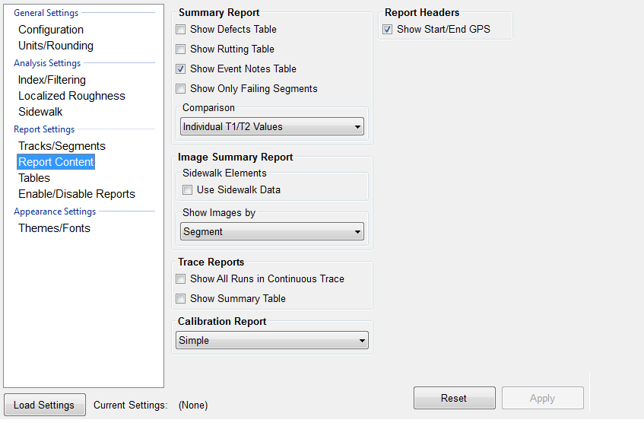

Figure 103: The Report Content window

## Summary Report

The operator can decide the data to report in the summary report. These include: The Defects Table, the Rutting Table, the Events Note Table or to Show Only Failing Segments. The data can be compared by individual Track 1 and Track 2 values or using the average of these. The Report Headers option lets the operator choose the Show Start/End GPS coordinates for the run.

## Image Summary Report

This section of the Report Content Tab allows for the operator to choose how to show the images collected (applicable to systems with a camera). The images can be shown by Run, Segment, Image or All. For Sidewalk Profilers, the operator should select the checkbox above the drop-down menu.

Figure 104: The Image Summary Report options under Report Content.

## Trace and Calibration Reports

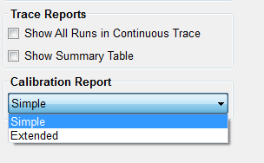The operator can choose to **Show All Runs in Continuous Trace.** When this box is selected, all runs within the file will be displayed within the continuous trace. The organization of the runs and tracks is always the same when this option is selected. If Run 1 will come first, then Run 2. Track 1 will always be the left-most trace on the report.

### Show Summary in Table

When this box is selected, the summary header will be included in the All Traces report.

Figure 105: The Trace and Calibration Report options

### Simple Calibration Report

The simple report contains information about the software version and the calibration summary. The included calibrations are the accelerometer calibration constants, distance calibration counts, and inclinometer calibration settings.

### Extended Calibration Report

The extended report has the calibration and the verification data from the last verification procedures. The verifications for the inclinometer, height sensor, and the bounce test are all included along with the calibrations for the accelerometer, inclinometer, and distance encoder.

## Tables

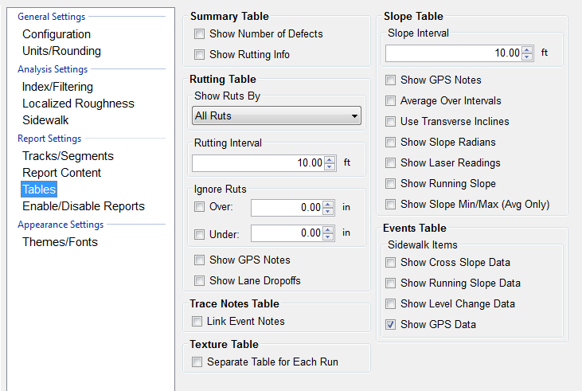

Figure 106: The Table options under Report Settings

The table options under report setting lets the operator chose what tables to include in the report. **The Summary**, **Trace Notes** and **Events** Table are used thought SSI’s Profiling systems. The Summary Table section includes the ‘Show number of Defects’ and the ‘show Rutting Info’ checkboxes. **Show GPS Data** is selected by default in the Events Table.

### Enable/Disable Reports

This feature allows the user to select the type of reports that appear in the drop-down menu. To have a report not be displayed in the drop-down menu, deselect the check box. These reports will be reflected in the dropdown menu to the right and also in the Reports Section of Profiler V3. See figures 128 and 129.

Figure 107: The Enable/Disable Reports window

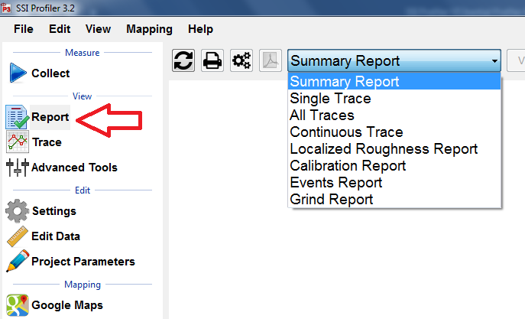

Figure 108: The Reports selections after Enable/Disable configuration is set

## Themes/Fonts

Figure 109: Themes and Fonts option under Appearance settings.

Profiler V3 lets the operator choose between two different Reports Themes: Classic (default) and Light. The Font can also be changed along with the Threshold Colors and the Defect Colors.

# View

Refresh Icon Print Icons Page Setup PDF Drop Down Report Menu

Figure 131: The summary header of a single trace report.Refresh Icon Print Icons Page Setup PDF Drop Down Report Menu

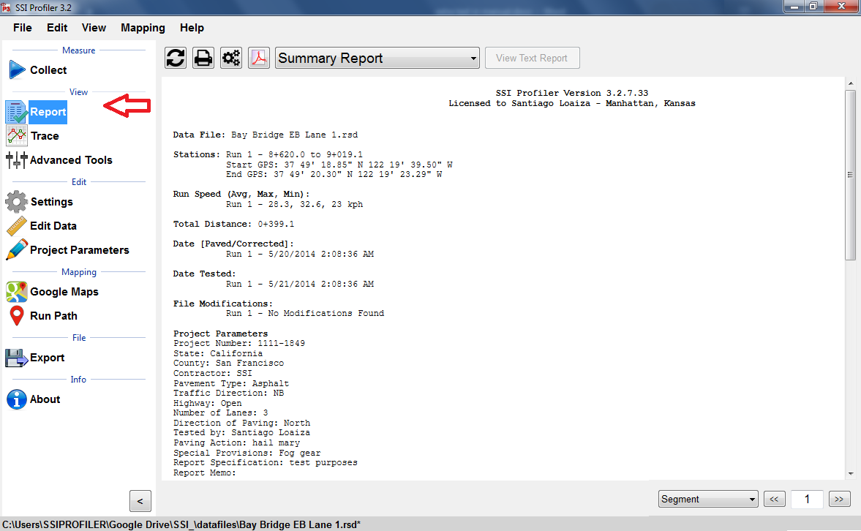

Figure 110: The summary header of a single trace report

## Report

### Refresh

It is required to refresh the Report window whenever a change is made to the Project Parameters, Settings, or Report Options. The refresh icon is located at the top left of the Report window. Select the refresh button and verify that the information is accurate before printing.

### Print

Always confirm the correct report is being printed by selecting the refresh icon.

**A Connected Local Printer**

To print a report, select the print icon in the Report window or select CTRL+P on the keyboard. The print window will appear. Within the window, select the printer to be used and verify that the printer settings are correct. When ‘Print’ is selected, the document will be sent to the printer.

If more printing options are needed, select the ‘Preferences’ icon. This icon will open a window that is printer specific that contains information about the orientation, paper size, and image quality.

Figure111: Printing Options Window

### Printrex 422 Thermal Printer

Confirm under the settings for the Printrex 422 that the paper size is 4 inches wide on a 150-foot roll. This setting can be chosen under Preferences>Advanced Settings. It is recommended to use Contiguous as the end of page control.

### To PDF

The Adobe Symbol between the Printer symbol and the report type will print the report to PDF format if the Broadgun PDF printer is installed. Contact SSI support is Broadgun is not installed or you are having issues with your PDF printer.

## 

## Report Options

The Report Options available in Profiler V3 are Summary Report, Single Trace, All Traces, Continuous Trace, Proscan Trace, Localized Roughness Report, Calibration Report, Rutting Report, Slope Report, Events Report, Sidewalk Report, Text Report, QA Suite Report, Events Text Report, Image Summary, ALR Image Report, Airfield Report, Grind Report, Profile Design Report, Texture Report.

Unless directed by the overseeing agency, the frequently used reports are Summary Report, Single Trace, Continuous Trace and Calibration Report. These reports are commonly used due to the information provided within them. All of these reports have the locations of defects and the information entered in Project Parameters and Localized Roughness.

Figure 112: The drop-down menu for the report options

## View by Segments

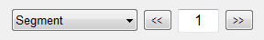By selecting Segments (the default setting) the operator may navigate through the segments of the file by typing in the segment number and selecting ‘Enter’, or by using the arrow keys to the right of the box. If the operator is not in Single Trace while using this feature, the program will adapt and open Single Trace when the Report window generates.

Figure 113: The segment or defect navigator

# Collect

To collect data the operator should select the Collect Icon when the hardware is attached. Once the hardware is found, the data collection may begin. See the Collection section of this manual for procedures to perform prior and during a collection.

# Trace

Figure 114: An example of the profile trace

## 

## Choosing Tracks for Plotting

To choose tracks for plotting in the trace window, select the check box next to the desired tracks. Once all of the necessary tracks are checked, select the refresh icon to view the tracks within the plot.

Whenever a change is made by deselecting a track or checking a new track, select the refresh icon to have it appear in the trace*. If the refresh icon is not selected, the trace will not update and the changes will not be shown.* Review the legend to verify that all of the selected tracks are shown in the plot.

## Refresh

It is required to refresh the Trace window whenever a change is made to the track selections. The refresh icon is located at the bottom left of the Trace window. Select the refresh button and verify that the trace is accurate before a print is made.

## Plot Options Icon

### Profile/Continuous IRI

The drop-down menu allows the user to select options of Profile and Continuous IRI, MRI or HRI, Median Profile, Segmented Bar IRI and Birds Eye View. It is recommended to use the median profile option when reviewing the collected relative elevation profile. The operator may view two graphs simultaneously by selecting the secondary plotter option.

When Continuous IRI is selected, the operator may not choose the option to include Run Up and Run out data.

Figure 115: Recommended Plot Options window

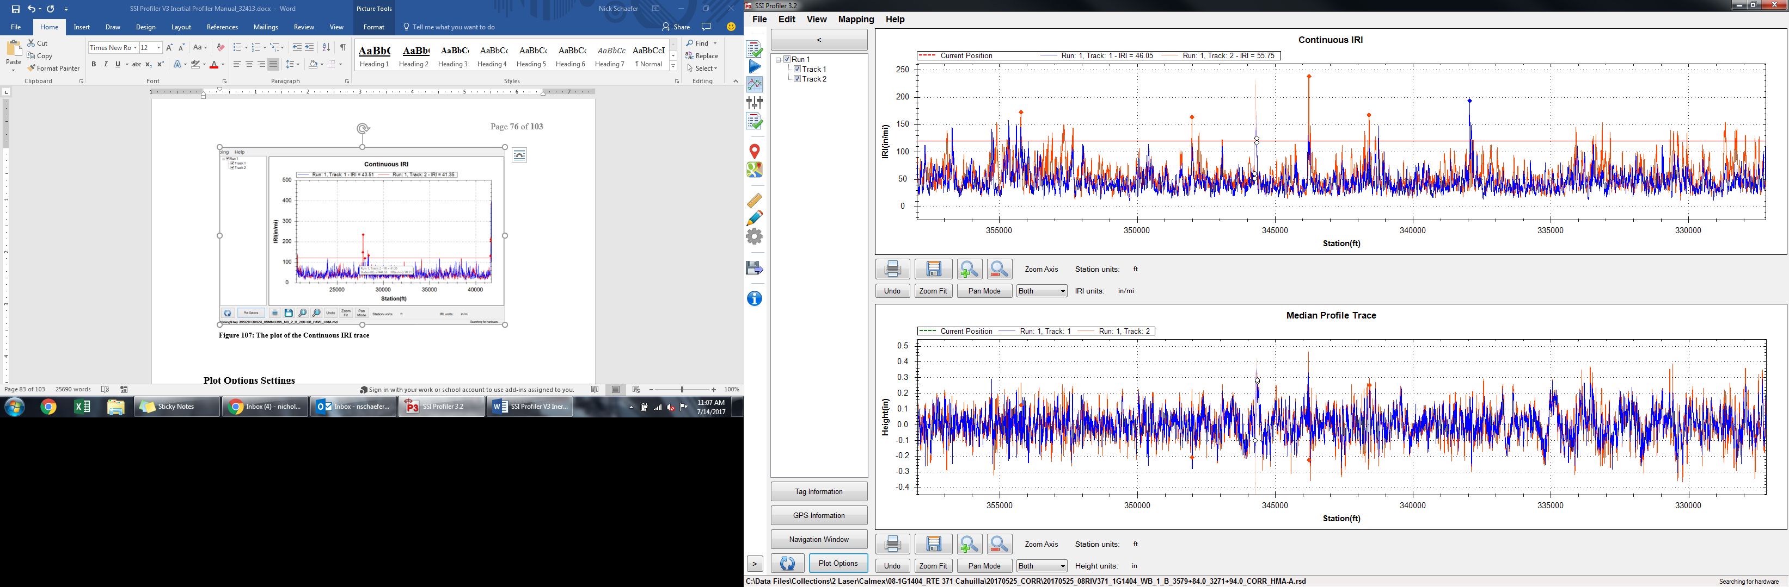

Figure 116:The dual plot of the Continuous IRI and Median Profile

## Plot Options Settings

### Display Run in/ Run out Data

Many High Speed Profiler data files have Run in and/or Run out data associated with them. To include this data in the trace, select the check box next to “Display Run Up and Run out Data.”

### Apply filters

To apply the filters select the check box “Apply Filters.”

### Show Point Labels

Showing point labels allows the user to move the cursor over the profile to find the stationing and height at a certain point of the plot. When the cursor stays over a point for one second, a dialogue box appears that gives information on station number and height at the cursors current position. The units of the stationing and height are the same as the units of the axes.

### Rendering Mode

Under the Rendering Mode section the operator can choose the type of rendering to increase the speed or increase the quality when refreshing the graph. When using the high quality rendering, the time it takes to refresh will be longer, however the resolution of the trace will be optimum.

## GPS Lock-On

### Display Current Location

This feature will display a vertical line at the vehicle’s current GPS location. This vertical line will move through the trace as the vehicle moves, allowing the user to locate the points of localized roughness.

### Center Trace on Current Location

Then this box is checked, the trace will pan with the motion of the vehicle so that the current location is always in the center of the window. ***This option is required for any navigation feature.***

## Highlight IRI Thresholds

### Base Length

The base length is the length of the California Profilograph or 25 feet. It will be the basis of the IRI localized roughness calculations.

### 1st, 2nd, 3rd [in/mi]

Three separate thresholds can be set to depict which plots exceed the thresholds on the graph. These thresholds will be plotted as a horizontal line across the trace graph at the IRI values of the threshold in inches per mile.

## Localized Roughness in Trace View

Be aware that when using the localized roughness the defects can appear below the threshold line. This is because the localized roughness is based off of a 25 foot length and not the entire profile.

## Display Localized Roughness

When this box is selected the trace view will have the localized roughness location marked with a diamond. If the user places the cursor over the red diamond, the information about the localized roughness will be displayed.

## Use Localized Roughness Settings in Trace View (Recommended)

Figure 117: The Continuous IRI trace with the localized roughness diamonds shown

By selecting this box the IRI Localized Roughness threshold established under the Settings and Localized Roughness Tab will be used to find and display the localized roughness in Trace View. If the other thresholds are used, the number of defects displayed in the trace may be different than the number in the report. ***This selection displays the same localized roughness as in the report.***

Threshold

Figure 138: The Continuous IRI trace with the localized roughness diamonds shownThreshold

## Navigation

***In order to use the Navigation feature in Trace View the GPS must be connected and you must select the “Display Current Location” check box under GPS Lock-On in the Plot Options Window.***

## GPS Tagging Tool

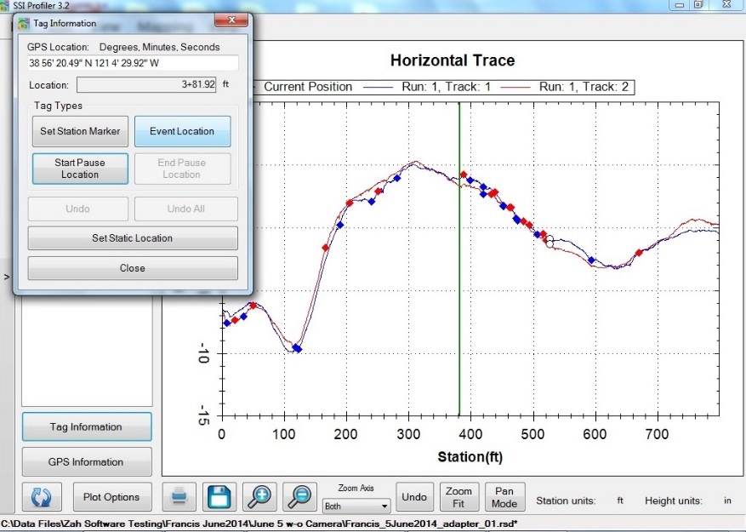Based on the GPS coordinates from the collection, the program can add events and pauses to the collection information. There are two ways of adding the events and pauses; dynamic and static tagging. The tagging tool is included in a deluxe Profiler license. ***Tagging tolerances are dependent on the accuracy of the GPS system used.***

### Dynamic Tagging

Dynamic tagging involves being physically at the location of the start or end of the pause or the event. The GPS string will be visible in the tagging window with the option of also having your current location displayed on the trace. Choose the type of location from the options and move to the next area.

Figure 118: Dynamic Tagging Feature

### Static Tagging

Figure 119: Static Tagging Feature

The static tagging feature allows the operator to enter a GPS location from a remote location, like your office. As long as the location’s GPS coordinates are known, a pause or event can be created.

## Grinding Simulation and Navigation

SSI has developed a feature to assist contractors in the removal of IRI Areas of Localized Roughness (ALR). The Grinding Simulation is included in a deluxe license of Profiler. ***Navigation tolerances are dependent on the accuracy of the GPS system used to collect and layout roughness.***

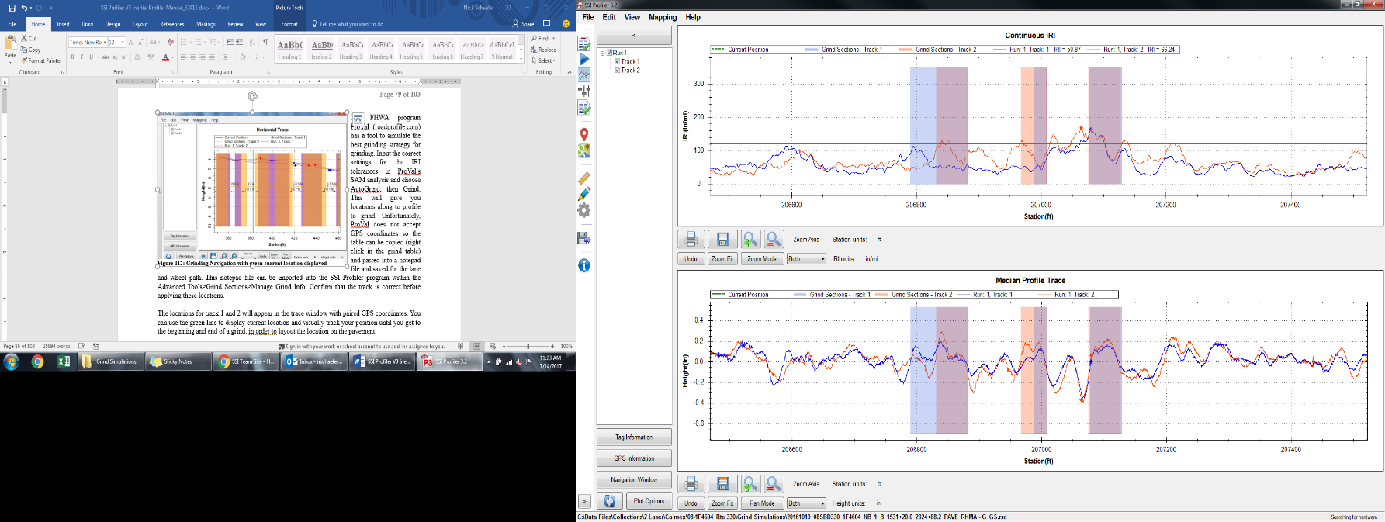

Figure 120: Grinding Navigation with green current location displayed

After collecting the data ALR can be determined from the amount of suspension movement over certain locations. These areas can be determined in SSI Profiler’s Localized Roughness section. However, grinding the ALR does not have the best result in removing roughness. This is because ALR can now include dips and bumps. Grinding dips takes a special procedure.

The FHWA program ProVal (roadprofile.com) has a tool to simulate the best grinding strategy for grinding. Input the correct settings for the IRI tolerances in ProVal’s SAM analysis and choose AutoGrind, then Grind. This will give you locations along to profile to grind. Unfortunately, ProVal does not accept GPS coordinates so the table can be copied (right click in the grind table) and pasted into a notepad file and saved for the lane and wheel path. This notepad file can be imported into the SSI Profiler program within the Advanced Tools>Grind Sections>Manage Grind Info. Confirm that the track is correct before applying these locations.

The locations for track 1 and 2 will appear in the trace window with paired GPS coordinates. You can use the green line to display current location and visually track your position until you get to the beginning and end of a grind, in order to layout the location on the pavement.

Under the navigation window icon in trace view you may choose to auto-center the current location and choose the Simple Grinds option. The simple grinds window displays the location of the grinds relative to the current position through numbers and colors.

## Print

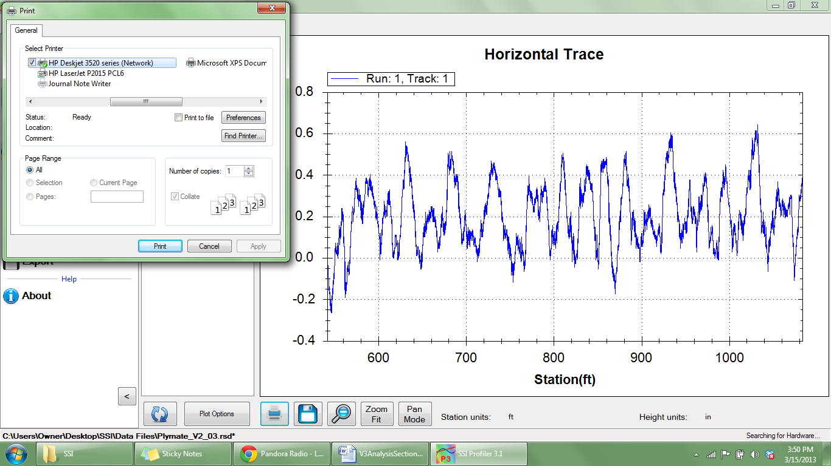To print the trace, select the Print Icon in the window or select CTRL+P on the keyboard. The print window will appear at this time. Within the window, select the printer to be used and verify that the printer settings are correct. When ‘Print’ is selected, the document will be sent to the printer.

Figure 121: The Print window after the print icon is selected

If more printing options are needed, select the ‘Preferences’ icon. This icon will open a window that is printer specific containing information about the orientation, paper size, and image quality.

## Save

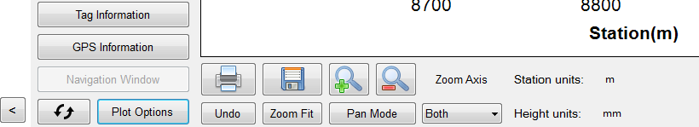When the Save icon is selected, the user is able to save the trace as an image in png, gif, jpeg, tiff, and bmp format. The image can be saved on the operating computer or on a connected external device.

Figure 122: The tool bar for the trace window

Refresh

Figure 144: Windows explorer to save a picture of the graph.Refresh

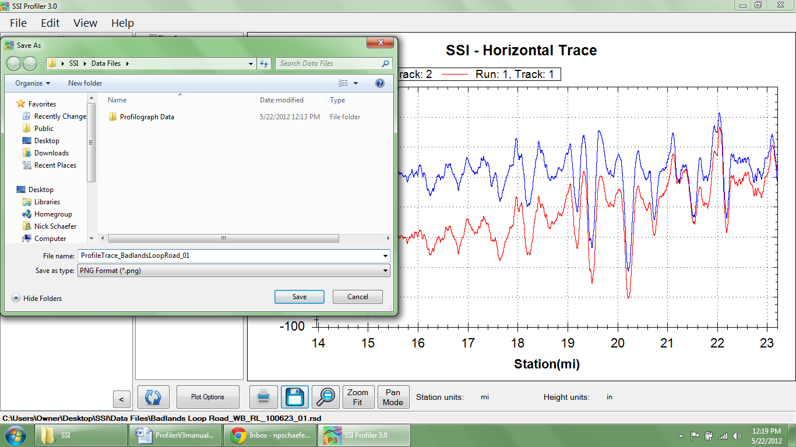

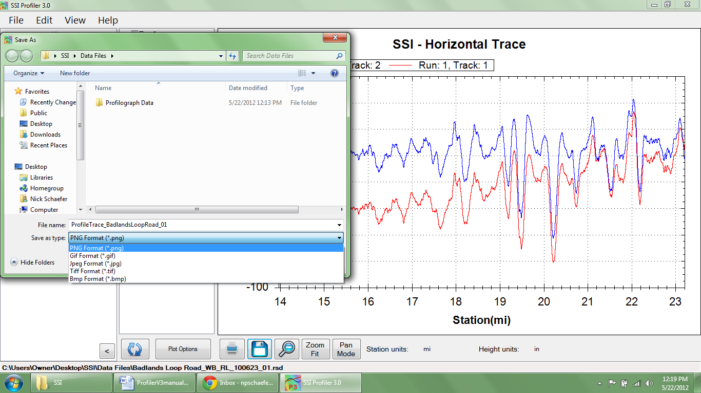

Figure 123. The available picture formats to save the trace graph.

Figure 124: Windows explorer to save

## Zoom

To zoom in the trace window, verify that the Pan/Zoom Mode icon displays ‘Pan Mode.’ To zoom in on the plot, left click and hold while dragging the cursor over the area to be blown up. While dragging the cursor, a dotted box will appear. This dotted box contains the area of the plot that will be blown up, by being fit to the size of the plot window.

### Zoom Previous Icon

When Zoom Previous is selected, the last ‘zoom in’ action is undone.

### Zoom Fit Icon

To return to the original aspect ratio, also known as the home view, select Zoom Fit.

### Pan/Zoom Mode Icon

The Pan/Zoom Mode icon has two functions. When Pan Mode is displayed, the cursor may be used to zoom in on the plot. To zoom in on the plot, hold down the left mouse button and move the cursor over the plot area to be blown up. The dashed box contains the area that will be enlarged.

When Zoom Mode is displayed, the operator may use the cursor to pan across the plot area. The pan mode allows the user to navigate through the plot area without changing the aspect ratio, or zooming out.

## Units for Height and Station

The units for height (y-axis) and stationing (x-axis) can be changed by left clicking upon the current units and selecting the necessary units from the dialogue box that appears. The units available are mils, inches, feet, yard, miles, millimeters, centimeters, meters, and kilometers. The units scale the plot area.

## GPS Editing and Tagging

The operator can use the GPS signal to edit the start and stop locations of the collections and add events to the collection.

# Advanced Tools

The Advanced Tools window contains options for images, transverse profile viewer, grind sections and profile design. These options will only be available if the user license permits this additional analysis. Contact SSI for a license upgrade.

## Images Window

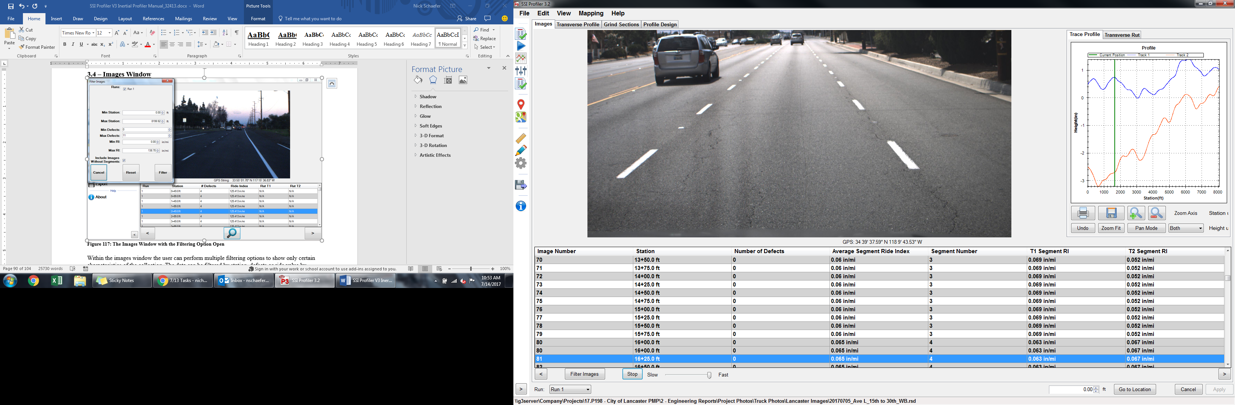

Figure 125: The Images Window under Advanced Tools

Within the images window the user can perform multiple filtering options to show only certain characteristics of the collection. The data can be filtered by station, defects or ride value. The software automatically enters the minimum and maximum values for each of these three fields. The units of these parameters can be changed by selecting the current units to enable to drop down menu to choose new units. After the operator has changed the parameters according to the range desired, select “Filter”. The images will reorganize and the new images will not be reverted until the parameters are changed to the original setting (“Reset”).

The information in the table below the image will be populated as long as the location is not in the run up distance and there is sufficient data. If the system was not a full lane width 5-laser system the rutting depths will read ‘N/A’.

The arrow keys on your computer’s keyboard can be used to advance the images. There will be a lag using the computer’s keyboard until the images are populated from the files. After the images are loaded the operator will be able to constantly hold the up/down arrow keys to view a slide show of the collection.

*The GPS string of the Images Window is based off of the nearest GPS coordinate and should not be used as a reference station.*

### Images in the Report

The images captured during data collection can be viewed alongside the trace within the any of the three trace reports. The user can view the images with the trace in the Single Trace, All Traces, and Continuous Trace reports. If the user hovers the cursor over the camera icon the image will appear.

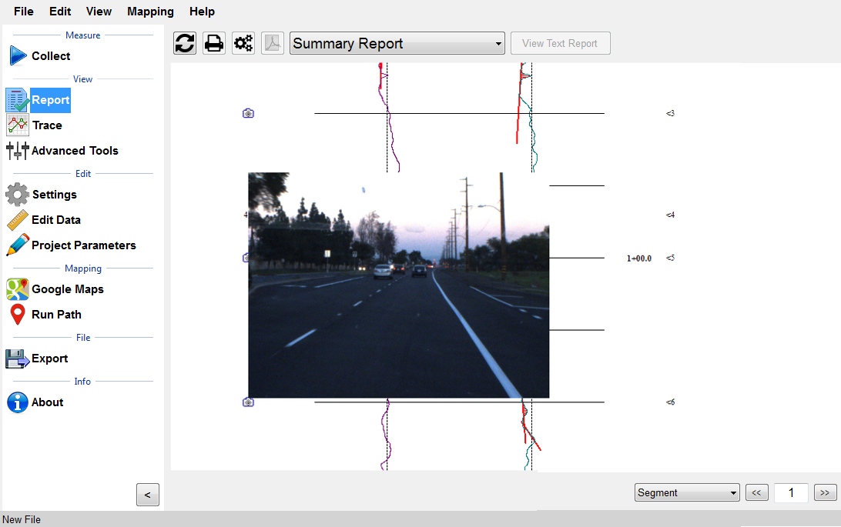

Figure 126: : The Continuous Trace Report with Images.

The user can right click on the image in the image window or on the trace to save it to the computer or other external device. As long as the user left-clicks above the image, windows explorer will open to choose where to save the image file. The following formats are available: BMP, JPEG, GIF, PNG, TIF. Right click to save image.

## Grind Sections

Corrective grinding locations can be imported from a grinding plan into SSI Profiler through a text or CSV file through the grind sections tab of the Advanced Tools under “Manage Grind Info….” Grinds should be imported using wheel path (track 1 and track 2) or full lane width grind plans. After the grinds have been imported, the user can merge grinds within a certain length or combine all grinds transversely across the lane (merge tracks 1 and 2). The grind locations can be edited or deleted within the manage grind info icon.

# Navigation (Map Views)

The Profiler V3 program two methods of location navigation: Google Earth and Trace View. They can be used to travel to the point of localized roughness, Segments, Events, or a GPS coordinate. For this reason, *all three navigation options require a GPS device to function*.

## Google Maps.

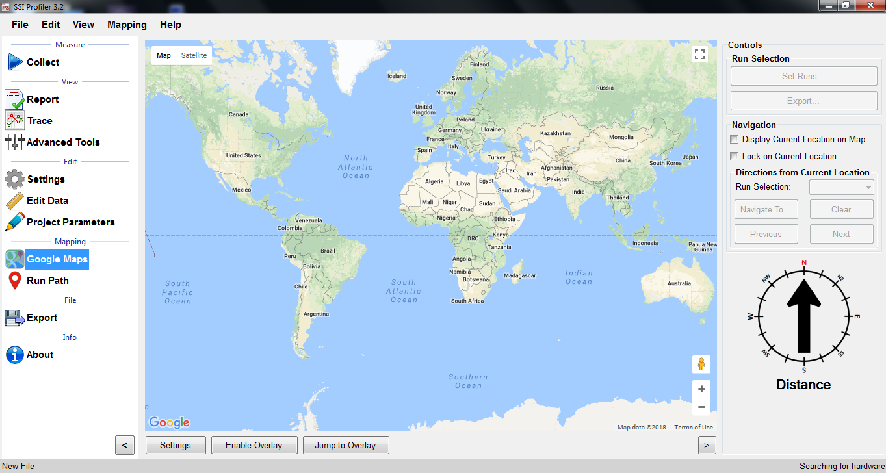

Figure 127: The Google Maps start window.

***\*An internet connection is required for use of Google Maps***

Google Maps can be used to show the location of the run path, segments, and localized roughness. Google Maps can also be used within Profiler V3 to navigate to defects, the start of the run or the end of the run.

***To view the location of the collection without any collection information displayed:***

1. To begin, select the Google Maps icon in the shortcut bar.
2. The world view will be the initial view in the window.
3. The right side of the window has the controls section. Choose the run number of the collection to be viewed in the map.
4. Select Jump to Overlay or “Navigate To…” and select an event.

***To view the Run Path, Segments, and Localized Roughness:***

1. Select their corresponding check boxes of the parameters. If one parameter is not desired, do not select its check box
2. Select the “Enable Overlay” icon.
3. Select Jump to Run
4. If the push-pin is selected, the statistics and information for that location will be displayed.

For Localized Roughness: Red Pin is Track 1, Blue Pin is Track 2, and the Green Pin is Track 3. To deselect a track to not show it on the map, select the “Set Runs” icon and uncheck the box next to the unwanted track.

Once the run is displayed in Google Maps, use the scrolling and cursor to navigate through the run. The run path, segments and localized roughness are shown if their respective box is selected. These features can be shown if the box is checked reading, “Disable Overlay.”

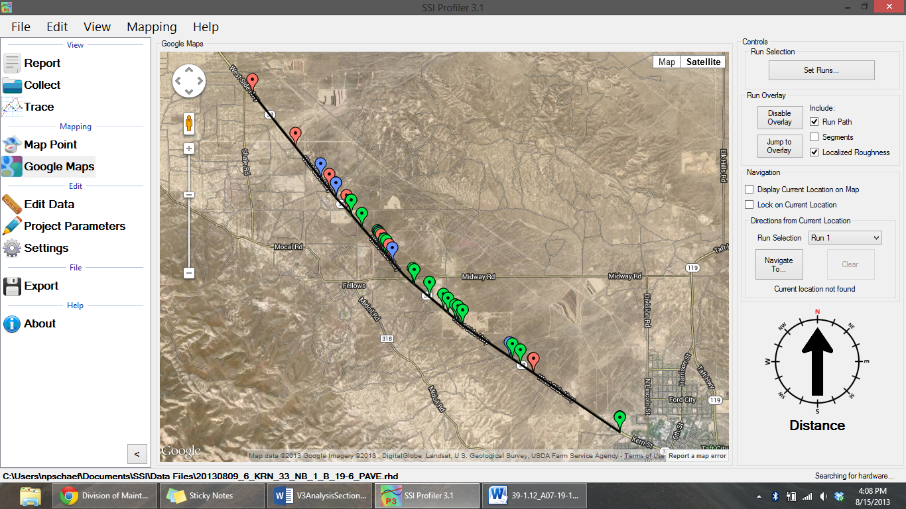

Figure 128: Google Maps showing the localized roughness

### Display Current Location on Map

If this check box is selected, the current location of the profiler is marked by a large green arrow in the map window.

### Lock on Current Location

If the check box for “Lock on Current Location” is selected, the location of the profiling system will remain in the center of the map window.

### Directions from Current Location

The V3 program will navigate to the start or end of the run and any defects found during collection. Select the destination from the drop-down menu and select the calculate icon. The route will appear as a black line from your current location to the “B” landmark.

To navigate to an event, pause, segment, or defect, select the correct run number and hen the “Navigate To” icon. If GPS is connected the program will ask the user where to be navigated to. Once the location is selected Profiler will direct the device to the location.

***Note: GPS must be connected to use the Google Maps and Map Point features.***

# About

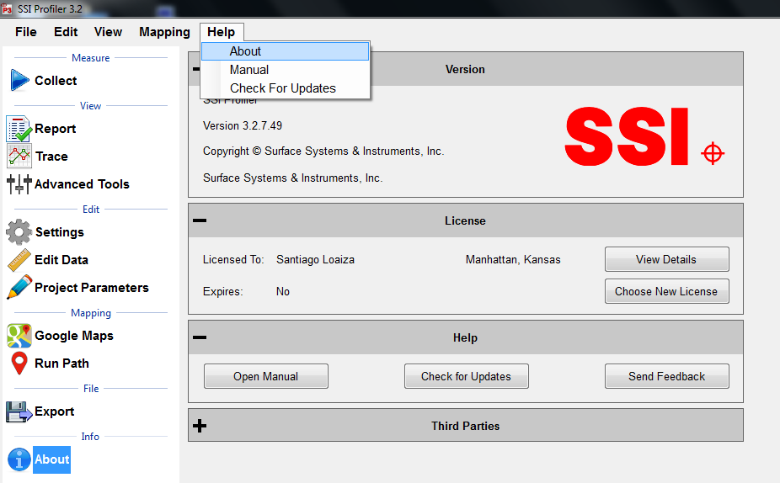

Figure 129: The About Window

The About section has information concerning Profiler V3 software and its licenses. The software version, copyright and license can all be found in the ‘About’ window. Additionally, third party software licenses are listed in the About window.

The About window is where the user can view the terms and features enabled with their license. Select View details to see the applicable collection devices and software features that are enabled. The update icon allows the user to update to the latest version of software.

## Manual

The manual can be found under the Help Tab or on the About Section window.

## Check for Updates

The operator can manually check for updates through Help>Check For Updates. By default, the program will check for updates every time it is opened. To not check for updates at each opening, deselect the check box in this window.

## Send Feedback

If SSI should be informed of issues or advancements of the software, please send us feedback so we can improve our services.

## Third Party Components

The Third Party Components of Profiler V3 are:

ZedGraph Copyright © 2004 John Champion under the LGPL 2.1 license.

Modified source code is available for download at: http://www.smoothroad.com/support/download.asp.

SharpSSH Copyright © 2006 Tamir Gal

Mentalis.org Crypto Library Copyright © 2002-2007. The Mentalis.org Team

Full copies of all third party licenses can be found in the Licenses folder located inside the Profiler V3 installation directory.

# Recommended Tools

## Create a personal default file name convention for you project

Under General Settings the operator may select “Configure File Naming” to create a new file name convention for FHWA and State DOT submissions.

## Load analysis parameters and settings from previous projects

When a previous file has the correct project information and settings saved within it, the operator may load the previous file’s settings into the current file. By selecting “Load” under General Settings the user may select the previous RSD file and load its settings into the current project.

## Set a default file location

The user may select a default folder to save all files and reports under General Settings. It is recommended paste the folder destination into the address input.

## Use the extended calibration report to print PDFs

The extended calibration report option is located under Settings>Report Options. The extended calibration report adds the bounce and laser height verifications to the calibration report.

## Use dual plotter in trace view

Under trace view the plotters can be viewed to see the elevation and the IRI roughness. This is useful when determining if an area of roughness is caused by a bump or a dip in the profile trace. It is highly recommended to use this feature for correction operations. The trace view can be chosen under Trace>Plot Options and Enable Secondary Plotter. It is also recommended to link the secondary plotter X-axis.

## Use GPS navigation within trace view

During correction operations it is important to be accurate. The SSI Profiler system allows for the user to navigate along the collection path using GPS. Depending on your GPS system you may have to connect to hardware and have your antenna attached. The GPS accuracy can be found listed on your profiling documents or by calling your SSI representative. The GPS navigation can be enabled under Trace>Plot Options>GPS Lock-On options. The check boxes should be enabled for Display Current Location and Enable Navigation.

## Use hot keys during collection

During collection the operator can assign a command to any keyboard key except for the space bar and the enter key. The keys can start or end a collection, arm and electric eye or create an event for various types of scenarios such as pavement distresses or debris.

## Import grind locations into Profiler for use in trace view navigation

Once grind locations are created the grinding plan can be imported into Profiler through the Advanced Tools>Grind Sections tab. The locations can be added through the Manage Grind Info Icon. Once the locations are added, they will appear within the trace view to be used with the GPS navigation. Under Trace View>Navigation>Simple Grinds the window can display the distance to the grind locations per wheel path.

## Use Google Maps to crop and edit data based on stationing and pin information

Google Maps can be used to compare multiple runs to each other and determine the stations to crop an RSD file back. The operator may use landmarks, a collection event or a previous collection to adjust a starting location.

# Troubleshooting and Support

## When Contacting SSI Technical Support

If possible, have the profiler system type, profiler software version, operating system, computer model number, and company of ownership ready. If an internet connection is available, SSI staff may request your data files for comparison and troubleshooting.

## Attaining Profiler Software and Replacement Parts

For technical support with the High Speed Profiler (HSP) software contact SSI to obtain a User ID and Password to download the most recent updates from the [www.smoothroad.com](http://www.smoothroad.com) website. Software issues should also be reported to SSI by email at support@smoothroad.com, with a copy of any data files to be reviewed by SSI technical support staff. SSI support staff can also be contacted by telephone at (530) 885-1482 (Auburn, CA); or (785) 539-6305 (Manhattan, KS).

Parts can be ordered online from SSI at <http://www.smoothroad.com>. For support issues involving the profiler hardware (DMI, Pelican cases, hardware, cables, etc.), contact the SSI office in Auburn, California at (530) 885-1482 or by email at [support@smoothroad.com](mailto:support@smoothroad.com).

## Panasonic Toughbook Computer

For technical support for Panasonic Toughbook computers, contact Panasonic Technical Support at 1-800-Laptop5 (800- 527-8675) or go to the Panasonic support website at:

<http://www.panasonic.com/business/toughbook/support.asp.>

## Paper Supplies or Printer Servicing.

For printer paper supplies or printer servicing, contact SSI at support@smoothroad.com or (530) 885-1482.

## Is your Software Up to Date?

Contact SSI to upgrade your software if your problems reoccur after support assistance.

## Do Not Attempt To Repair Electronic Components

All of the electronics within the SSI Profiler systems are built custom for Surface Systems and Instruments. Do not attempt to fix issues without contacting SSI.

## Is your Power LED Illuminated?

No power to the system would cause the hardware to disconnect from the software.

## Hardware Not Found

Check the cables of your system for any wire breaks. If the Amphenol connections are twisted, it can break the soldered wires. If problem persists, contact SSI Support Staff.

## Example Diagnostics

By selecting the button on the upper right of the Collect screen with a single digit number on it. The single digit number will be the same as the number of lasers on your system. The button is colored green for systems without an issue, yellow for systems with a device disconnected and red for connectivity issues.

**SSI Profiler 2.1: Q0g0r0r0x0x0x0**

‘0’ means that the device is connected.

Q is the encoder symbol

g is Trimble GPS

r is for a Roline laser. The order is Track 1 laser, Track 2 laser, Track 3 laser (if equipped).

x is an open port

**Topcon V2.1: Q0G0r1r0d0P0P0x0**

‘0’ means that device is connected

G is Topcon GPS

‘r1r0’ means that the electric eye is disconnected.

d is the symbol for a dot laser

P0P0 is the symbol for connected inclinometer (only for 3 laser survey systems).

## Failed Height Verification

1. Check block Orientation. Do not block receiving laser sensor.

2) Check Laser Type in System Settings

3) Check the integrity of the cables and pins. Make sure the pins are not bent inside the connectors and that the cables are not damaged.

4) Check the height of the lasers from the measurement surface. For Roline and low stand-off spot lasers the minimum height is 200 mm (7.8 inches). For high stand-off spot lasers the minimum height is 12.8 inches (325mm).

5) Is there a glare on the verification blocks?

## Failing Accelerometer Calibration

**Main Cause:** Not rotating both accelerometers at the same time or a connection issue.

**Are you:**

Rotating both accelerometers during calibration?

Matching the white lines on the accelerometer and cable disconnects?

Check the condition of the small pins within the disconnect cable and the secureness of the serial connections to the grey box.

## Lasers Not Firing

**Main Cause:** None/ not sufficient power reaching the lasers

* + - Is the blue light flashing on the Roline laser
    - Is the blue LED on the white housing emitting light?
    - Are the red lights on the grey box serial ports emitting solid red light?
    - Check the condition of the pins in the cables.
    - Is the vehicle off or running?
    - Does the same problem happen with the engine running?

## Failed Bounce Test

When were the accelerometers calibrated?

Are the front wheels straight?

Is the vehicle moving forward and backward while bouncing?

***This causes the lasers to read additional height differences, adding to the ride value.***

Is the bouncing only vertical? (No transverse rocking)

Is the laser type correct under System Settings?

What are the shift calibration values?

***If none of these work, try the Simulated Travel option under the ‘Advanced’ tab of the Collection Parameters window. Follow AASHTO R57 to complete the bounce test.***

## Distance Not Correct

When was the last calibration performed?

Was the actual distance traveled during calibration entered correctly?

Is the DMI damaged or loose?

Is the DMI Amphenol cable attached correctly?

How long is your calibration track?

Is there a large temperature gradient?

Is the calibration track a straight line?

## High IRI/Ride Value

Are the lasers firing and streaming?

What does the diagnostic string look like?

Are the lasers or accelerometers loose and/or vibrating?

When were the last accelerometer calibration and height verifications performed?

Is the laser type correct in the System Settings? (Check with a laser verification)

## Electric Eye Events/Pause/Start/Stop Collection Did Not Work

Is the correct EE turned on?

***There will be an amber or green light on the back of the EE. Flip the switch on the white housing if it is not on.***

Is DOT-C2 reflective tape being used?

Is the angle of the reflector matching with the EE orientation?

## GPS Navigation Timed Out (Map Point, Google Maps, Trace View)

1. Check if the system lost GPS signal (Open the Collect window then GPS Options to check the satellite reception).
2. Disconnect hardware and reconnect hardware.
3. Check that all cables are securely connected.
4. Check power source for consistency.
5. If using a Topcon system, review the MC-R3 rover settings for accurateness.

## The Camera is not taking color pictures

1. Choose another pre-formatted option (Low, Medium and High Resolution).

**Advanced User Options (Custom Resolution)**

1. The camera settings can be found under the Collect window in System Settings.
2. Go to the Camera Settings tab
3. Open Advanced Camera Settings
4. Review Custom Video Mode to affirm that Raw 8 is the pixel type.
5. Select Standard Video Mode
6. Select the button for resolution and pixel type to be Y8 (Raw 8) and 1280x960.
   1. Once this change is made the preview will also be in color